Bontdu
OS SH 67464 21422 elevation 240 m
Aspect SW facing, quick drying. Some good trad climbing here as well.
Approach: 35 minutes, mainly on tracks. Once you leave the tracks and cross the bridge the going can get quite tough.
Two tiers of jumbled grit blocks.
Parking OS SH 66669 20250 elevation 180meters
From the village of Bontdu take the road leading uphill (past the old Bontdu Hall) and northwards inland to the old house of Hendreporion. Parking by the stile. Over the stile and follow the track through a gate: after passing a second gate the track divides. Take the right fork leading downhill to a stile and an old stone bridge over the river. On the far bank wade through high grass and tall heathers to the boulders. The crag and the boulders are easily visible during the approach.
There are three areas:
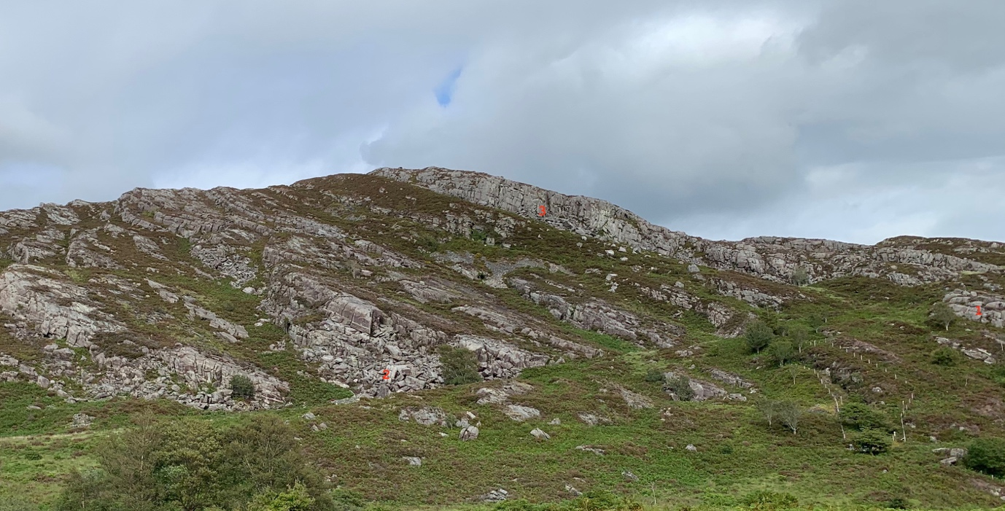

Area 1 The Right-hand section: a mix of low, jumbled boulders and very minor.
Area 2 The left-hand section: another jumble with quality stones.
Area3 The upper Tier: a good dense jumble of stone.

Area 1 OS SH 67454 21307 elevation 230 m
The first boulder on the right is actually on the west bank of the river while all the others are on the hillside above the river just the other side of the old mine entrance which is fenced off.
After crossing the stile and the bridge turn right.
1 Small Fry 6A+ OS SH 67365 21249 A solitary boulder on the bank of the river on the right of the stile before crossing the bridge.
Sds low and right and TO leftwards.
Terry Taylor 7.11.2020

Main area 1.
2 Trumped 5A
Sds and avoid the left edge.

3 Learning to crawl 4C
Sds low and left and traverse right.

4 Golden Dawn 6A+
Sds under the perfect pinnacle and pop over the top.
Mari Rees 7.11.2020
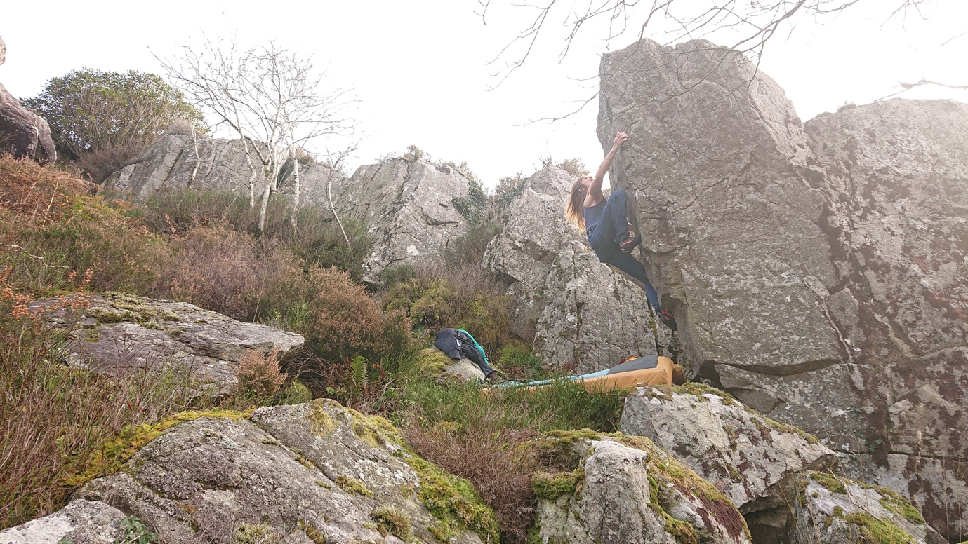

5 Don’t throw in the towel 6B
Sds under the small, overhanging prow with some compression and hit the juggy lip at the tip of the prow. Skedaddle leftwards around the overhang for the mantel.
Mari Rees 7.11.2020

6 Golden Powers 6B+
Sds way over on the right edge and traverse leftwards around the corner to the mantel.
Terry Taylor 7.11.2020
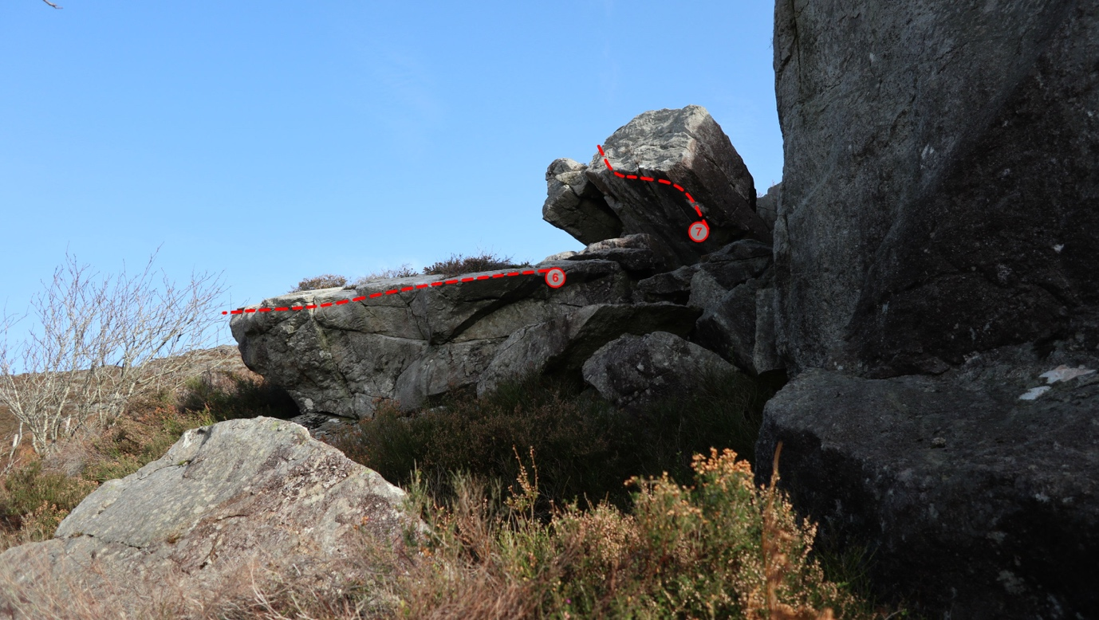

7 Golden Nuts 6A
Sds and traverse left to the TO.

Area 2.
From bottom to top.
8 The Laurel and Hardy Yoga party 6B
Sds low on the left, hand traverse right around the corner and finish on the apex.
Terry Taylor 2.8.2020

9 Crap 5A
Sds with a hard pull onto the edge and gain the apex.
Cian Taylor 2.8.2020

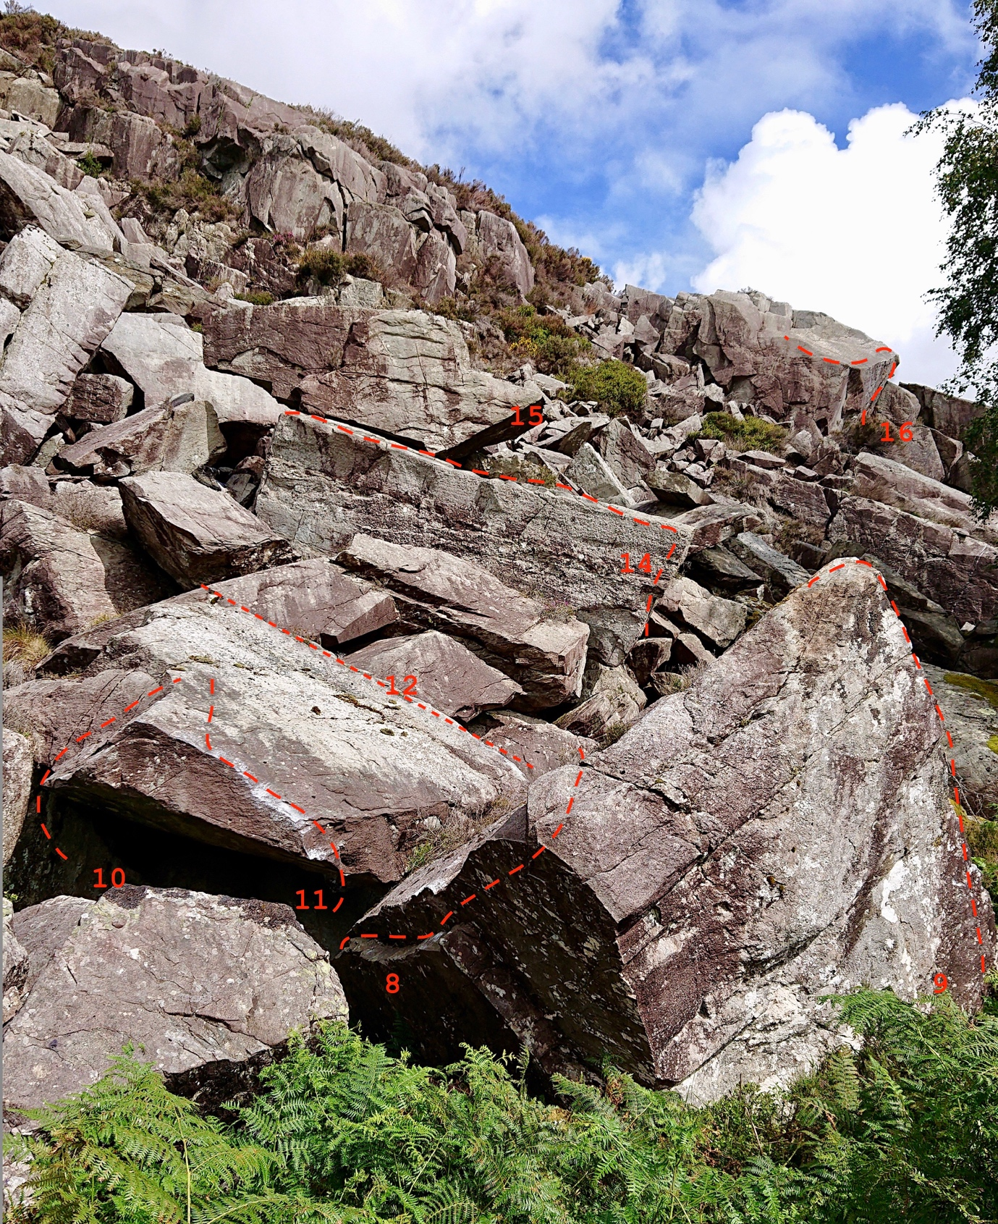

10 Nagini 6B
Crouch start under the roof and mantel over.
Mari Rees 3.8.2020

11 Basilisk 6B
Sds under the right edge of the roof, high heel and traverse left to mantel.
Mari Rees 3.8.2020

12 Gringots Roof 6A+ (no photo topo)

Sds under the left edge of the back roof of the same boulder and traverse right to the mantel.
Terry Taylor 3.8.2020

13 Long Way to Thailand 5C (no photo topo)
Sds over on the left of the boulder opposite Basilisk and traverse right to the rock-over mantel.
Cian Taylor 3.8.2020

14 Wall of Flesh 4B
Stand start on the right and traverse left to turn the corner.
Cian Taylor 3.8.2020

15 Bull boat 6A+
Sds over on the left edge of the perched, boat-shaped boulder and follow the edge around the corner to gain the face and the topout.
Terry Taylor 3.8.2020

16 Voxcox 6A
Sds under the right roof handle over at the entrance to the boulder field and traverse left to turn the corner for the topout.
Terry Taylor 2020

Area 3
Upper Tier OS SH 67613 21416 elevation 300 meters
A hard bash uphill through heather and bracken takes a further 15 minutes from the lower tier.

The biggest boulder over on the left is
17 Tick Teaser 6B+
Sds hands matched on the good rail and gain the jug on the lip above. Continue along the lip leftwards to the apex and TO.
Mari Rees 29.8.2020

18 TBE 5B
Stand start with the good lip jug on Tick Teaser and rock over directly on to the slab then pull up left to finish.
James Harris 29.8.2020

Under the roof are two problems
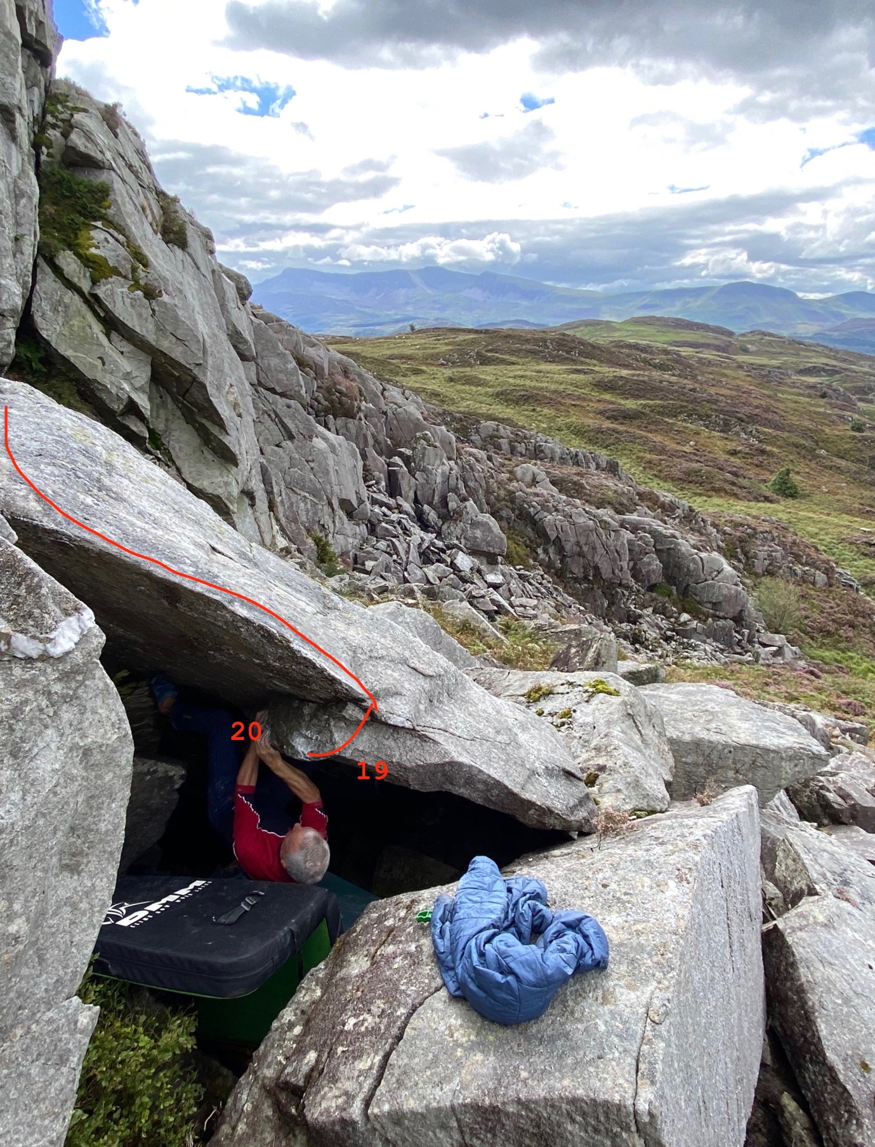

19 One green Bottle 5A
Sds deep under the roof, LH on boss, RH on the lip, pull up and traverse the juggy lip around to the left and TO.
James Harris 29.8.2020

20 Two Green Bottles 6B
Sds under the deepest part of the roof with hands matched on the left end of the boss and distant toehold. Push off and gain the lip for the TO.
Terry Taylor 29.8.2020

21 Dead Fish Manoeuvre 6C
Sds on the slab below this boulder, pull on and traverse right around the corner using only the higher boulder. Flop over like a dying fish.
Terry Taylor 29.8.2020

22 James and The Giant Reach 6B
Sds on the rock platform under the right end of the lip and traverse leftwards around the corner to reach the final faraway jug on the left for the mantel.
Terry Taylor 29.8.2020

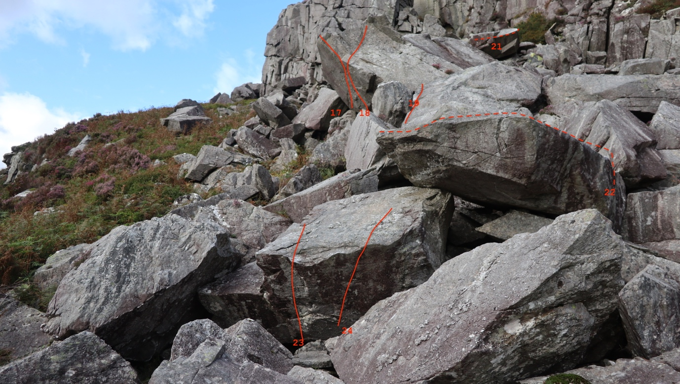

23 Tardy 5A
Sds and use the good holds on the slab above to TO

24 Lardy 6B
Sds and using the lip fingerholds slip and slide and belly flop over.
Mari Rees 29.8.2020

25 Skid Marks 5B (no photo topo)
Sds low on the right in a little pit below the small, pinnacle-shape boulder, pull out to the lip and traverse left around the corner.
James Harris 29.8.2020.

26 The Price you Pay 6B+
Sds under the prow and rock over.
Mari Rees 29.8.2020

27 The Swinger from Lymm 6A+
Sds with good LH crimp and RH layaway, slap up to the better layaway and rock up right to topout.
James Harris 29.8.2020

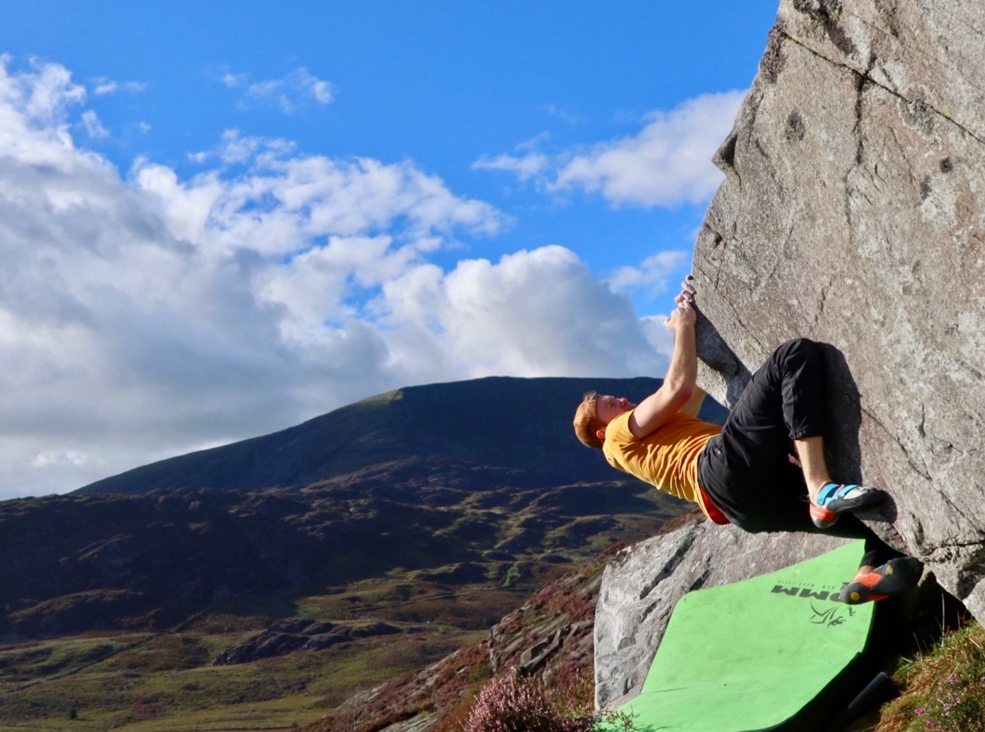

James Harris is the Swinger from Lymm.

Above this crag on the summit of the hill there is a good selection of slabs called Mynydd Cwm Mynach. Topos online here at midwalesbouldering.com

