Llandecwyn BEACH OS SH 62012 38253

LLandecwyn forest OS SH 62889 38851

A beach venue and a roadside forest venue.

The beach.
Park in the layby at the south end of Penrhyndeudrath bridge, walk through the gate and the small beach escarpment is on your right.1 minute. A great venue on the sandy shore facing the afternoon sun and only bothered by the high tide for 2 hours a day.

From LTR.

1 The Heart’s a lonely hunter 5C
Sds under the roof and crimp directly up to the jug dismount.
Mari Rees 24.4.2022

2 Sol Tapedo 5C
Sds under the scalloped edge.

3 The Cosmic Game 6B+
Stand start from the alcove and march leftwards to the end.
Terry Taylor and Elliot Twiddy 24.4.2022

4 Sweet Tides 5C
Sds and up the left wall of the groove to the dismount.

5 Satyam Shivam Sundaram 6A
Sds and up the groove to the dismount.
Elliot Twiddy 24.4.2022

6 Saudade 6A
Sds under the right wall and up to the sloping dismount.
Terry Taylor and Elliot Twiddy 24.4.2022

7 Ghetto Matrix 6C
Sds by the crack and up the steep wall on crimps before heading right to the easy rib dismount.
Elliot Twiddy 24.3.2022

8 Let the Chalice Blaze 6B+
Sds just right and gaston up to the high jugs.
Mari Rees 24.4.2022

9 La Femme Parallel 6A+
Sds and follow the good lefthand edge to the dismount jug.
Terry Taylor 4.5.2022

10 Mandala 6B
Sds under the right edge and follow the perfect ramp to the jugs for the TO.
Terry Taylor 4.5.2022

The Forest Stones.
OS SH 62889 38851
A land of walls and slabs and home to the Zappa crag (thanks to Leo Holding) at its zenith. The rock, however, is shale, sharp and snappy and only 4 boulder problems have been realised to date.

Approach
- OS SH 62012 38253 From the same parking as the beach by the bridge follow the footpath over the hill and up-river to the road. Cross the road and walk north for 15 meters to the path on the other side of the road. Up the hill, through a wall then right for Iconoclast wall and left for Half Man area.
- OS SH 62556 38236 It is possible to squeeze one car at the gate entrance to the forest on the east side of the road taking care not to block access. Drive from Maentwrog and not from Llandecwyn so as not to have to cross the road as this is a blind bend. To exit head south -use the well-placed mirror to spot any traffic. Spooky!
Pass through the gate on foot and follow the track to where the FP joins it on the left. For Iconoclast stay on the vehicle track for 50 metres more and the wall appears on the left. For Half Man follow the footpath leftwards down the hill and take a track parallel to the road for 100meters. The Spanorama wall is 300 meters beyond this on the same contour line.

1 Spanorama 6B+
Sds and take the steep, jug-festooned wall to the far right for the dismount in the corner.
Terry Taylor 22.4.2022

2 Spantasy 6A+
The groove in the corner with good layaway edges to the dismount jug.
Mari Rees 22.4.2022

3 Half Man, Half Weird 7A
Stand start on the left and follow the edge rightwards and downhill. A good finger jug turns the corner then carry on to the right edge and TO.
Terry Taylor. 22.4.2022

4 Iconoclast 6B OS SH 62788 38426
Sds over on the right and wander leftwards to the edge on the small rail before TO.
Terry Taylor 19.3.2019.
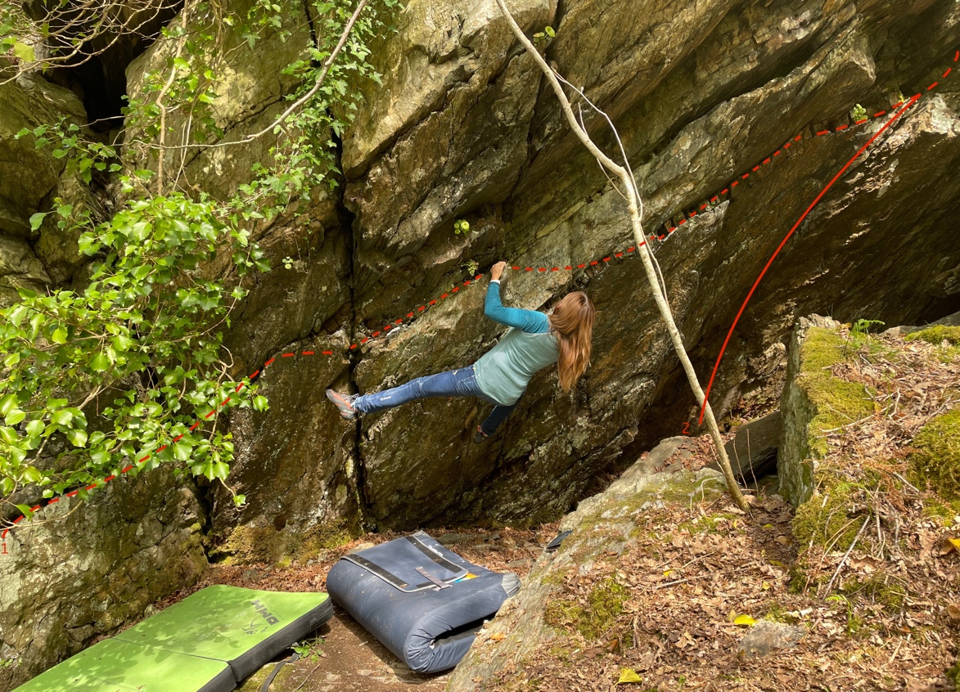

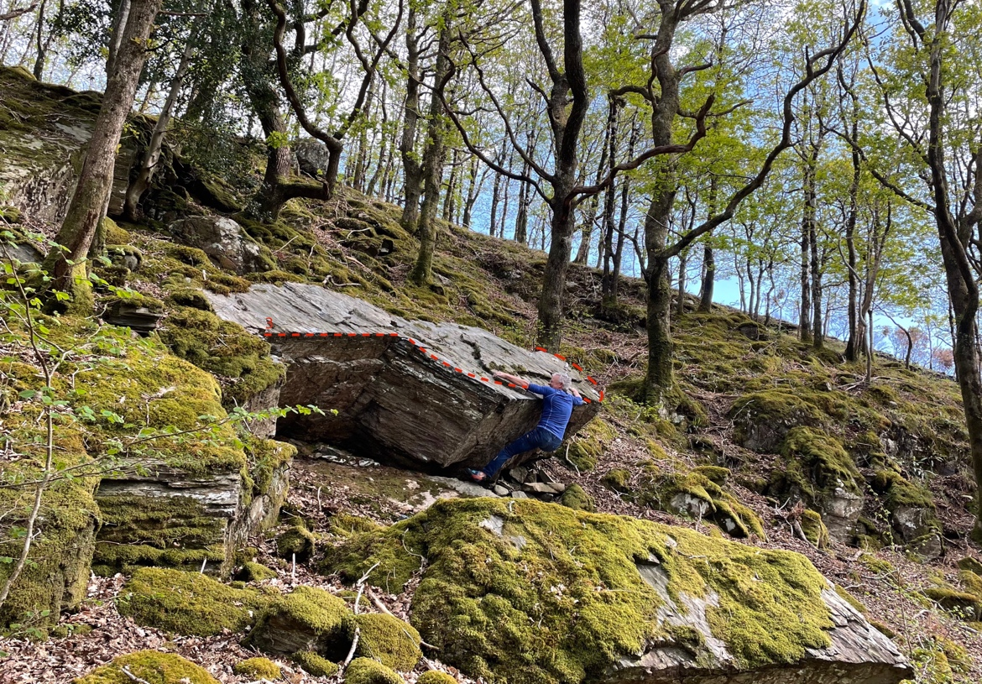

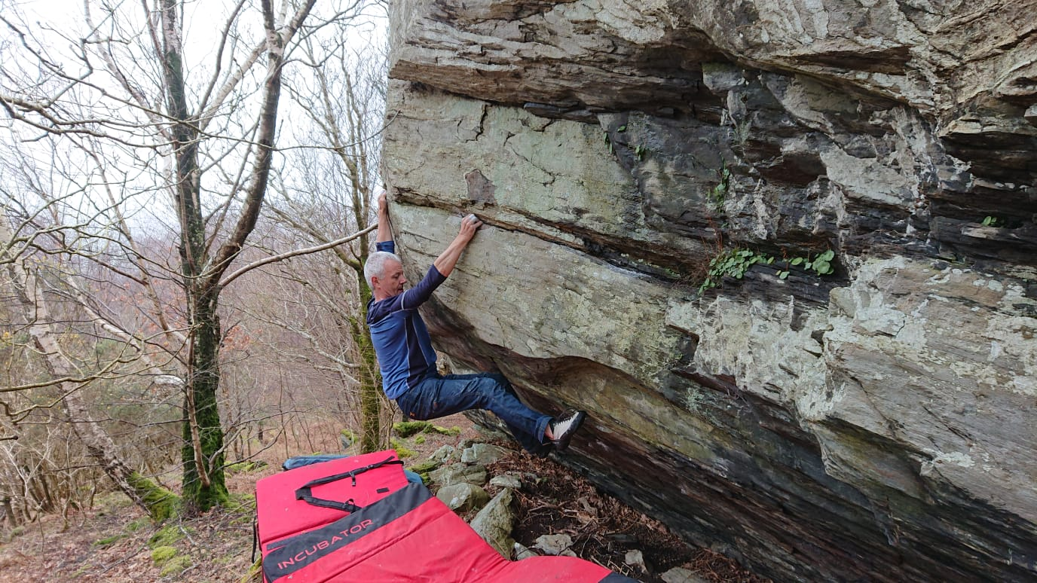
Iconoclast

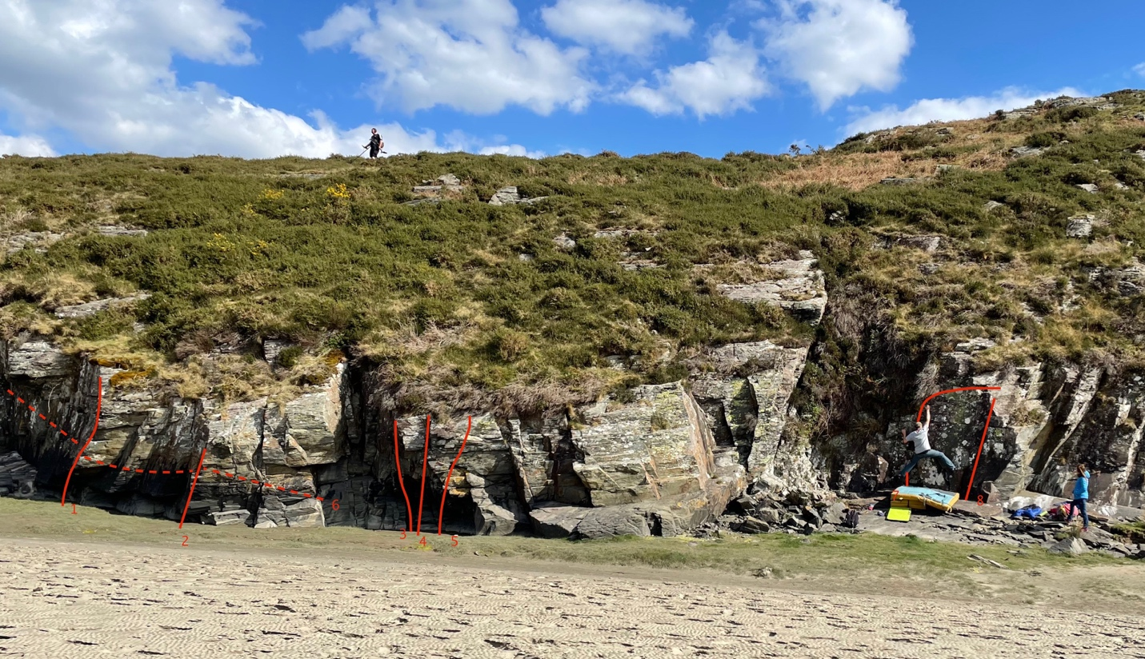
\
LLandecwyn Beach. Elliot Twiddy on Ghetto Matrix

