Moel Penmaen. OS SH 72188 29048

There are three areas on this hillside. Areas 1 (Carreg Gain) and Area 2 (Moel Penmaen north slopes) are to the right of the stone track. Area 3 (The Burma stones) is to the left of the track.
Elevation 300m

The Burma Stones
A tiny escarpment close to the visitor centre of Coed y Brenin. When first developed in 2019 access from the track was easy. Since then vigorous trees and shrubs have all but hidden the rock which is excellent clean, white grit.

Approach. To the north of the entrance to Coed y Brenin visitor centre is a small road heading eastwards. Follow this to a junction by an old house. Turn left and pass through a wooden gate. Continue northwards on the track, popular with cyclists, to a large parking bay below the stones. Follow the track on foot for 100 m and hack a path leftwards to the stones. Easier to drop into them from above. Developed in 2019 by M.Rees and T.Taylor.

Left to right.
100 m left of the main complex is a white slab with one problem.

1 Mule Variations 6A
Sds under the cleanest part of the slab and head up.

The main complex.
2 Foreign Affairs 5C
Nice sds and up the middle.

3 Clap Hands 5C
Sds and up the sweet pillar.

4 Blue Valentine 4B
Low start then up the flake.

5 Lie to Me 6A
Low sds and up the left edge of the boulder.

6 Burma Shave 5B
Nice traverse right to left.

7 All Stripped Down 5C
The fun right edge of the big boulder from a sit.

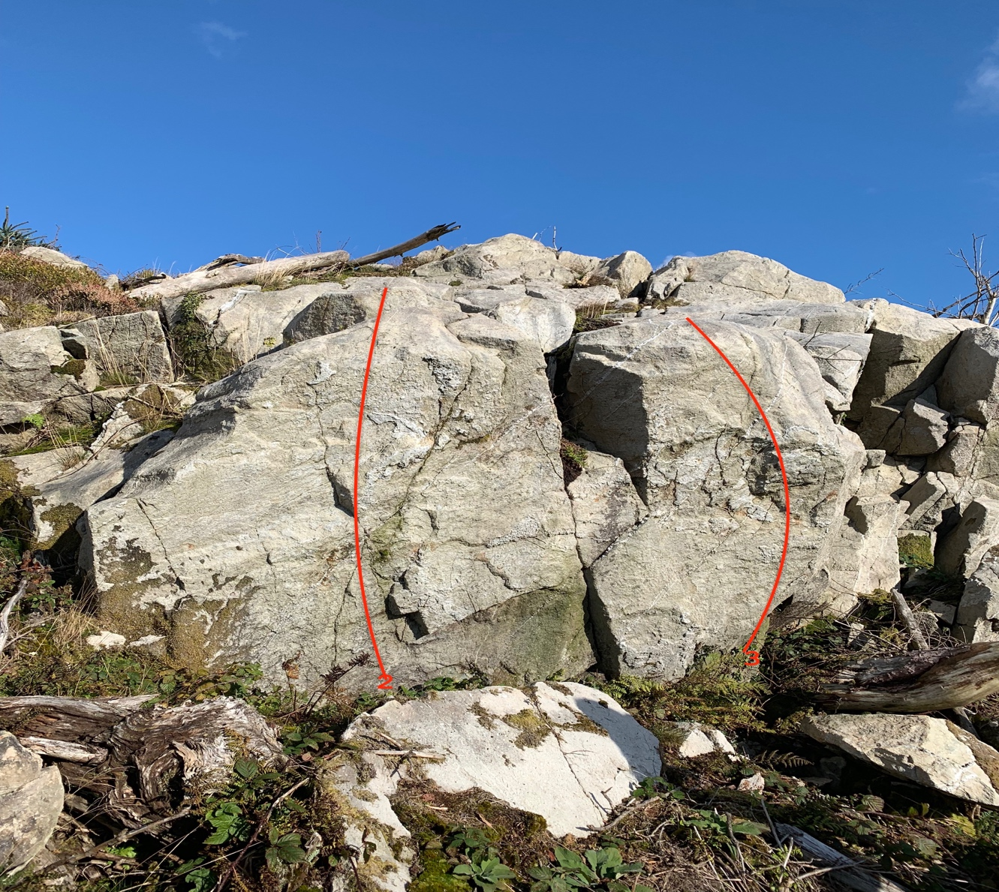

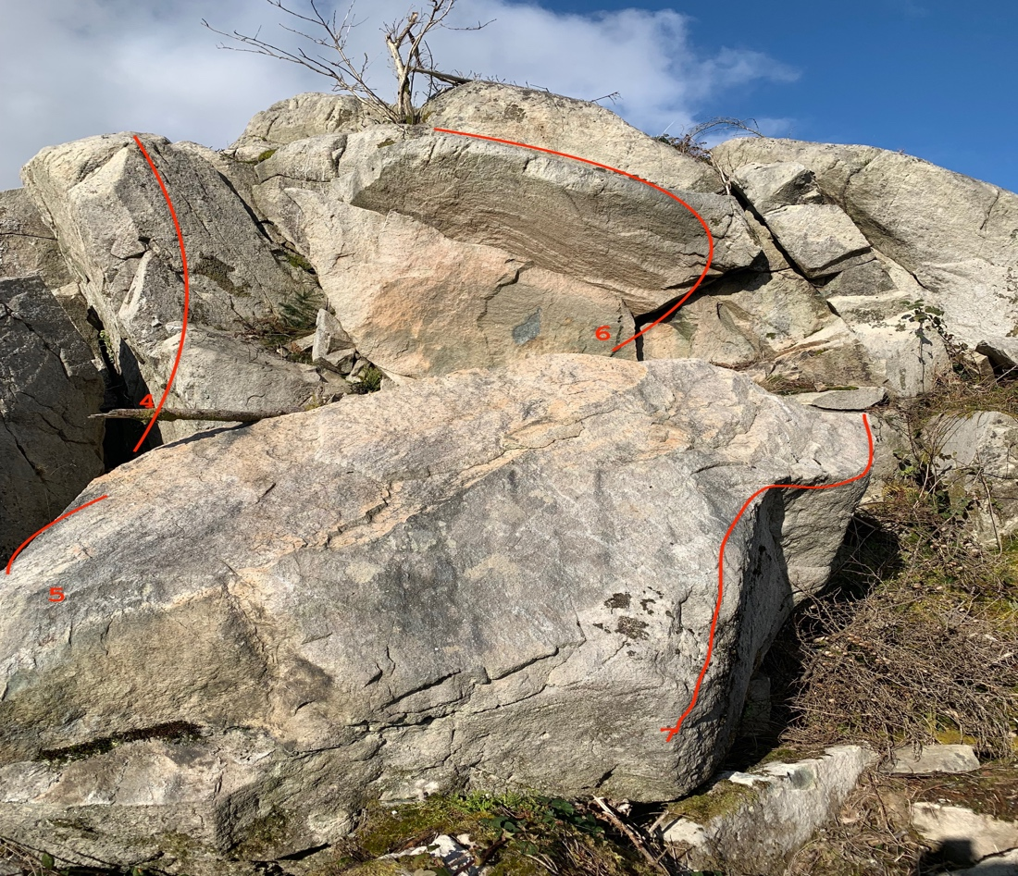
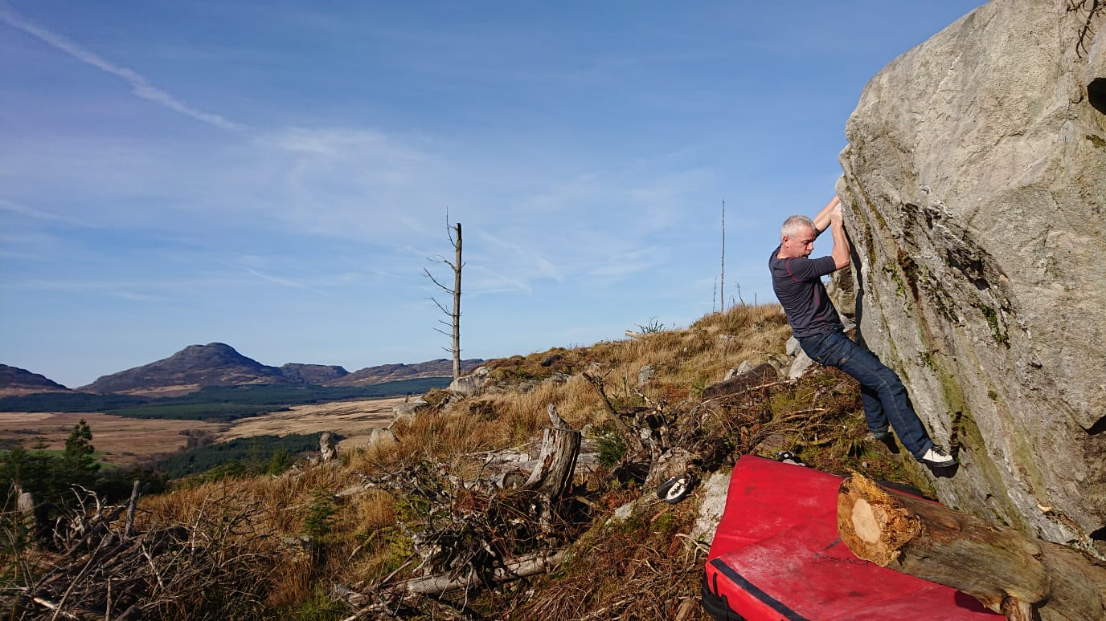
Foreign Affairs.
