Trawsfynydd new 2025 SH 66182 37099 Elevation 232 m

Twiddy Elliot on Block Control by the dam stones
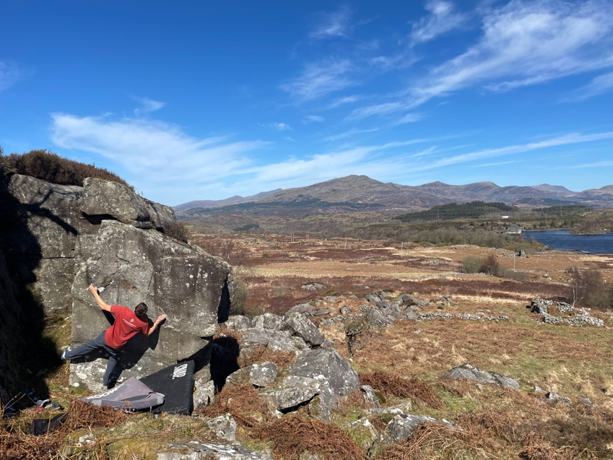

Craig Nant Ddu
Time for approach 35 minutes mainly on wide track.
Park by the dam of Llyn Trawsfynydd, cross on foot and follow the lake bicycle track to the fork. Take the right exit and follow the track by the watercourse until a 4-pillar bridge over the water course and a gate —20 mins. Pass through the gate and follow the quad bike trail diagonally up and right wards to the area for a further 15 minutes.

Multiple escarpments mostly facing south and SW.

Escapment 1: runs east to west and has a stone wall running at right angles to it. The western edge has a prominent unclimbed prow. The wall just west of the dry-stone wall has a good traverse. The walls to the east of the dry-stone wall (by a stile) have several problems.

Prow area.
Some good walls to the right of the prow.

1 Beside the Monster 6A+
Sit start under the block and slap over.
Terry Taylor 3.4.2025

2 Knot so fast 6B+
Pull onto the featured wall at its left end and traverse right on the good break until the chimney before the dry-stone wall.
Terry Taylor 8.10.2023

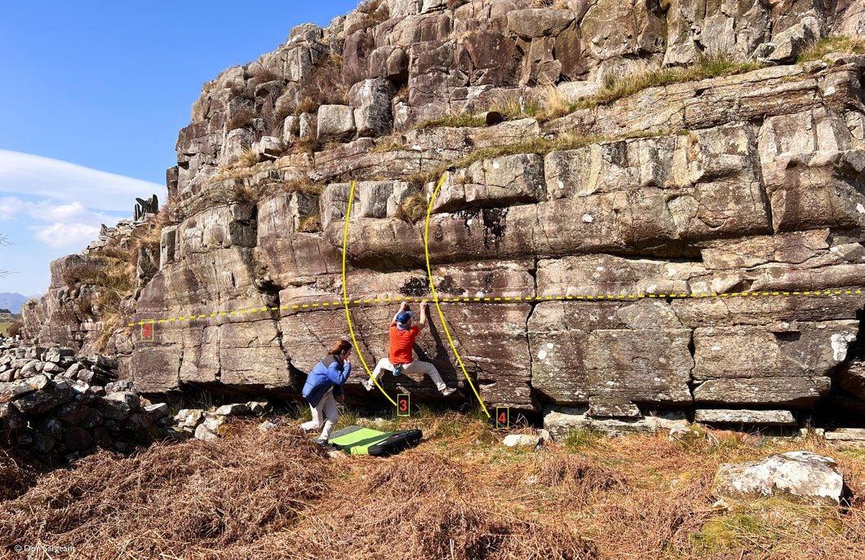
3 The Trim Reaper 6B
Excellent line from a sit and up the incipient crack.
Terry Taylor 8.10.2023

4 The Rim Reaper 6B
The companion line from a sit.
Terry Taylor 8.10.2023

5 Tie me in knots 6B, 6C (aller-retour).
Pull on to the left end of the leaning wall by the deep vertical crack and traverse to the prow on the far-right end. Traverse under the prow to a finishing jug out right. For the aller-retour just carry on back leftwards from here to the far-left end.Terry Taylor 8.10.23
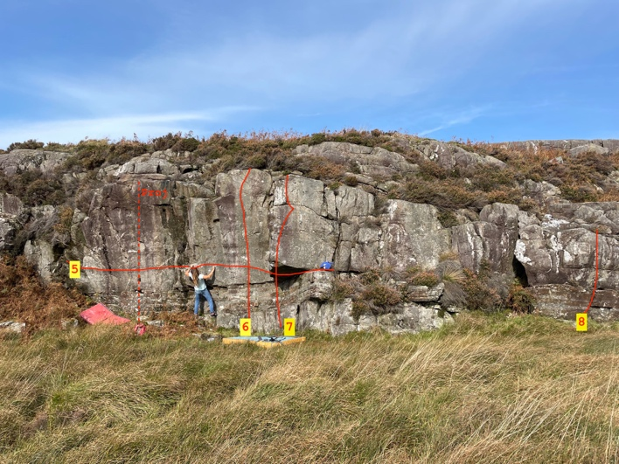

6 Tie me with Ribbons 5B
Sds with the good ledge then join the deep edges to the top.
Mari Rees 8.10.2023

7 Ribboned Knot 6A+
Sds under prow, opposing edges lead upwards to a RH exit.
Mari Rees 8.10.2023
8 Forget me Nots 5A. The short wall from a sit.

STILE wall.
Directly behind the Coed Cadw sign by the stile over the dry-stone wall is a perfect sheet.

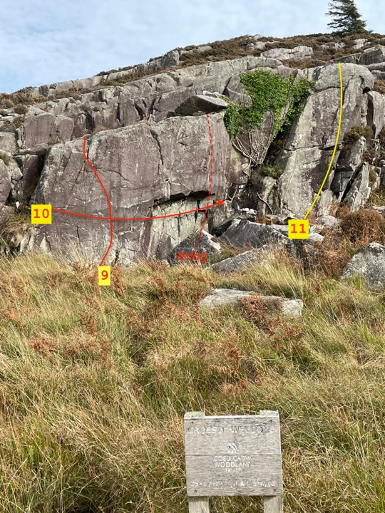

9 In Style 6B
Sds and use the RH layaway to gain the top.
Terry Taylor 8.10.2023

10 With Style 6B+
Stand start at the left edge and head rightwards on finger- holds to an easier finish at the right end of the wall.
Terry Taylor 8.10.2023

11 Mark the Man 5B
Superb wall climb.
Mark Davies 3.4.2025

OS SH 66380 37007. 250m alt.

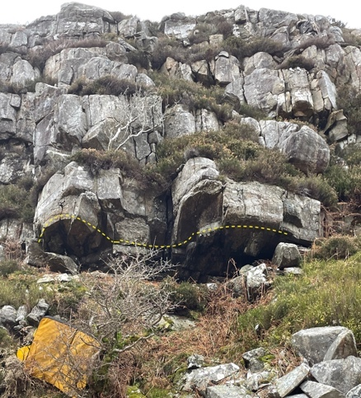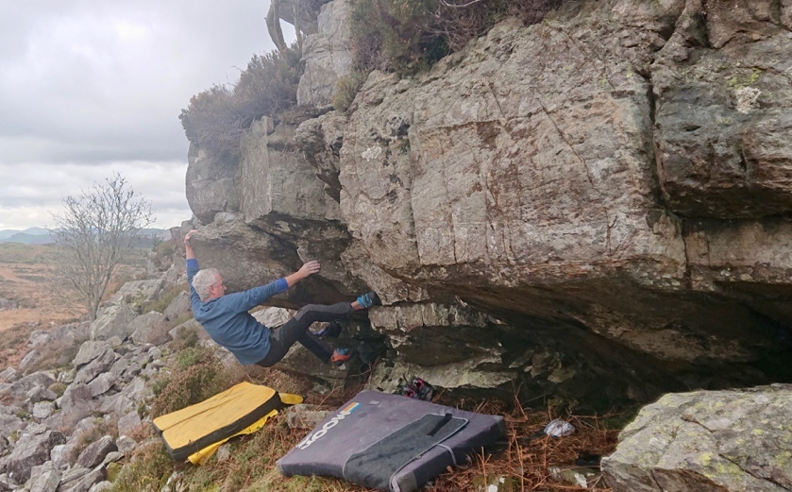

This long escarpment of Craig Nant Ddu has some high walls. Its northern end has two good, unclimbed leaning boulders. At the centre of the escarpment is a low roof.
12 Stretchalongatingthong 6B+
Sds under the right roof, then traverse left around the far-left prow for the topout.
Terry Taylor 20.11.2023 ( pic above )

A much smaller escarpment sits just to the west of this cliff.
13 Small Fry 5C
Excellent left to right traverse of this short, compact wall with an easy topout far right.

Blockland OS SH66452 36648 elev 273m WNW facing.

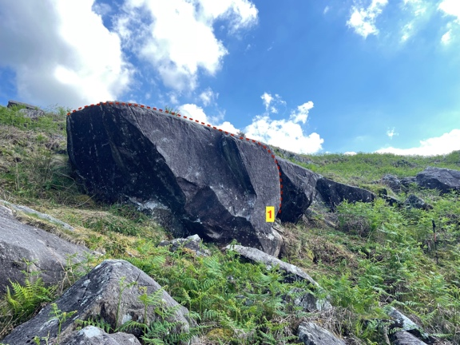

1 Touching the Velvet 6C+. (OS SH 66676 36767)
This perfect prow sits 200 metres over to the east of Blockland. Sds in the corner and head left with the crux being standing on the ledge below the prow. Finish easily far left for TO.
Terry Taylor 17.5.2024

2 Ned Burgler 6A stand.
Traverse left to right on the leftmost low boulder of this collection.

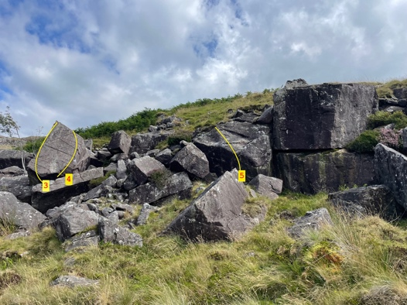
3 Head banger 6A
Sds and up the perched block.
Terry Taylor 28.7.2024
4 I had to use my head 6A
The right-hand exit from a sit.
Mari Rees 28.7.2024
5 All Limbs on Board 6A+
Sds with the juggy crack, span left and rock up.
Mari Rees 28.7.2024

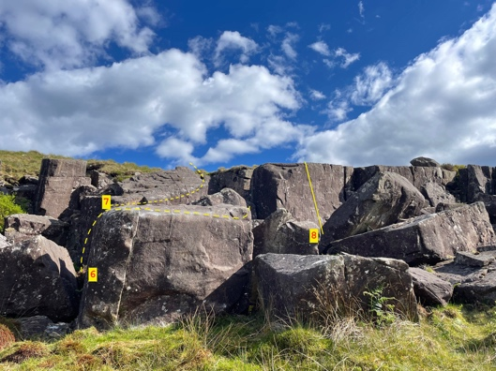
6 Brood Parasite 7A.
A compelling traverse along this low boulder from the left-hand crack to the right end and topout.
Terry Taylor 15.5.2024
7 Besame Mucho 6B
Sds and traverse merrily to the far right.
Terry Taylor 28.7.2024

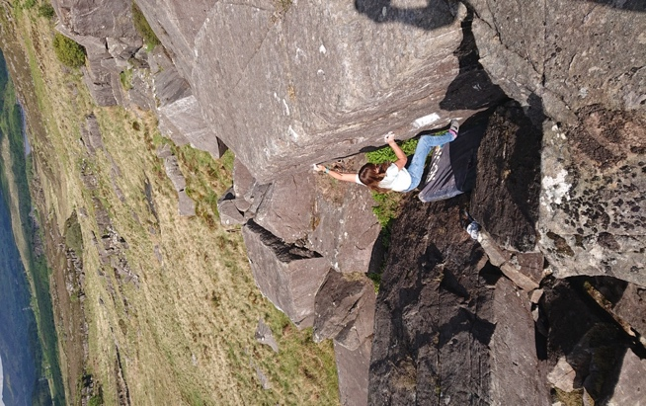

8 Reptile in Chalk 6C
Sit with good RH sloper and hit the high LH crimp for the top.
Mari Rees 15.5.2024 see pic below.

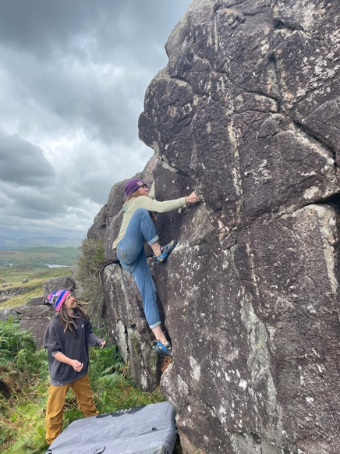
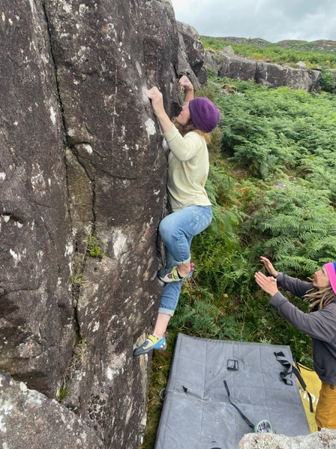
Rose Layton on Billy Big Balls and on Sickle
9 Billy Big Balls 6A+
Excellent wall climbing up the centre from a stand.
Rose Layton 4.8.2024 pic above

10 Sickle 5C
Stand and layback the sickled edge to the top.

11 Unfinished Business 6A
Sit start under the next good wall and up very steeply to jug.
Mari Rees 19.5.2024

12 Hyena and Dipstick 6B
Crouch and layaway the right edge to hit the central crimp of the wall then up and over.
Mari Rees 11.5.2024

13 Small Stones 5B
Stand and up and over.
Rose Layton 4.8.2024

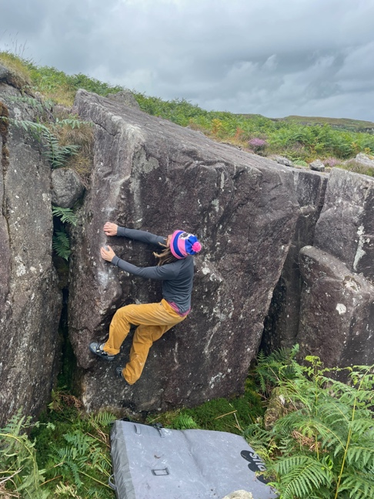

14 Sausage Roll 5B
Stand and layback the good edge. Roll over the top. Pic Sam Tolhurst preparing to roll.

15 School of Rock 6A
Stand below the centre of the wall and using the LH crack and some smears on the wall top out.
Rose Layton 4.8.2024

16 Tickled Rib 6A+
Sds under the rib and giggle up and rightwards to the TO.
Terry Taylor 4.8.2024

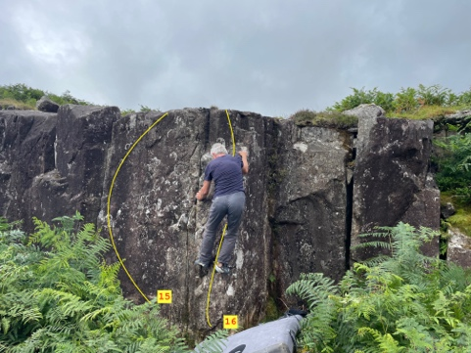

The next block to the right
17 Who wears the trousers 6B
Sds and up the centre to finish rightwards.
Terry Taylor 11.5.2024

18 Got the Gear and the Idea 6B
Sds under the perfect edge with good RH layaway and up and over.
Mari Rees 26.5.2024

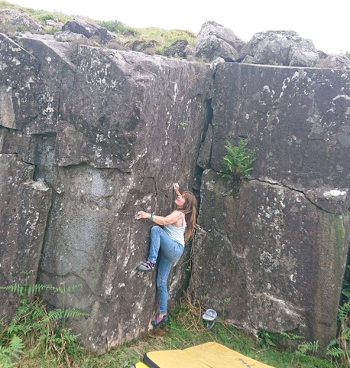

19 High is the Sky 6C
Sit with low holds and crimp fiercely up to the top.
Mari Rees 20.5.24

20 Six at Noon 6B
Sds under the rib forming the left edge of the Crystal wall with RH finger jug in the groove and layback the left edge of the rib to better holds.
Terry Taylor 20.5.24

Mari Rees FA How High is the Sky 6C

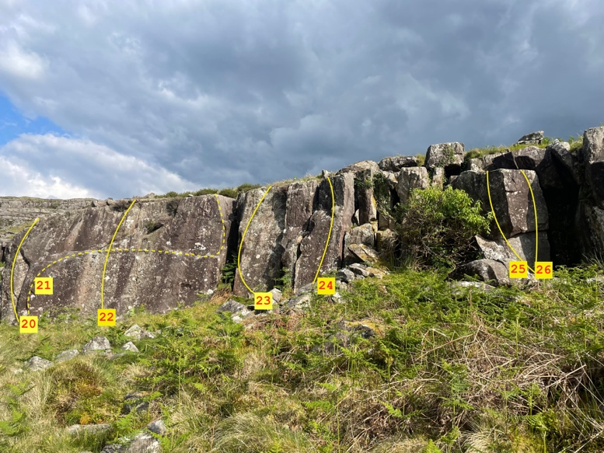

21 Crystal Traverse 7A+
For lovers of technical crimps and balance this is it. Stand start in the far-left hand groove and follow good holds rightwards to the edge for the topout.
Terry Taylor 26.5.2024
22 Eight second drop 6B
Sds and up the thin crack in the middle of the traverse wall
Mari Rees 20.5.24
23 Rose Gold 6B
Stand under its centre and stylishly find your way straight up.
Sam Tolhurst 4.8.2024
24 Stolen birthday bottle 6A+
Sds and compress up the slim pillar next right
Mari Rees 7.5.2024
25 Twist about 6B
Sds and up the left edge of the short wall
Mari Rees 26.5.2024
26 A Stone’s Throw 6B
Short compression problem up the right edge of the same wall.
Terry Taylor 7.5.2024

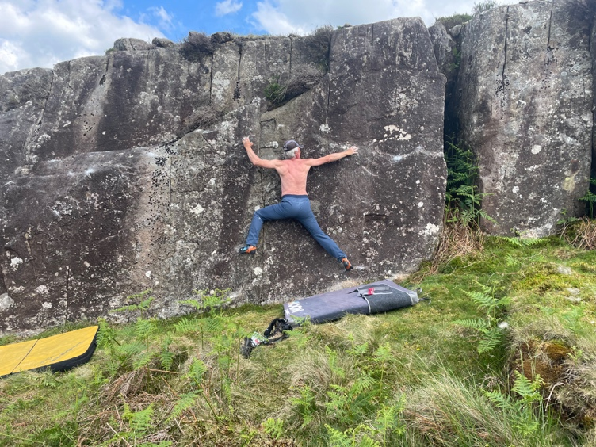
Crystal Traverse

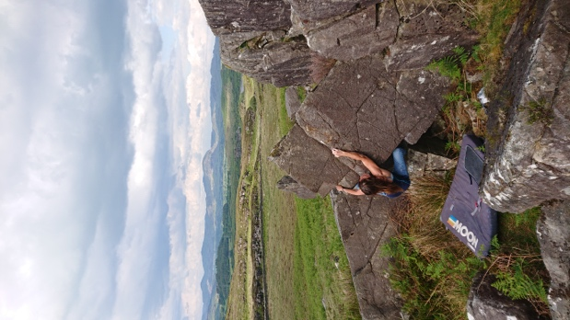

27 Noodle’s Rhinog return 6B
Sds under the low prow with low RH layaway and pop up to the ledges high and left for the topout.
Mari Rees 25.5.2024

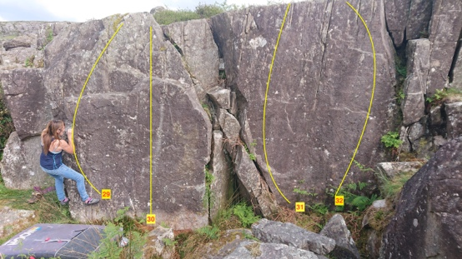
28 My non-designer rock 5A
Sds and layback the right edge of the same, short face.
29 My designer escape 6A+
Stand under left side wall and join the crimps.
Mari Rees 7.5.2024
30 My Designer Rock 6B+
Crouch under wall centre and crimp right up.
Mari Rees 7.5.2024
31 Done and Busted 6B
Sds with high LH jug, poor feet and low RH and power up avoiding the supporting block out left
Mari Rees 26.5.2024

32 Tit for TAT 5B
Sds with good right edge and topout with help from the toe ledge out left.
Mari Rees 17.6.2024

33 No Tits for TAT 6A
Sds with good finger crack to the top.
Mari Rees 17.6.2024

34 Rules of Disengagement. 6B
Sds and compress up and over.
Terry Taylor 17.6.2024

35 Larking about 4C
Sds under the very small block.

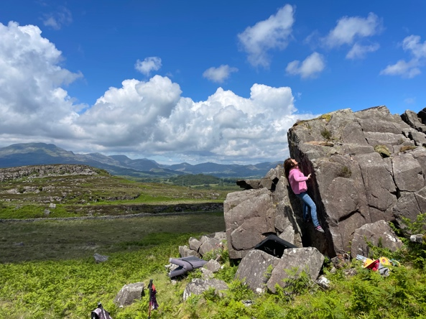
36 Rendezvous with Blockland 6C
Sds and crimp up the wall with help from the vertical flake to TO.
Mari Rees 17.6.2024

37 Rendezvous with Rain 5C
Sds with good right edge and follow the top to the far left.

Follow the escarpment uphill to one clean, very small block.
38 Short Stories 6A+
Sds and up the crimpy left edge
Terry Taylor 17.6.2024
39 Essayed 6A
Sds under the right edge
Terry Taylor 17.6.202
More wall projects then good walls 200 m west and in the valley of Cwm Moch
OS SH 66463 36504. Elevation 290m
A good west facing steep wall inside an enclosure.

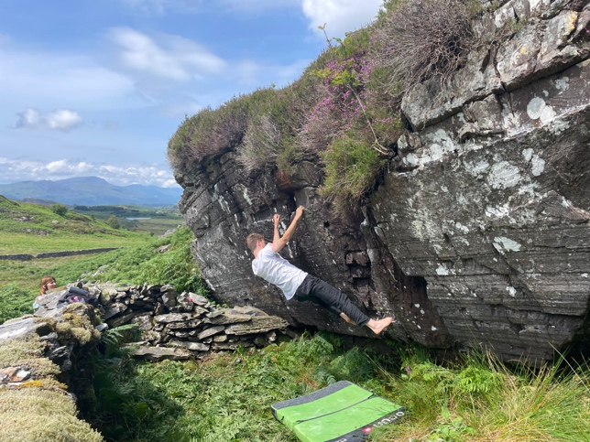 40 Serpent Boa 6C. Cian Taylor.
Stand far right and traverse the finger ledge leftwards crossing the groove to join the higher line of jugs for an easy finish. Very steep.
Terry Taylor 19.7.2024

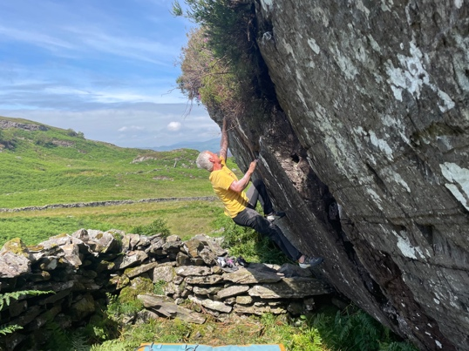
41 Slithering 6B
There are some low steep prows just right. The second prow from sds.
Mari Rees 16.7.2024

Serpent Boa .

Continue uphill along the same escarpment to a good traverse.

OS SH 66483 36423 elevation 310m
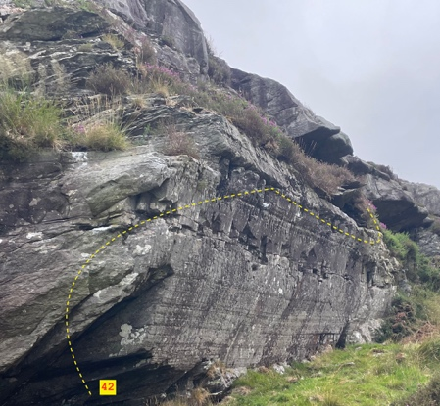

42 The Lizards of Oz 6B
Sds low and left and stroll rightwards across the small wall on good holds to its end.
Terry Taylor 19.7.2024

Carry on up along the escarpment to a large stone enclosure with a short roof at its right.

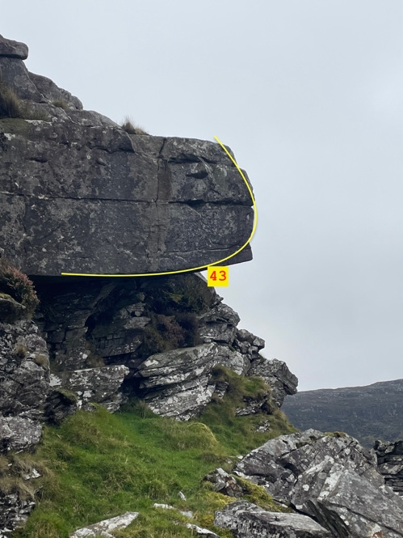

43 Force Posture 7A+
Stand start in the first acceptable LH crimp and smaller RH crimp over on the left. Pull on and campus right, then heel and cross through to better hold. Big span out to the nose then pull up via the break above.
Sam Tolhurst 17.8.2024
See video on midwalesbouldering.com

44 The Rim Creeper 7A
Sit under the roof and traverse left, around the corner and continue along the topout.
TT 11.10.2025

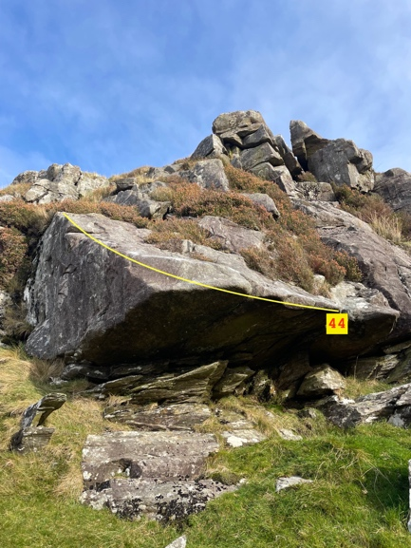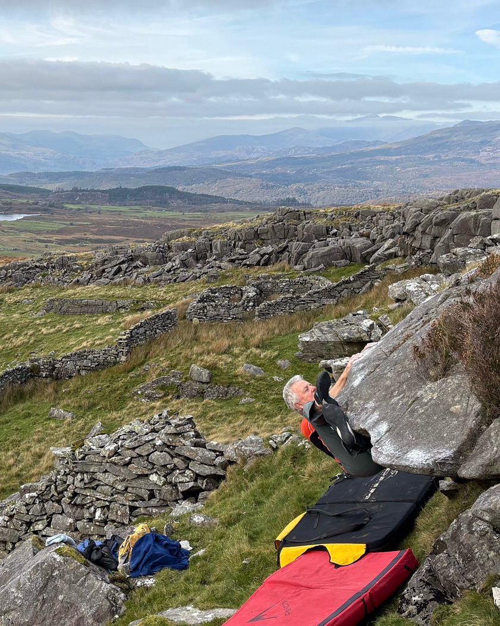

Another small escarpment sits back to the east on the hillside over towards upper Blockland.

OS SH 66660 36481. Elevation. 320m
A collection of small blocks facing west.
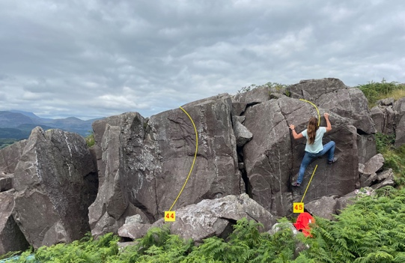
45 666 5B
Sds and up the pillar.

46 All sixes and sevens 5C
Sds and up and over.
Mari Rees 19.7.2024

Upper Blockland SH 66801 36557 elevation 333m.
A short walk up the hill to the higher blocks the biggest of which is the King of Blockland.

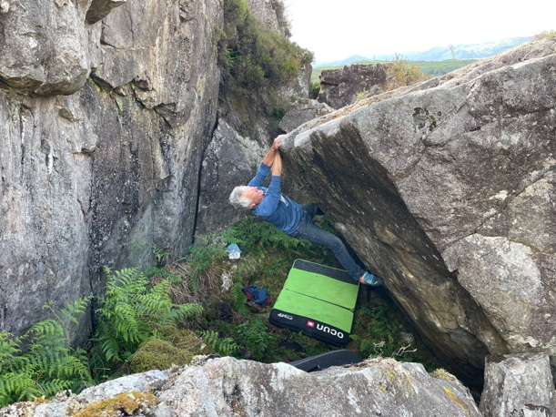
47 The King Of Blockland 6C
The very steep wall forming the back of the biggest boulder starts with a sit down below the flat ledge on the left then a huge span up to the continuation lip which finishes around the corner above the steep wall. Terry Taylor 9.6.2024
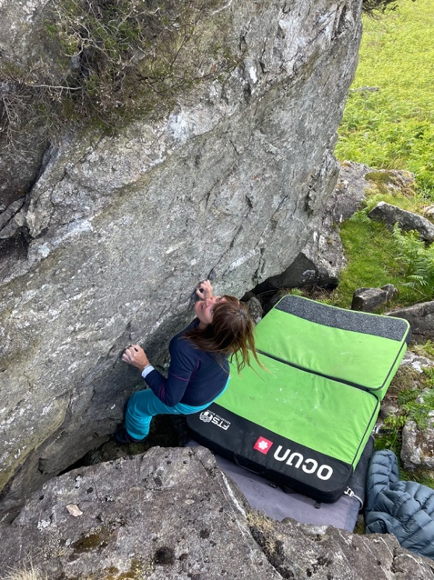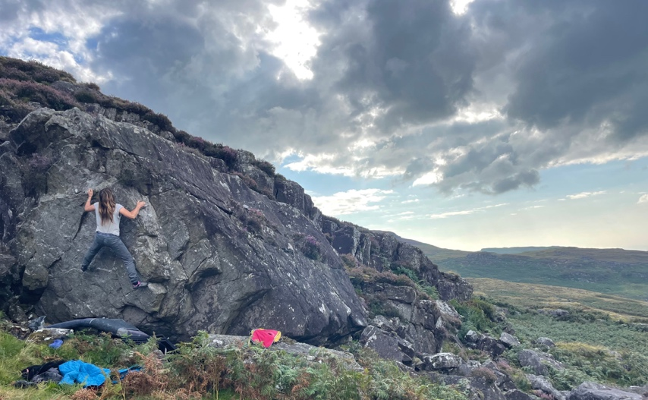

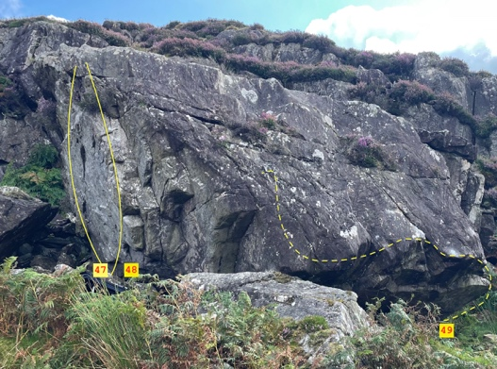
47 The Willy Warbler 6B
Sds under the steep wall with crimps and get the jug rail to finish up and right.
Mari Rees 9.6.2024
48 Moody Blues and Greys 6C
Sds under the right side of the undercut wall and head up to the juggy finish.
Mari Rees 30.8.2024
49 Queen of Tarts 7A
The traverse from sds on the right, turn the corner, gain the boss then span out left to the spike to finish.
Terry Taylor 12.6.2024

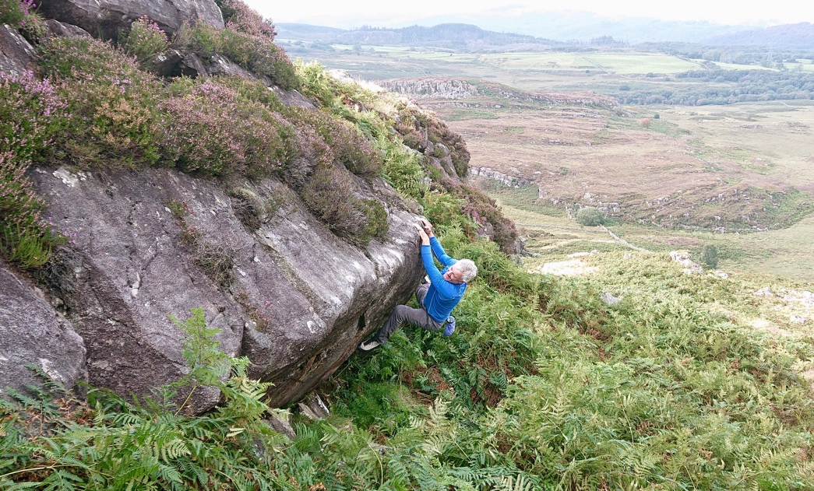

50 A swarm of Flying Pants 6C
100 m further up the same escarpment and facing east is a good sloping traverse. Stand start at right end and with some help from the ledge below the leaning face get to the last crack on the left before dismount.
Terry Taylor 30.8.2024

Opposite this among the huge jumble of boulders is one traverse.

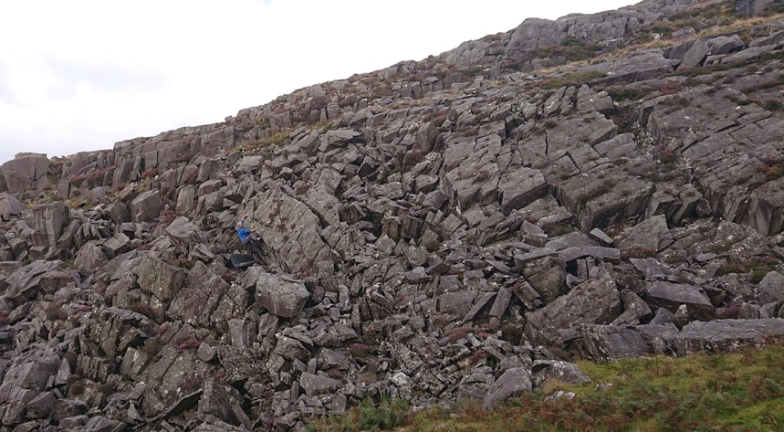
51 At Sea in Stone 6B+
Sds low and right and follow the sloping edge above the very steep wall to the left arete for a juggy finish.
Terry Taylor 30.8.2024.

50m west of the King block is another escarpment facing NE with mainly steep, slabby rock up to 4m high—lots of potential.

4 problems here
52 Cafard 6A
Sds and layback the left edge of the canyon.
Terry Taylor 20.9.2024

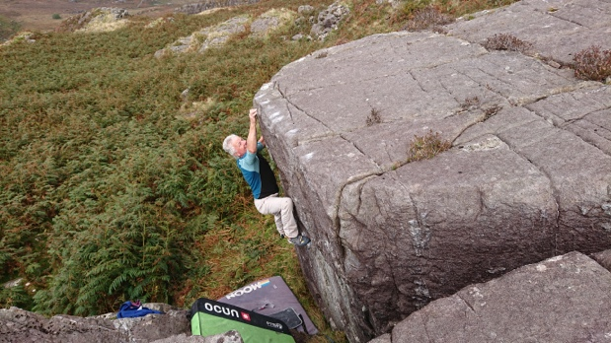

53 Corona 6A+
Nice sds and up the lowest wall, then traverse right until possible to topout.
Terry Taylor 20.9.2024

54 Corolla 6B
Sds under the short prow and compress up and over.
Mari Rees 20.9.2024
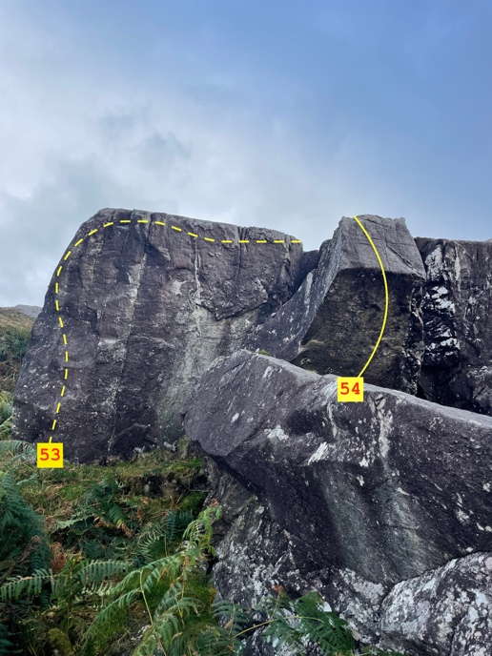
55 Snitch 6A+
Sds under the right wall of the prow and follow the quartz vein to the topout up and left.
Mari Rees 20.9.2024.

10 minutes uphill is a collection of slabs and blocks
OS SH 66844 363809 elevation 360m.
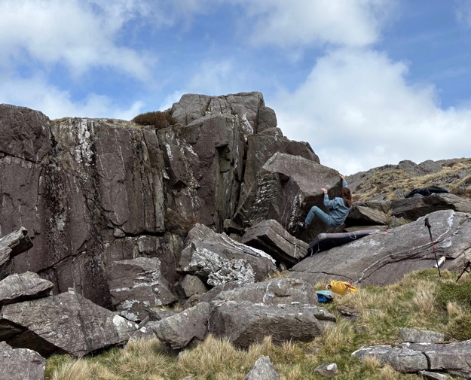

56 Zuri’s Three 6A+
Sds under left edge then pop up and over the crest.
Mari Rees 27.4.2025
57 Poo Bum 6A
Sds under the wall behind and topout at its centre
Mari Rees 27.4.2025
Western walls
Carry on along the track by the watercourse to a good wall trackside. Approx 5 minutes from 4-pillar bridge. This large wall justifies an effort to clean and do the true traverse line on tiny holds and slopers.
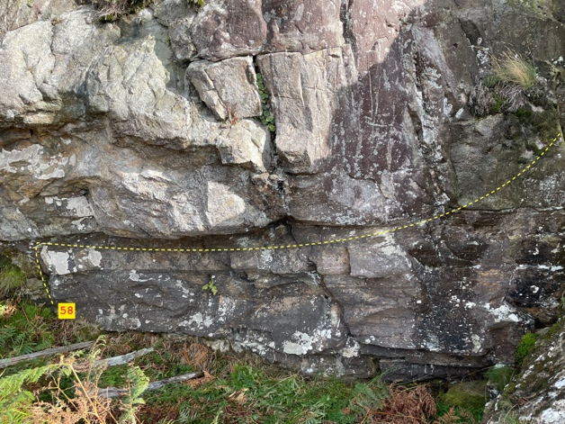

58 A walk with Zuri 6B+
Sds under the centre of the wall and follow the very low line of holds rightwards to an easy exit.
Terry Taylor Oct 2023

The Dam Stones OS 67357 37085
Follow the cycle track from the dam through 2 gates. The easily visible escarpment faces east and sits 50m metres from the track.

Block Control 6B+ see header picture
Sds under the leaning face and with help from the left edge head directly up and over.
Elliot Twiddy 1.4.2025

Sock Control 6A
Down and right of the block is a black slab.
The traverse right to left with a step across the gap on the left to finish.
Elliot Twiddy, Terry Taylor 1.4.2025

The cycle way stones OS 68004 36430. Elevation 300m

4 boulders of interest only to those cycling past

1 Bog Stone traverse 6B. different OS
Follow the road at the right fork as it contours around the western lakeshore. After gate one look left across the bog and this stone is clearly visible. Sds low and left and finish high and right.
TT 2024
At the end of the tarmac road the cycle track rises up the hill. At the picnic area the stones up and left are immediately accessible.
2 The bench press 6A
The small stone behind the bench from sds and up and over
TT 3.4.2025

3 Dysfunctional legs 5C
The boulder right of the wall. Sds only using the boulder and follow good holds all the way up and over to the right.
MR 3.4.2025

4 Dysfunctional Bull 5B
To the right of the track just after the picnic area. The perfect slab up its centre from stand.
Tony Loxton and TT Jan 2017

