Abu Dhabi
Jebel Hafeet.
Green Mubazarrah Park
24.082451,55.756184

4P4R+P3 Al Ain, Abu Dhabi
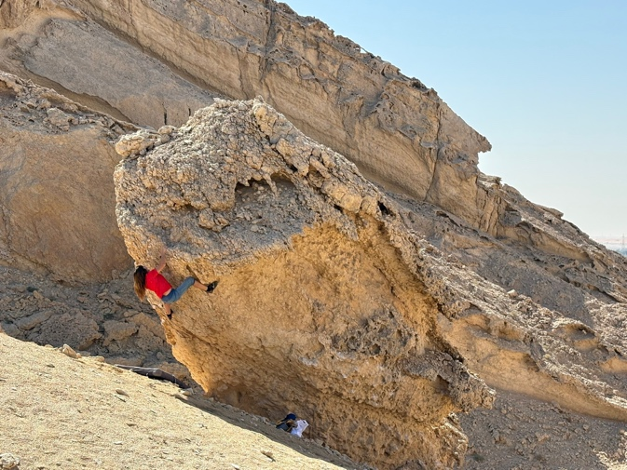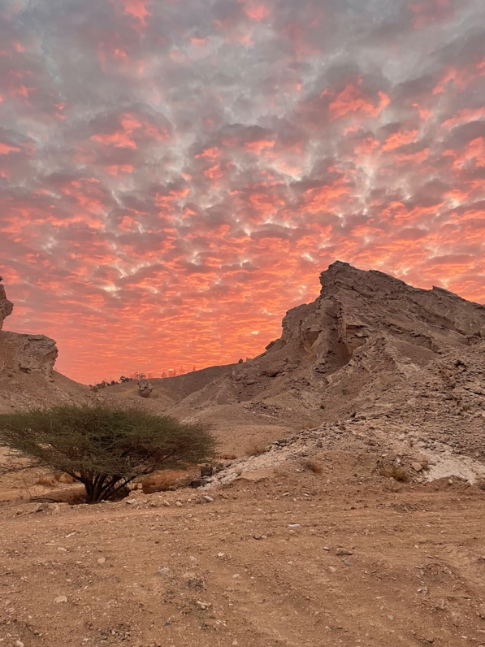
A collection of limestone blocks on the hillside behind the park. Follow signs for the historic dam then pull off the road into a dirt parking area below the rocks.
Great care should be taken with the stone and all holds need to be treated with caution. The preparation of the problems involved removing loose rock-skin and blocks without incident but you can never be sure.
Access for the moment is free as you are in Jebel Hafeet national park. The boulders are clearly visible from the road. From parking a 5 minute walk brings you to the first collection over on the right.

1 Heartbroken 7A.
Sit start under the slim pillar, hard pull up and link the edges up and left to the topout.
Mari Rees 23.10.2025.

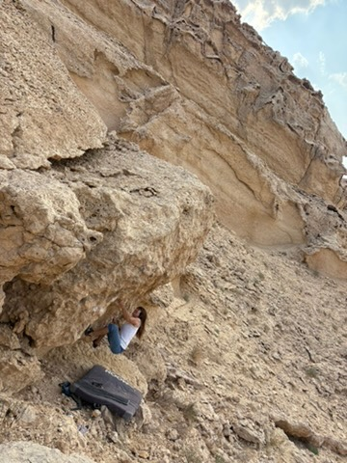
The big roof just right is unclimbed.
Above the water pump is a large prominent boulder.

2 Tumblin’ Dice 6B+
Sit down low on the sunny side and follow holds rising up and rightwards to the dismount from the high jugs.
Mari Rees 28.2.2025

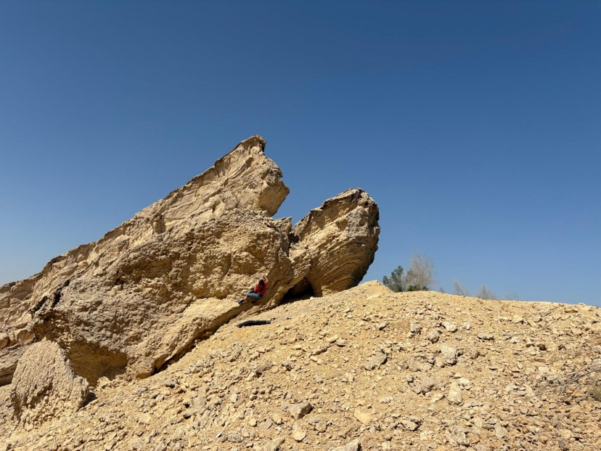

3 Storm Cows 6C
Low sit down and right on the shady side of this impressive boulder and follow holds up leftwards. Some stiff spans to reach the dismount jugs out left. A hard extension is possible.
Terry Taylor 28.2.2025. https://vimeo.com/manage/videos/1080806066

A collection of blocks sits over on the right.
4 Easy arete 6A
Sit under the juggy arete and wander up.

5 Hawkwind 6B+
Excellent traverse from sit with nice rock up.
Mari Rees 30.1.2025
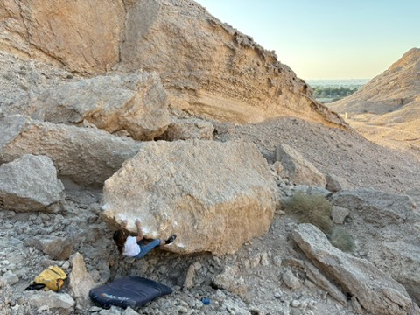

6 No fly zone 6B+
Another nice traverse from right to left on the block behind.
Terry Taylor 30.1.2025

The huge square block has one problem.

7 Wall Fright 6C
Sit over on the right with small holds, rise up and leftwards to reach the left edge for the dismount.
Mari Rees 30.1.2025
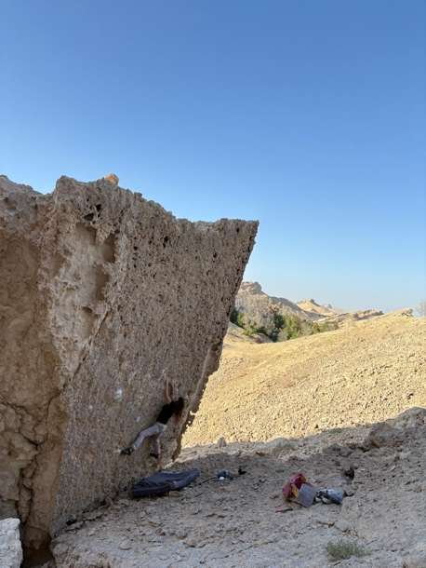

Higher up the hill is another good traverse.
8 Scorpion Hands 6C
Sit start and hang the protruding lip with confidence until passing the left corner for the topout.
Terry Taylor 26.2.2025. https://vimeo.com/manage/videos/1080806827
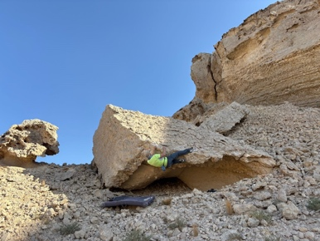

Just to its right is
9 Francolin Files 6A+
Crazy lowball traverse from a sit with topout. It works.
Mari Rees 28.10.2025

In front of the cliff is a good steep traverse.
10 Flat on a hot skin roof 6C+
From sit below the good rock, crimp and palm leftwards to turn the corner and head for the easy topout.
Terry Taylor 28.10.2028
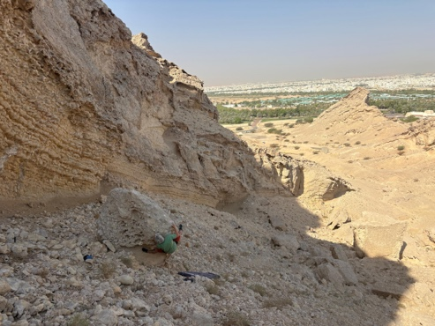

11 Desert Fox 7A
Apparently solid traverse across the cleaned lip from a sit. Sustained heel-toe walking.
Terry Taylor 02.2.2025
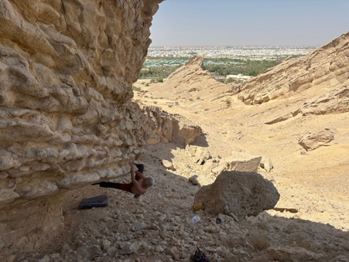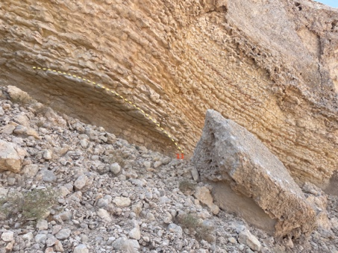

Over the crest behind Scorpion Hands is a ravine holding the childrens’ mini-ride so the large collection of blocks here is highly visible.

12 Rock Banditos 6A+
This wall is in this suntrap corner by the metal childrens’ ride. Sit under the left arete and layback up.
Mari Rees 23.10.2025
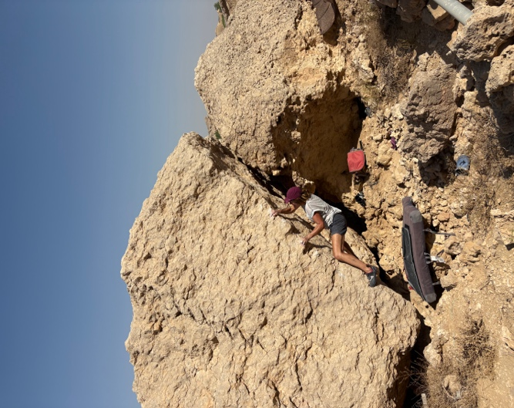

Project from sit up the centre of the leaning wall right of the arete. Possible in cool conditions.

The next blocks are just up the hill.
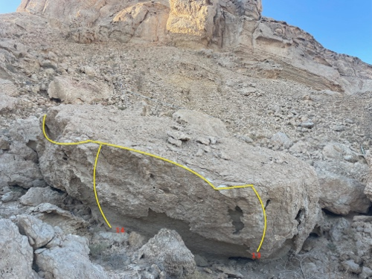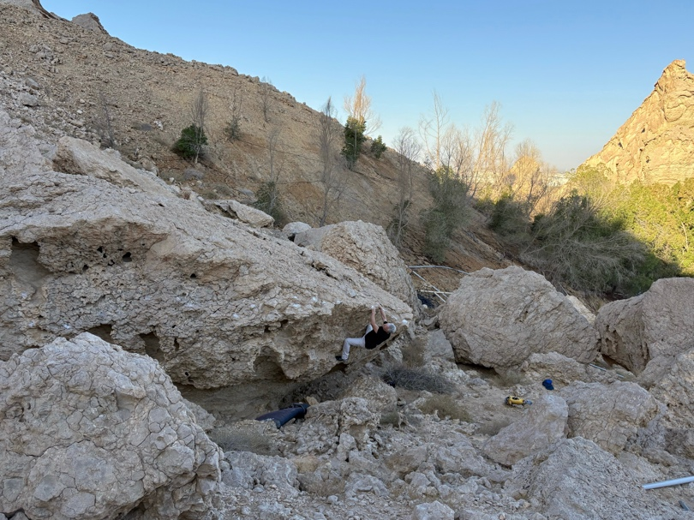

13 Ozymandias 6C
Stand with the big pockets to gain the lip follow it all the way to the far left for easy topout.
Terry Taylor 24.12.2025

14 Crumblecore 6A
Sit by the big layaways and over the top.
Mari Rees 27.12.2025

Project direct up the wall just right.

Up the hill are more big blocks.

15 City of Djinns 6C
Excellent traverse from sit below the big starter jug to a neat topout far left.
Terry Taylor 27.12.2025.

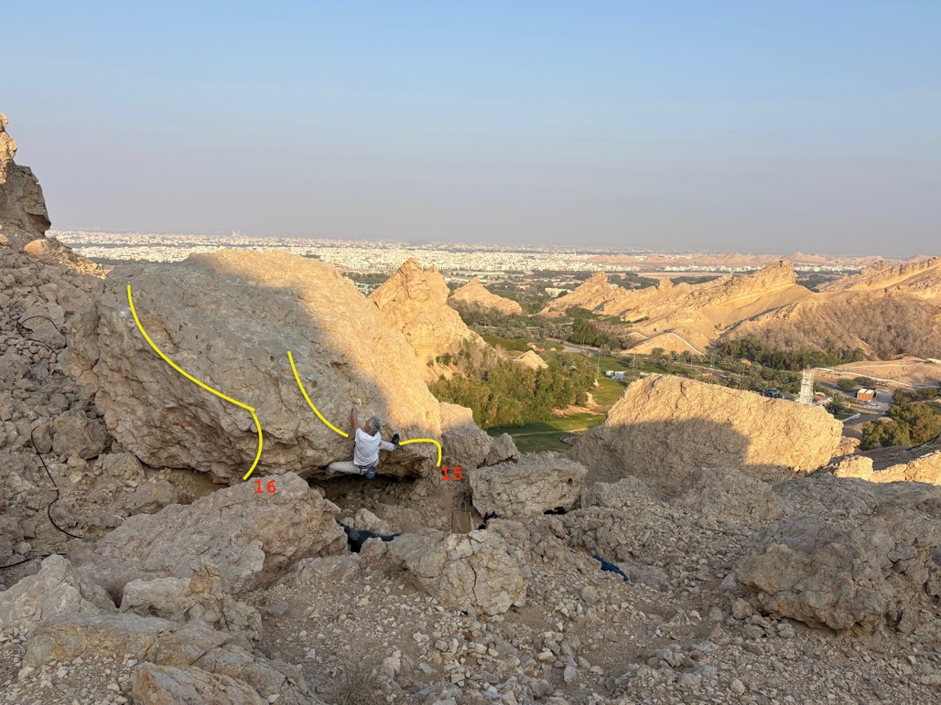

16 What I’m wearing to the Revolution 6B
Cool sit start problem from low under the wall then traverse left for easy finish.
Mari Rees 27.12.2025
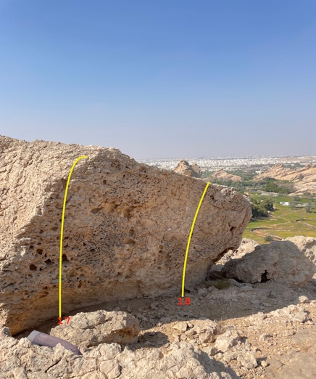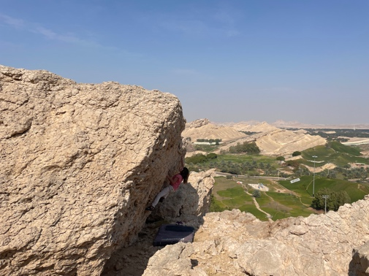

17 City of Ruins 6A
The left end of the leaning wall above the edge of the large cliff. Sit and pull up on ever improving pockets.
Mari Rees 27.12.2025

18 Close to the Edge 6A
Sit and direct past a good pocket.
Mari Rees 27.12.2025

Above these blocks is a good wall of very compact rock.
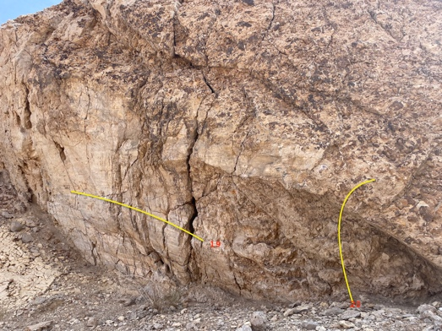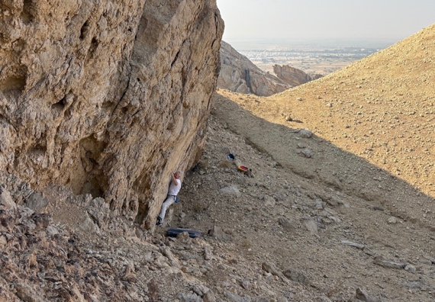

19 In the Beginning 7A
The best part of the wall from a stand by the blocks and the crack. Finger traverse the line to the next deep crack for the dismount. Extensions possible.
Terry Taylor 27.12.2025

20. Bad Company 6A
Short direct right side of the wall up onto the bubbled rock.
Mari Rees 27.12.2025

In the park play-area are several impressive blocks sitting on a nice green lawn by the road and highly visible to all. Several good problems have been cleaned and completed here but you need to go at dawn before wandering gardening and security personnel take too much interest. Parking is 100 meters from the blocks.

21 Dawn Patrol 6B+
Cool, long traverse left to right.
Terry Taylor 04.02.2025
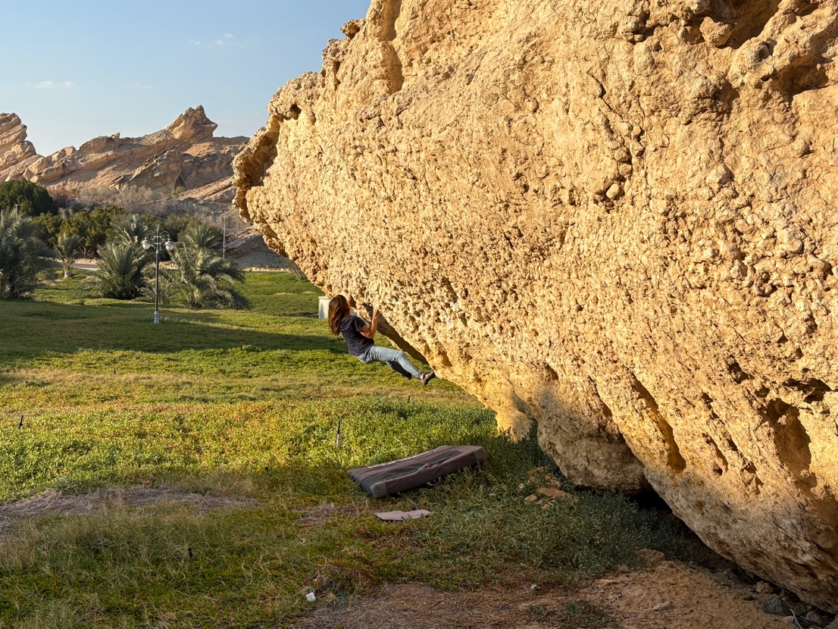14

22 The long Run 7A
Great juggy steep traverse around the corner on the same huge block from sit way out right to juggy prow dismount.
Mari Rees 4.2.2025

Several other problems have been completed here.
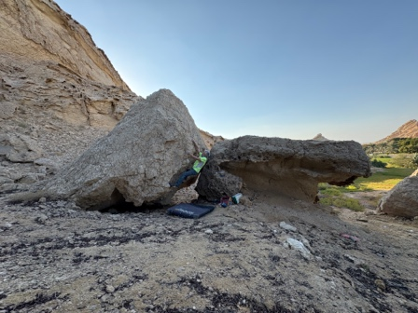A good collection of stones by the play area.

Pura Eco Retreat boulders. N24 9 25.83
E55 45 36.17

Jebel Hafit Desert Park is situated at the base of Jebel Hafit Mountain. Access: The park's entrance can be found off Zayed Bin Sultan Street, to the south of Al Ain city. There are many hundreds of boulders scattered here on the eastern slopes of the mountain. The desert park is both a nature reserve and a Unesco world heritage site and most of the boulders are presently off limits to climbers although, with the push to increase tourist numbers, the management may be persuaded to encourage climbers to visit. A stay in one of the Pura tents is recommended even if it is expensive.
After discussion with the manager of the Pura eco retreats permission is given to climb the boulders on the footpath way over to the south of the beehive tombs. The big collection of boulders in the canyon above and behind the tombs have been developed but are out of bounds.
Follow the footpath left from the parking by the tombs and a large boulder quickly becomes visible.
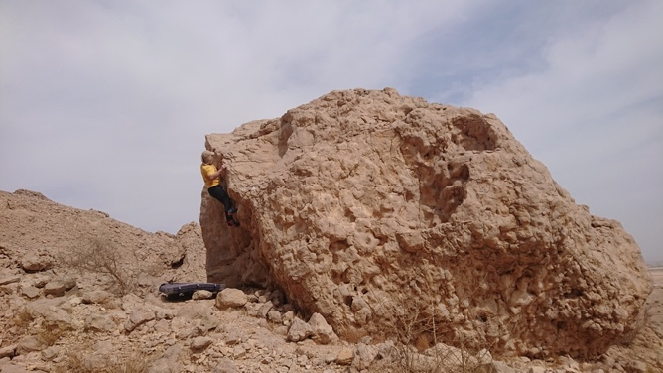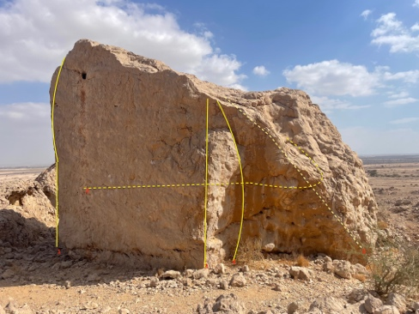

1.Missing my Oryx 6B+
MR 6.2.2024

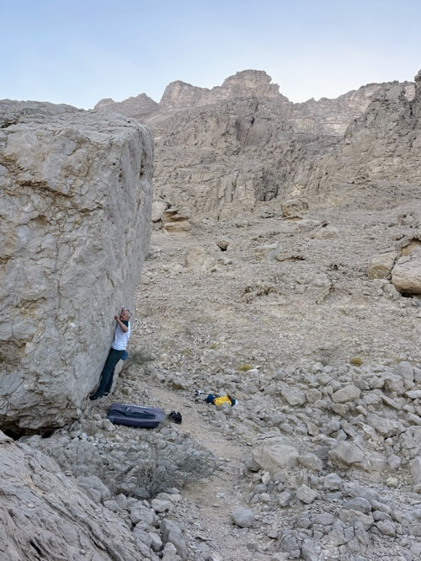
2.Guarding the Border 7A
Stand start on the big foothold and follow crimps right, around the edge, across the groove for an easy pull into the recess.
TT 30.12.2025

3. Skink 6A+
Good edge with cleaned holds from a sit.
TT 6.2.2024

4 Oh Man What a rock! 6A+
Very good climbing up the intricate groove from a sit.
MR 6.2.2024

5 How high the Hyrax 6B
From a sit follow the well-defined edge.
TT 6.2.2024

6. Frog-marched from the wadi 6B
Sit under the bulge around on the south face and go direct.
MR 6.2.2024

Just up the hill is the excellent dice block.
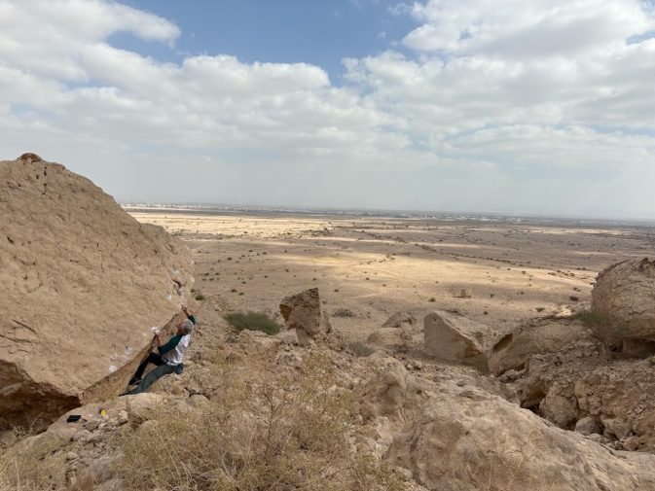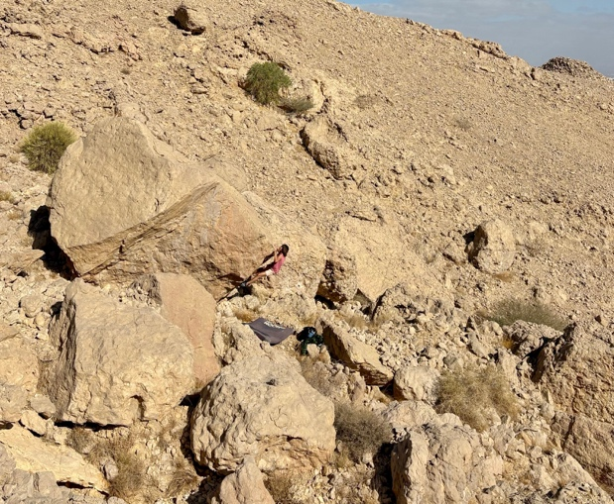
Caracal crawl Bedouin for a Night.

7. Caracal crawl 6C
The good, clean edge with outstanding friction.
TT 30.12.2025

8. Bedouin for a night 6C
Amazing edge from a stand.
MR 30.12.2025

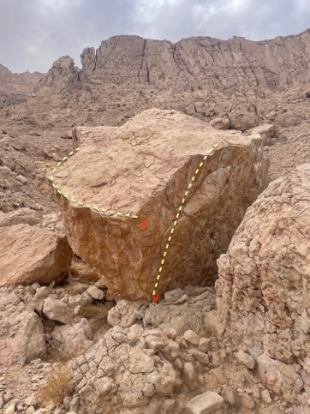
9.Hyrax 6A+
Good line from a sit.
TT 30.12.2025

The industrial area.
The large collection of concrete factories past the park sit below an open hillside facing south which is littered with boulders of all shapes and sizes. The rock tends to be better quality white limestone but will need a good clean to make it safe. No recorded developments to date.

