Cwm Orthin Boulder problems not included in the South Snowdonia Bouldering Guide

Car park OS SH 68299 45433 elevation 250m

OS SH 68259 45525

A good collection of walls by the carpark easily accessed in minutes. Pass through the metal gate and head uphill. First problems are on the right.

In the small bay above the good arete is a prow.

1 The Climbing Man 6A+
Sds and turn the lip to the TO.
Steve Cain 29.5.2022
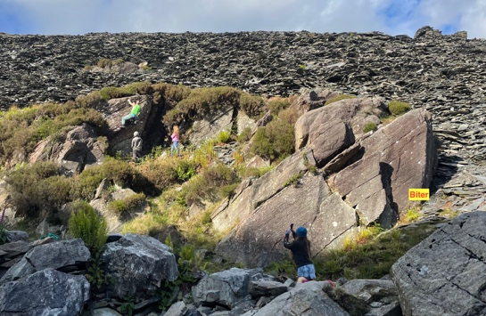
2 Alexanger 5C
Up the prow from sds.
Steve Cain 29.5.2022
The arete wall

3 Alexandrage 6A
The fun wall left of the arete from sds. Head out right on good horizontal break and finish over the top.
Matthew Thompson 29.5.2022
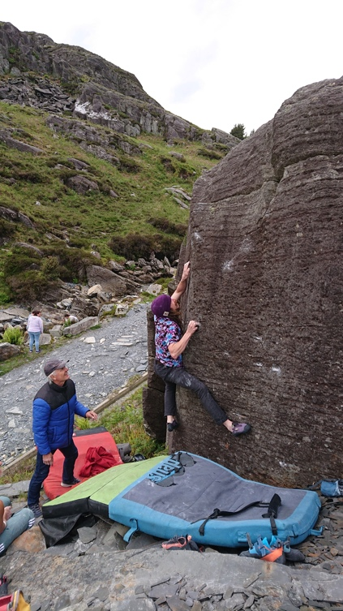
4 The Biter 7B+
Follow the lower line of crimps rightwards, turn the arete and take the finger ramp to the jug on the right edge.
Sam Tolhurst 29.5.2022

5 Hongian Fest 2022 6C
Sds under the arete and enjoy the festival.
Terry Taylor 29.5.2022

6 Four Day Spankholiday 7A
Sds under the wall just right of the arete with the good pocket and head directly up and over.
Mari Rees 4.6.2022
To the right is a small face.
7 Sway 6B
Sds and head up via the crack.
Terry Taylor 28.5.2022
Sam Tolhurst on FA The Biter 7B+

8 Curtsy 6B
Sds and up the wall right of the crack.
Terry Taylor 28.5.2022

Directly across the river is a black corner with an excellent edge.

9 River Monster 6C
Sds and up the edge to the jugs at the top of the short wall.
Sam Tolhurst 29.5.2022
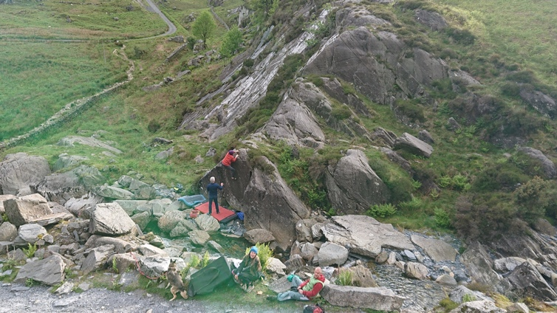

Above the white slab is a good escarpment. OS 68187 45570

10 Hourglass left hand 6B
The fun compression from sds.
Mari Rees 4.6.2022
11 Hourglass 5C
Sds and up the steep crack to LH exit.
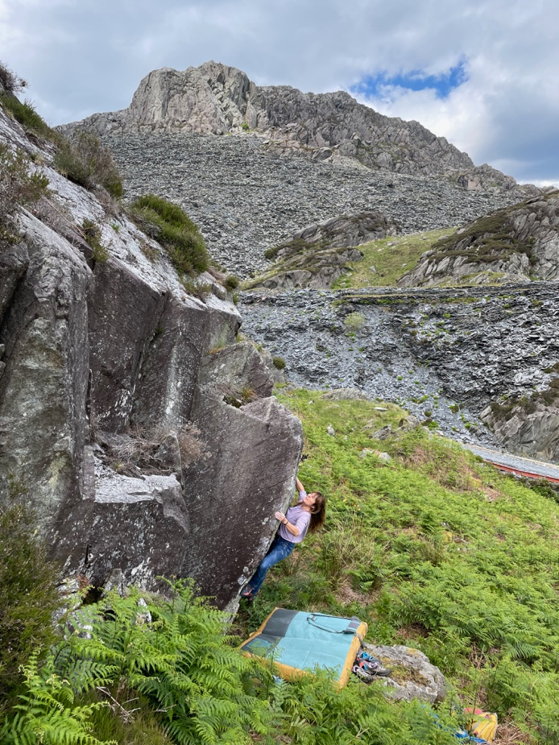
12 Hourglass Right hand 6B+
Sds with small RH layaway and low LH and pop up to the finger jug. Use the crack and then RH exit.
Mari Rees 4.6.2022

13 Elizabeth Regina’s jatty Pubes 6B.
Sds with the finger pocket and jubilee up to jugs and easy TO.
Mari Rees 4.6.2022

14 70 years of Tyranny 6B+
Sds over on the right by the thin crack and despot leftwards to the end.
Terry Taylor 4.6.2022

Mari Rees on Hourglass

From the car park follow the track uphill to where it plateaus and take the track on the right that runs back along the slate piles above the carpark. Some walls are sitting on the left.

15 Sais highway 6B+
The obvious excellent arete next to the path. Start on a good jug and climb direct, not rightwards, via underclings, pinches to a committing finish.
Matthew Thompson 21.3.2022
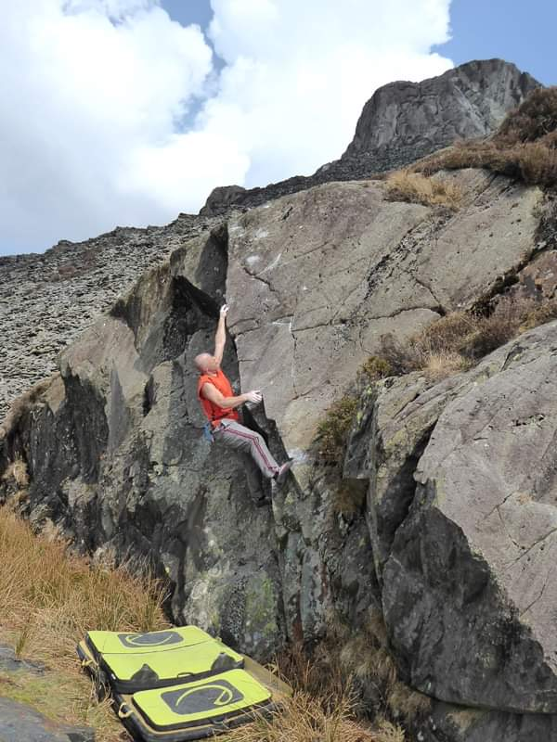
16 Slim pickin’s 6A
Up the thin crack on nice layaway moves to a jug at the crest then reverse one move and dismount.
Matthew Thompson 21.3.2022

17 Sow’s Ear 6B
The small pokey prow. Crouch on a good jug and then up to match the sloping jug in the corner. Step off. Bring a spotter.
Julie Mair 21.3.2022

18 Bi-doigt By-pass 6B+
Pull up the crack the swerve right via the duo-pocket and span right into the sharp finishing jug. Downclimb the easy ramp.
Matthew Thompson 21.3.2022

Mat Thompson on FA Sais Highway pic Julie Mair

The descent gulley behind Clipiau has another good collection of rocks at the top of the gulley with 4 problems.

The snake Pit area
19 Crackdome 6A
Crack in the wall to the right of the chimney has a good rounded finish.
George Smith 25.3.2022

20 Snake pit Crack 6A
Up the wall within the slab.
George Smith 25.3.2022

21 Snake pit Wall 6C+
Sds up the wonderful wall just right.
Martin Crook 25.3.2022

22 Snake in the Eagle Shadow 6B
The arete to the right is grasped and mantled with tremendous difficulty.
Martin Crook 25.2.2022

Above the approach track to Clipiau is a good dome
23 Interrabang 7A
Sds then gain the sloping rib and fire up.
Pete Robbins 10.4.20222

24 Crimpanzee 7A+
Direct up the centre of the dome. Sds then up the middle of the wall on obvious undercut to high sloping TO.
Pete Robbins 10.4.2022
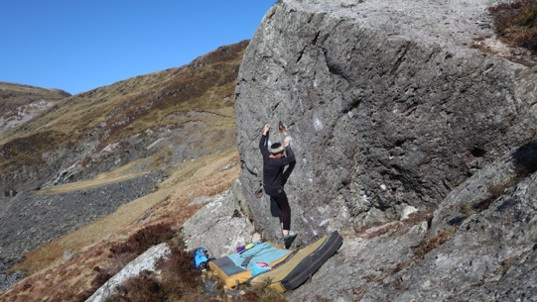
25 Crimpanzeecrab 7B
The obvious LTR traverse of the dome gives a technical challenge. From a stand teeter right into the thin crack then a surprising move allows you to gain the big undercut .Follow this with a short slap to the RH rib and the TO shuffle.
Martin Crook 14.4.2022
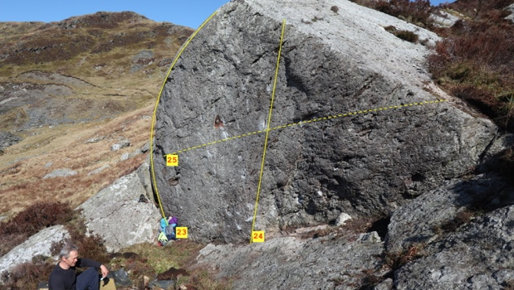

Heavy Metal Bowl Approach terraces OS SH 68005 45656 elevation 320m
Cross the river by the stepping-stones and head up the hill by the far shore of the pond. Wall one by the pond is Jet-scream 6B traverse. Just up the hill are terraced walls on the right.

26 Jet-Scream 6B
Excellent pocketed traverse left to right.
Terry Taylor

27 Direct 6B+
Sit and go direct on the small pockets.
Sam Tolhurst 28.8.2022

28 Sixty-Nain 6B
Sds just right of the crack and link the good holds leading over the top.
Mari Rees 7.6.2022.
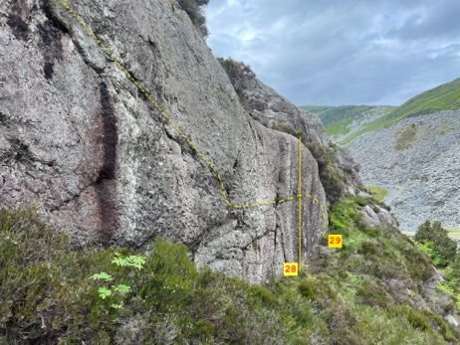

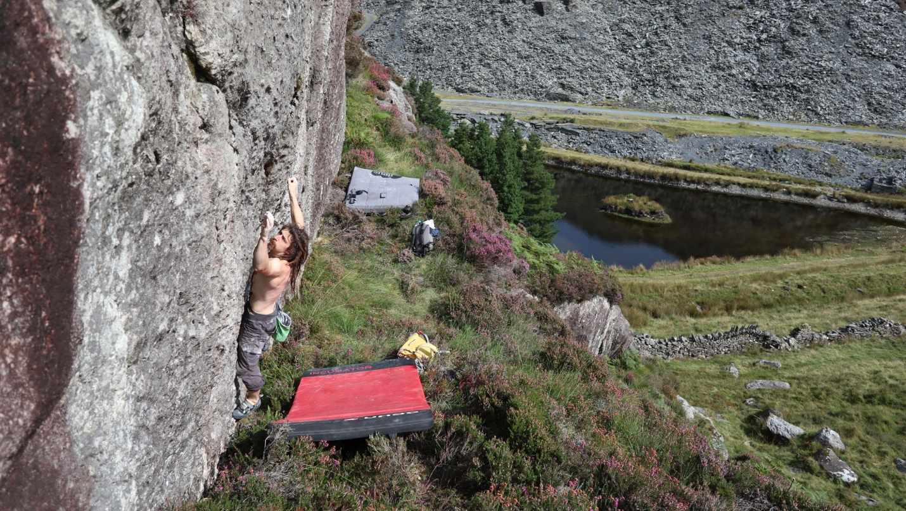
Sam Tolhurst on Nain Lives
29 Nain Lives 7A
Step on by the shallow pocket at the right edge of the wall and follow holds leftwards past the crack to a fingery crux before finishing up a good finger break and dismounting by the little garden in the crack.
Terry Taylor 7.6.2022

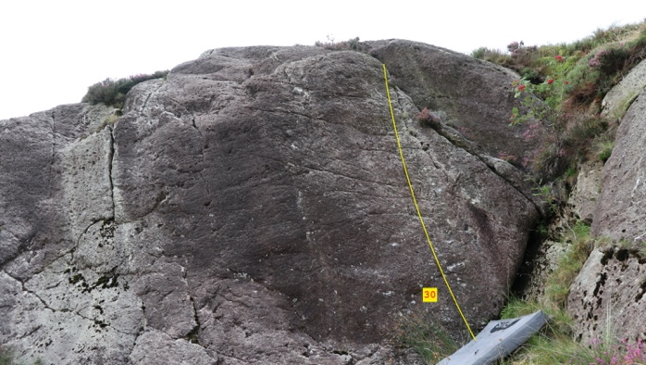

30 Nainty Nain 6B+
Up to the crack and over.
Sam Tolhurst 28.8.2022

Cwm Orthin. The slab slopes. OS SH 67463 45855. Elevation 470m

The gate walls.
After crossing the stone bridge by the lake pass through a gate on the track. Over on the left are various walls of quality stone.

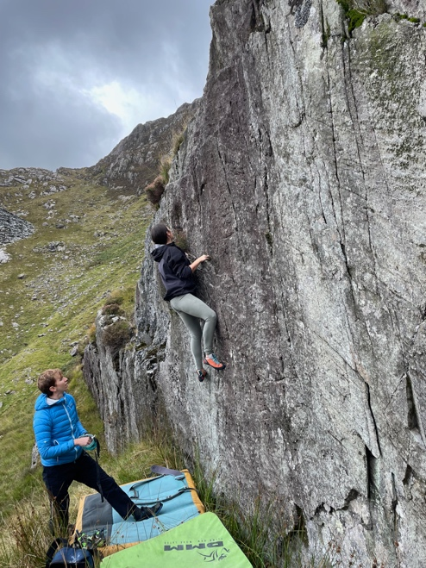
31 One Ring 4C
Up the wall past the ledge.
Aoife Taylor March 2022

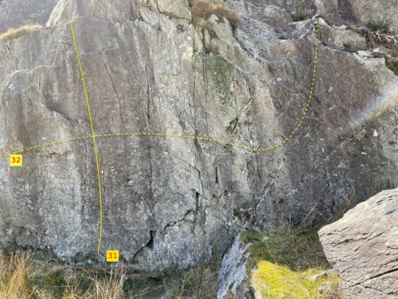
32 Ring of Power 6B
Sit start over on the left and traverse right past the step to a hard finish.
Terry Taylor March 2022

33 Ring Me Up 6A+
Sit start to the jug above then drop right to next jug below the easy direct finish.
Terry Taylor March 2022

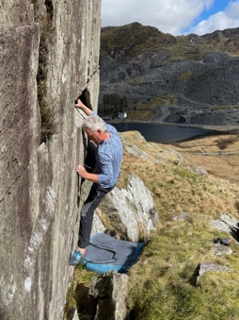
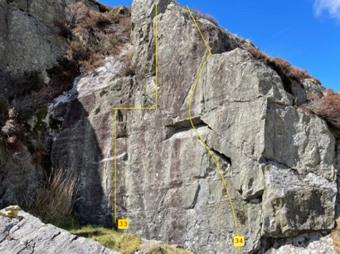
Terry Taylor on Ring Boozle

34 Ring Boozle wall 6A+
Sit start low and right then layback up to finger jug. Finish up and leftwards.
Terry Taylor March 2022

Lakeside slabs.
Follow the track along the lakeshore and pass under some clean,white slabs. Multiple problems here in low grades. Three good examples are

35 The Road to Spain 4C
Nice padding up the perfect slab.
Vince Orts March 2022
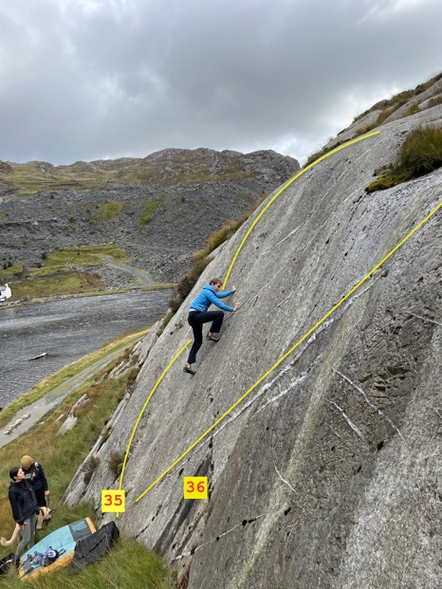
36 The Road from Pain 4C
Another very good slab climb.
Kiki Rees March 2022

37 Crackin’ Finish 5A
Sit start the traverse right to left to head up the crack.
Aoife Taylor March 2022
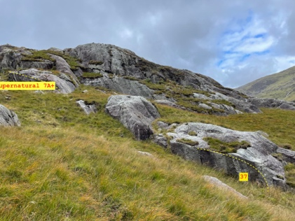

Continue along the track up the valley to the old ruin on the left. Across the bog behind the ruin is a good south-facing wall.

38 Rockerfella 5A
The tricky left-hand groove.
Aoife Taylor 20.3.2022
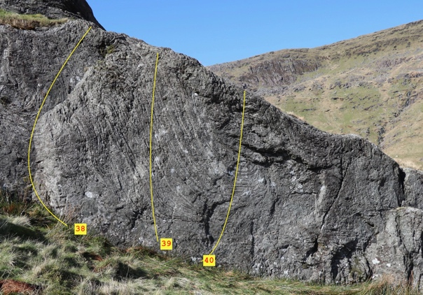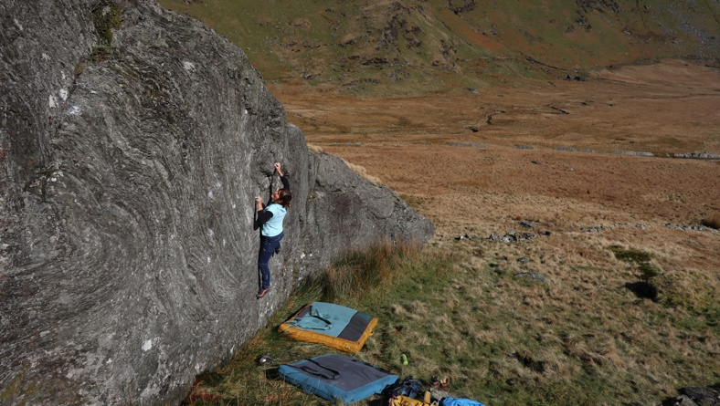
Mari Rees and Rockweiler 7A
39 Mad Dogs 5C
From a stand pull onto the wall and go direct.
Matthew Thompson 2022
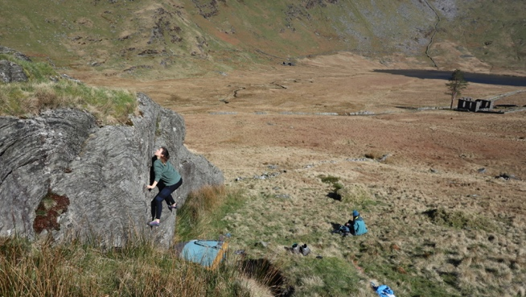
40 Rockweiler 7A
Ferocious sit start under the centre then snarl up and over.
Mari Rees March 20.3.2022

Aoife Taylor on Rockerfella

OS SH 67444 45902 elevation 440m
The tiered eastern slopes of Moel yr Hydd rise up from the lake and form a large collection of slabs and short walls of perfect white rock. Excellent for beginners and well worth the pleasant walk up the easy angled slopes.
45 minutes from parking to the main section. 1 hour to the highest problems.
Best to leave the track just after the gate by the lake shore and pass by Craig Llyn Cwm Orthin Isaf. Continue uphill onto the right shoulder of the slopes above and the slabs and walls come within range.
The first wall is quickly reached.

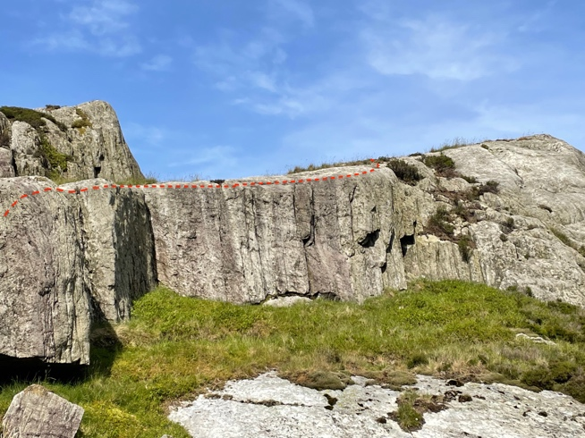
41 Passer-by 6B+
Left to right traverse of the low downhill facing wall.
Terry Taylor 2022

Continue up the hillside to this good wall. To access the next levels follow the animal track that zig-zags uphill from here heading right.

42 The Beginning 5C
The good wall from a stand to the sloping ledge.

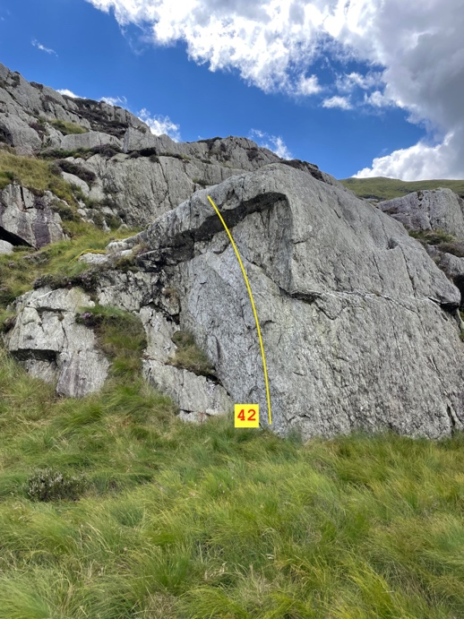
The next level on the animal track.
43 Wall Stall 5B
Fun stand and up to the sloping top.

The next level has a little slab with a long wall behind.

44 Raindance 5A
Up the centre of the slabby shield below Ecozoic.
Kiki Rees Stavros 14.5.2022.

45 Ecozoic 7A
Sds low and left then hand traverse the top for several meters until a drop down to quartz jugs. Tiny crimps out right have to be used to continue to the snake crack then a bit of a rest on the footledge by the vertical crack. Move back up to hand traverse the top of the wall to its end. 20 meters. Can be split in two by stepping off at the footledge after the 7a traverse then stepping back on for the final 10 meters of 6b+ climbing.
Terry Taylor 4.8.2022

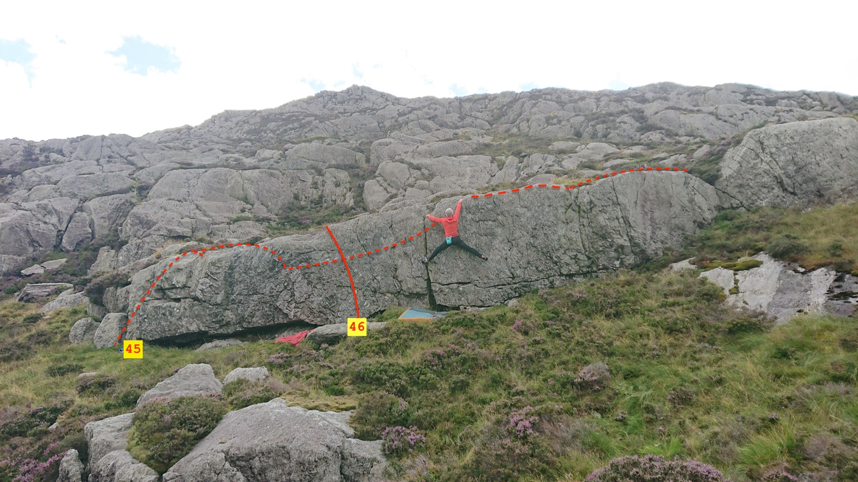
Terry Taylor on Ecozoic 7A

46 I zoi mou (my life) 6C+
Sds under the crux section of the traverse just left of the snaking crack and crimp directly up and over using the wall holds.
Mari Rees 4.8.2022

A stand-alone boulder sits up and left on the next level.
47 Goosed 6B
Sds and traverse the lip at the back of the boulder to the easy TO at the apex.
Terry Taylor 14.4.2022

48 Dabchicks 6B
Sds LH slot and RH flatty and wing it over the top without the dab.
Mari Rees 14.4.2022
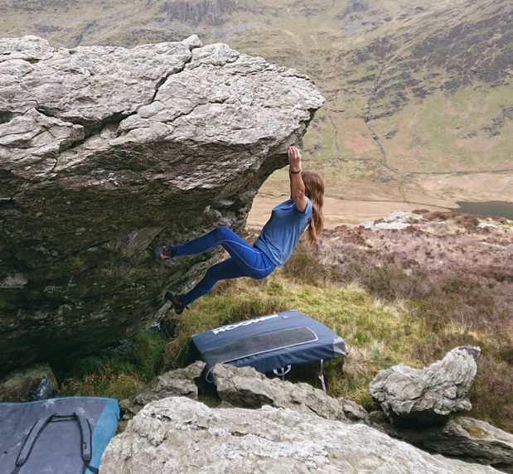
49 Wild Goose Chase 6A
Sds as low as possible and up through the roof on great holds.
Mari Rees 14.4.2022

50 Brent Geese 5A
The juggy right edge from sds.

51 Orange Parting 6A+
Stand under the wall behind the boulder with poor layaways to gain the good pocket and the slabby TO.
Mari Rees 14.5.2022

The low wall to the right has a 5C traverse passing the big flake.

200 metres to the right is another good boulder.
Just before this boulder and halfway along the terrace is another traverse lowball wall.

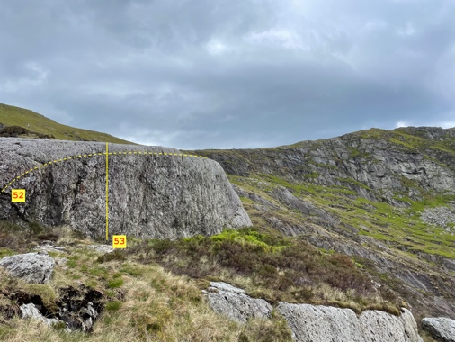
52 Fake Skull Tan 6B+
Sds over on the left and scuttle right past a good pocket and very low footholds to gain the jugs out right then carry on rightwards to the easy TO.
Terry Taylor 15.5.2022
53 Terry’s Chocolate Skull 6B
Sds under the crack and gaston up to the good pocket and the TO directly above. Mari Rees 15.5.2022

The impressive Dash-Hound boulder sits on the right edge of the slabs and is reached by contouring rightwards and upwards from the Dabchicks boulder in 5 minutes.
OS 67444 45902

54 Toenailed 6A+
Stand under the left side of the prow, hook up and nail the apex.
Steve Cain 15.5.2022

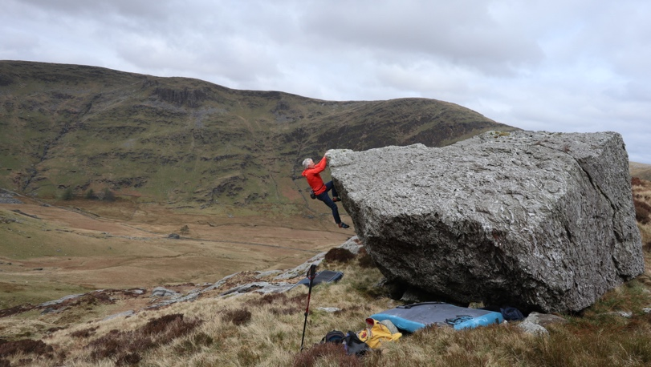
55 Dash-Hound 6b
Sds on the right edge and carry on to the easy rockover at the apex.
Terry Taylor 14.4.2022

On the hillside opposite is a good collection of slabs facing down the hill.
56 Rain on my Parade 5A
Up the centre of the first slab.
Kiki Rees-Stavros 15.5.2022.

OS SH 67359 45683 elevation 520 m. This is almost the highest point on the slab slopes and is a good hour’s walk from the parking. The problems and the views are good and you can be sure to have solitude as no one ever comes up here.

57 Cock and Bull 6C
Sds with feet on the lowest rock plate and swipe up and left to gain the series of holds to the topout.
Mari Rees 17.6.2022
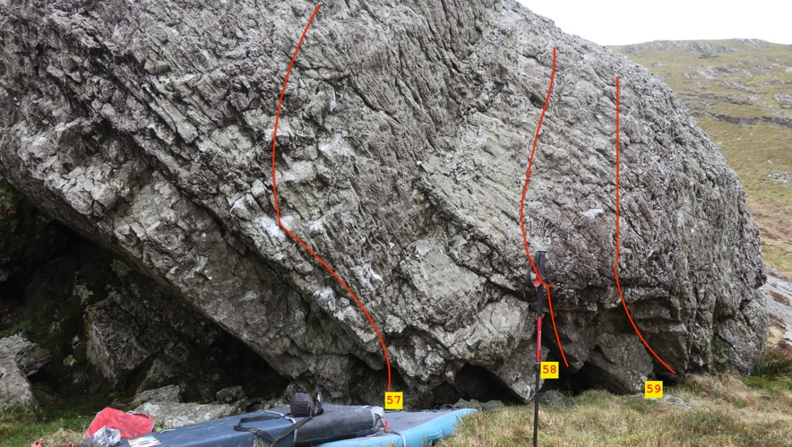

58 The Bane of the Pose 6B
Sds low under the face below a good pocket and muscle up.
Terry Taylor 14.4.22

59 Exiled to the Sky 6B+
Sds low under the right side of the shallow roof with good RH pocket and LH undercut and fly up to the good LH pocket to topout direct.
Terry Taylor 17.6.2022

The wall carries on to the right where there is a sustained 5C traverse.

Allt Cefylau
OS SH 66755 46823. Elevation 490 metres

Another collection of blocks sitting above the valley of Cwm Orthin and easily visible from the lake shore.
Approach time 1 hour.
Follow the Cwm Orthin track to where it rises up Rhosydd at the head of the valley. These outstanding stones can be clearly seen above the rising track on the right and are approached by contouring back across the hillside from near the top of the track.

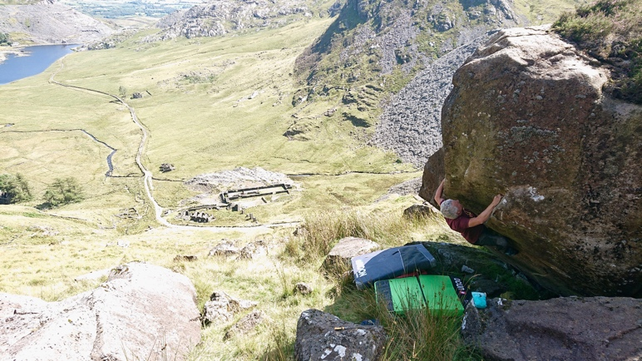

60 Black Trillium 6A
Sds under the prow and hand traverse left around the corner for the rock up.
Terry Taylor 6.8.2022
61 Hippo Banquet 6B
Sds and layaway up to the good edge for the rock over.
Terry Taylor 6.8.2022

62 The Brimstone 6B+
Sds with good undercut jug and span up and left via a boss to the good edge for the rock over.
Terry Taylor 6.8.2022
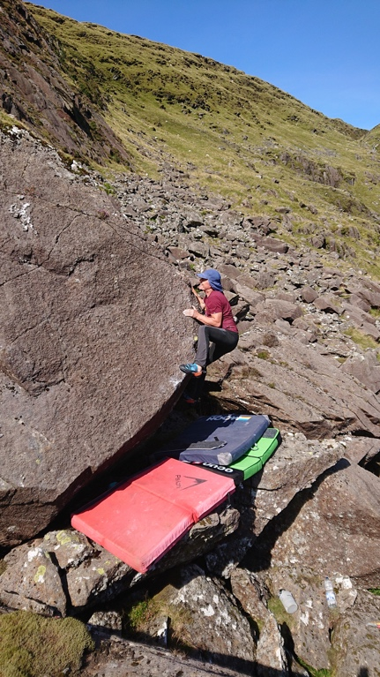
Taltos 6B+
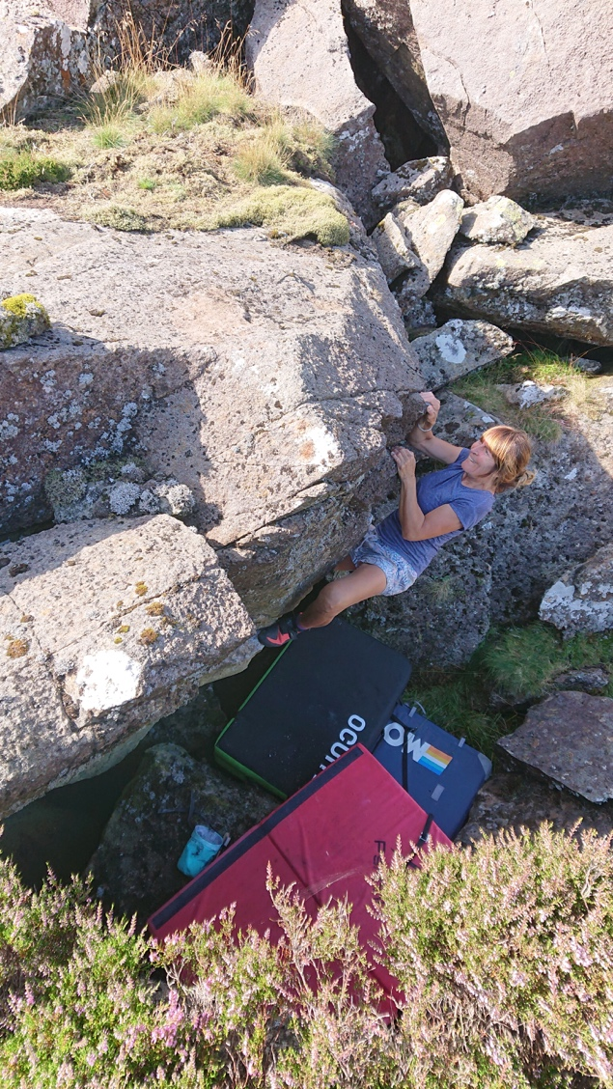
63 The Grinning Stone 6A
Sds under the juggy steep wall, get the good spike up and right then rock over leftwards.
Mari Rees 6.8.2022

64 Taltos 6B+
Sds over on the left end of the ledge and traverse up to get a good bobbly jug high right then use a good toehold to push over.
Terry Taylor 6.8.2022

The trad crag of Allt Ceffylau is approached by following the main track up to some old ruins then sweeping rightwards onto the hillside to the clearly visible escarpment.

Mari Rees on The Grinning Stone

Just down and left of the main face is a roof: See South Snowdonia Bouldering.
65 The Roof of Allt Ceffylau 7A
Stand under the imposing roof, commit out right on a thin rail then make the wickedly high rockover as your spotters shuffle mats around below you.
Sam Tolhurst and Zed Oliver-Jones 2022

66 Horsing Around 5B
The cool slab centre from stand.
Kiki Rees-Stavros 2022

