Llanfachreth. Pwll-y-gele OS SH 77222 21314

One tiny escarpment and one boulder.
Approach from Llanfachreth by heading east out of the village. Pass the first left hand exit and take the second one. Follow this to where a vehicle track forks right. Room for one vehicle parked. Follow the track for 100 meters. The escarpment is visible on the right 100 metres across rough ground. Perfect white stone.

(Left pillar unclimbed)

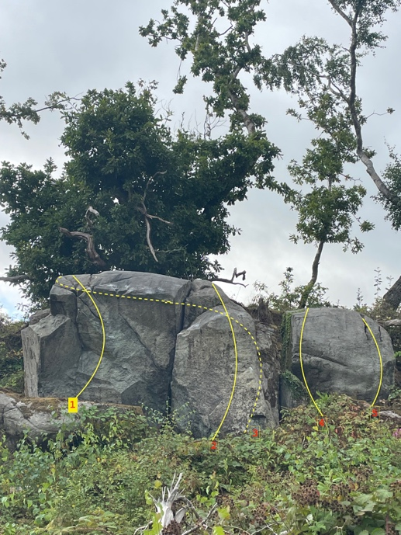

1 Recovering the satellites 6A
Sit start and pop over the top.
Mari Rees 14.8.2025

2 Counting Crowbars 6B
Sit under the pillar and straight over.
Terry Taylor 22.8.2023

(Hand jamming crack unclimbed)

3 Crowbar traverse 6B+
Sit start under right edge and slap nicely leftwards to the far left for easy topout.
Terry Taylor 7.10.2023

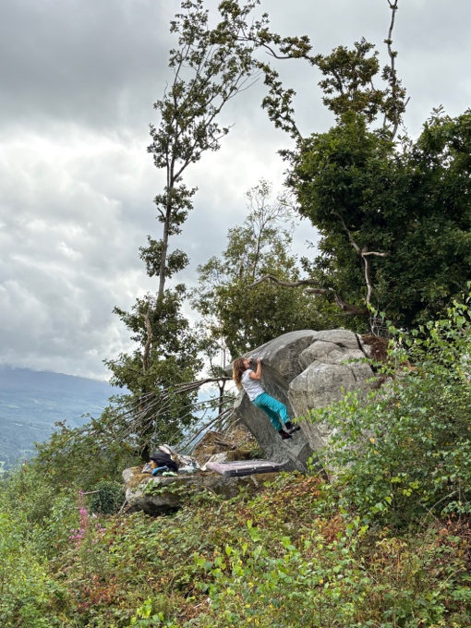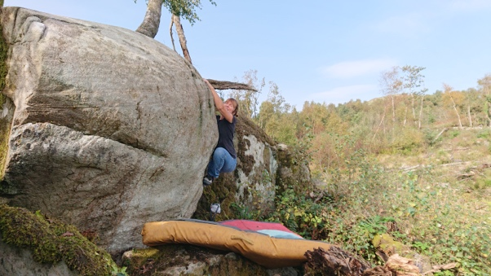

4 Funeral for you my Friend 6A+
Wicked crimping from sit down on good break and with use of left edge hop straight over.
Mari Rees 7.10.2023

5 Counting Blows 6B+
Another crimp from sit and over with some holds out right.
Mari Rees 7.10.2023

(On level below these rocks is an unclimbed traverse).
Continue on along the track until another 100 metres to where a footpath heads up left. Follow this for 50 metres to the solitary boulder.
6 Pedal Impulse 6B (sans bloc)
Stand and pull onto the stone with a high left toe hold and grind up right to the top jugs for the pullover.
Terr Taylor 12.8.2025
