Rhobell Fawr Cors y garnedd

The mountain of Rhobell Fawr rises gently to the north east of Dolgellau and has bouldering on its west, south and east slopes.

The west. SH 76552 24372. Elevation 380 metres
Easily approached from the village of Llanfachreth by taking the road marked Cors y Garnedd to where the tarmac ends. A good grassy layby on the left allows easy parking (OS SH 76647 23431). The western slopes are sprinkled with a large number of boulders and small faces only a few of which have been developed.
Approach time 10 minutes
Aspect west and south west
Rock: basaltic lava

From the parking follow the stone track to a metal gate, turn right and pass through a gap in the stone wall to the right of the gate. The boulders are described from left to right.

1 Stargazer 6B
The stand-out boulder halfway along the field. Sds under the prow and hand traverse rightwards to the TO.
Terry Taylor 5.4.2021
The next good boulder to the right has 2 problems

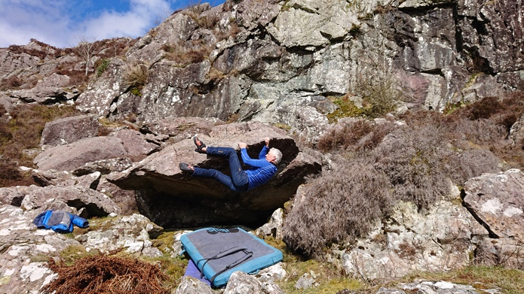
2 Rees Bach 6A+
Sds under the short steep wall and pop up rightwards
Mari Rees 5.4.2021

3 Birthday 6A+
Sds under the righthand wall and wander directly up.
Mari Rees 5.4.2021
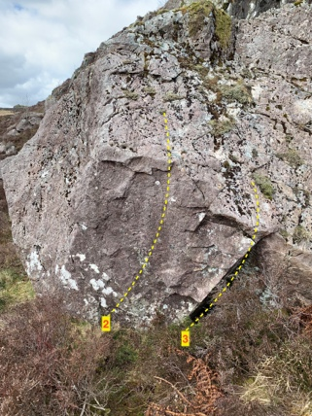

Over to the right by the stone wall is another good boulder with 2 problems

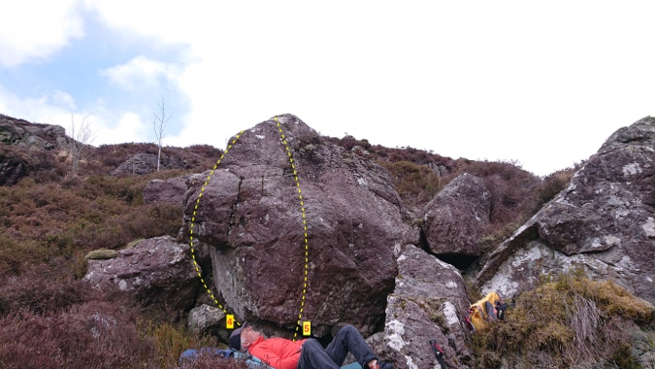
4 The History of Africa 6A
Sds under the prow and scramble over.
Mari Rees 29.4.2021

5 Afterthought 6A
Sds and pull up onto the slab.
Terry Taylor 29.4.2021

More walls lie on the hill directly above. One of the best is 100m uphill then contour rightwards to a hidden bay facing west.
SH 77205 24550. Elevation 480m
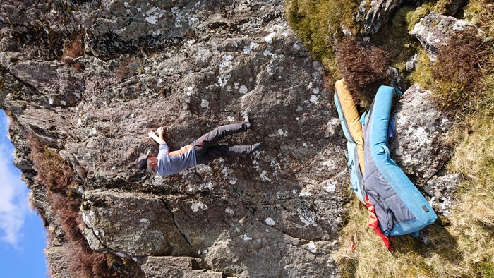

On the way up pass a nice clean wall with two problems 5A and 5B
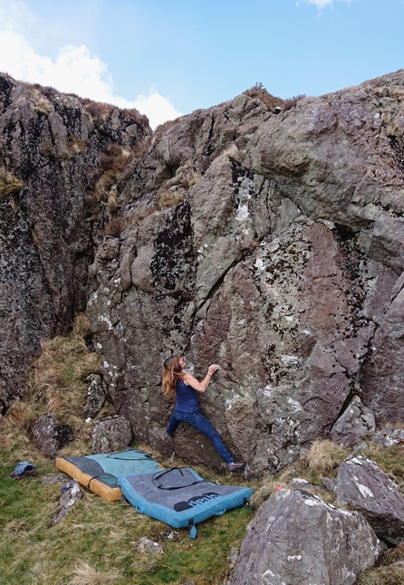

The Sounds of Africa 6B
Stand start on the left with good LH finger slot and drop down onto the RH jug. Continue traversing very low to the far right for the rock up.
Terry Taylor 29.4.2021.

