Tabor. OS SH 75000 17162. Elevation 240m

The boulders litter the small hill just north of the ruined Quaker house of Dewis-bren Uchaf. Park on Fford Serth by the post box beside Tabor Chapel (OS SH 75354 17344) and cross the road to pass through a gate onto a track. Follow the track for less than 10 minutes to a sign on the right for Dewis-bren Uchaf. Pass through the gate (sometimes padlocked) and past the ruined Quaker house. The boulders are visible over on the hillside just beyond the ruins.
There are two good rocks facing south, the remainder are on the north facing slopes of the hill above some houses. It is also possible to follow the FP past the house of Glasscoed below the northern slopes of the hill.

The north west slopes

The most left-hand wall
1 The Ducking Stool 6B+
Sds and traverse left to the end of the overhanging wall on jugs. Only a witch will survive.
Terry Taylor 21.5.2022
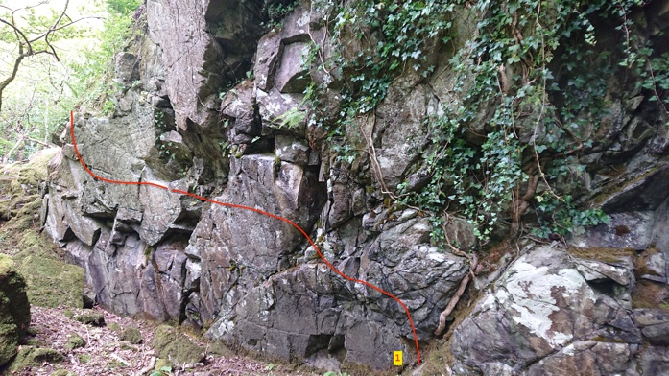
The overhanging high wall next right.
2 Hang ‘em High 7A
Sds on the rock by the jug, pull on and span right to another jug. Good holds lead rightwards to a hard drop by the vertical crack. Pass the crack onto the ramp and dismount.
Needs a far left start and a high right finish.
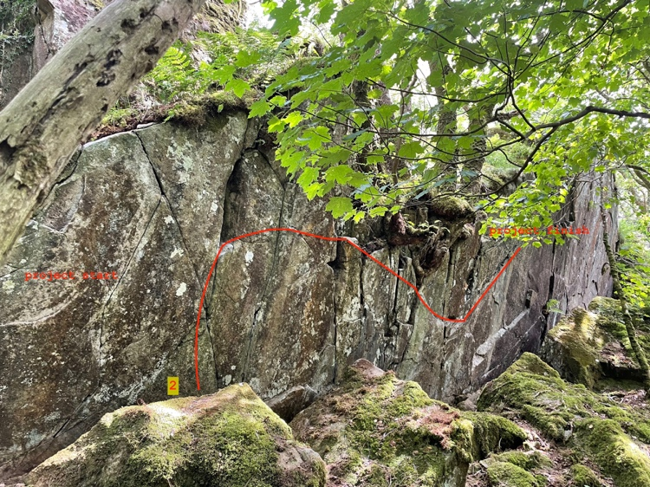
Terry Taylor 25.7.2022

Below is the big traverse boulder.
3 Don Quixote 6A+
Sds by the crack then canter rightwards to quixotic moves across the groove.
Terry Taylor 24.5.2022

4 Groove Direct 6B+
Sds on crimps directly below the groove and float directly up on poor slopers.
Mari Rees 25.7.2022
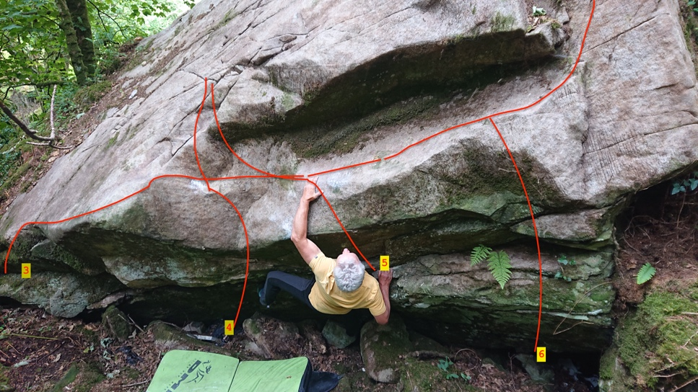
5 Groove RH 6A
Sds with good finger holds and lance up to the sloping traverse. Step up left.
Terry Taylor 16.7.2022

6 There’s a Fungus among Us 5B
Fun sds and strenuous ascent.
Cian Taylor 24.7.2022

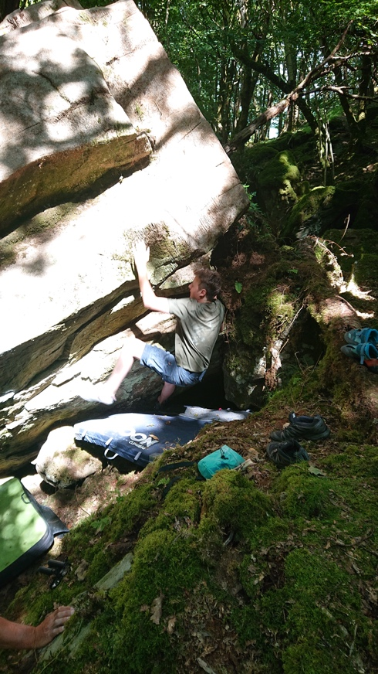

7 Mount the Donkey 5B
A fun mantel from sds.

Above are three small walls.
8 The Tenant 6A
Sds with good edges and sculpt over the top.
Mari Rees 24.7.2022

9 WildFall Hall 6A+
Sds and motor up to the lip then pop left to finish as for Tenant.
Terry Taylor 24.7.2022

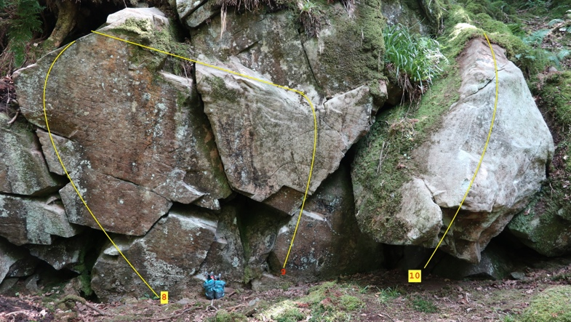
10 Size Matters 6A
Sds under this small stone aim for the jug to topout 9 (morpho).
A long arm makes the first move easier.
Mari Rees 6.8.2022
Above is the highball wall
11 Samtastic 6C
Stand under the overhanging face and fight up over the top.
Sam Tolhurst 2023

Same rock right face project MR
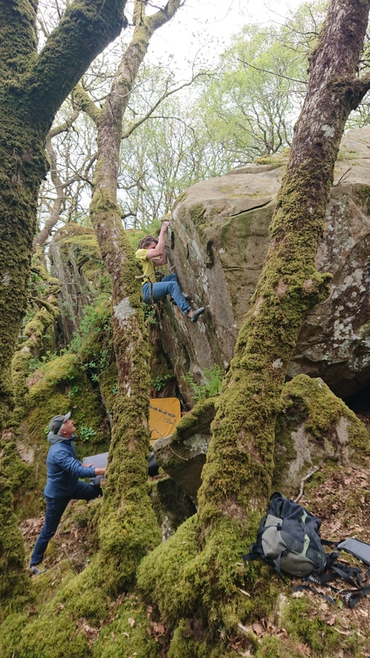

Next right are two more leaning walls

12 If in Doubt Await the Drought 6A
Fun sds to nice TO. Needs a long dry spell.
Terry Taylor 8.8.2022

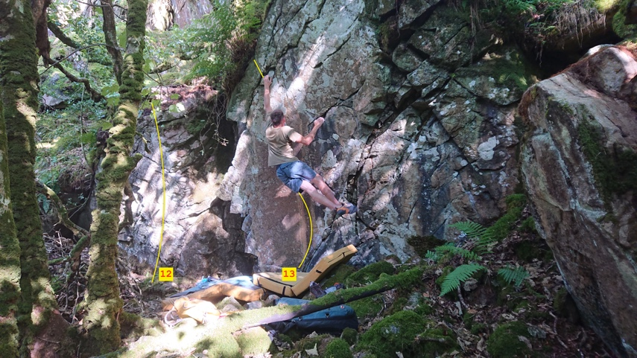

Next right is a higher steeper wall.
13 Twiddy, Won’t He 6B+
Fun from sit under the centre then head up to the small triangular slot then the better holds up and left for the dismount.
Eliot Twiddy 29.8.2022

Next right are three good boulders.

14 Giggy-back 6B+
Sds under the steep wall and ride up. Left or right foot on the small starting foothold?!
Mari Rees,Terry Taylor 19.5.2022

15 Oatsqueal 6A
Sds low and up the pillar.
Mari Rees 19.5.2022

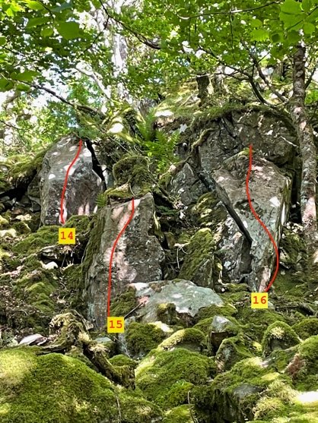
16 Corfu 6B
Sds and use the starter holds to rocket up to the left-hand jug. Stay on the one island -shaped boulder all the way.
Terry Taylor 19.5.2022

The south western slopes

The next boulder is just above the farm track rising past the west edge of the forest. Small and steep.
17 Don’t Miss the Oat 6B
Sds with good edge and launch rightwards past the flatty to TO.
Terry Taylor 17.5.2022
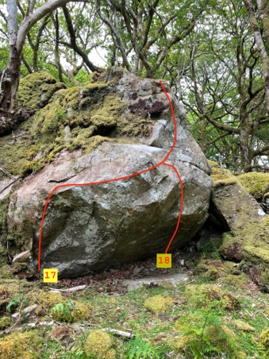18 Oat of no confidence 6B+
Sds over on the right and go direct to the top using the flatty out left and the RH layaways.
Mari Rees 17.5.2022

Next problems are on the steep face up and right.
19 Quakin’ in my Boots 6B+
Sds and follow the top rightwards to enter the horizontal finger cracks leading to the juggy RH TO.
Terry Taylor 17.5.2022

20 Mirthquake 7A
Sds low under the centre and launch up to the small flake to make the TO.
Mari Rees 17.5.2022
