Dolgellau Area
Twr Glas OS SH 67021 16503
Behind the residential home of Garthangharad there is a large collection of stones tumbling down the hill of Twr Glas which are quickly and easily assessed from the vehicular track running behind the house.
OS SH 66222 16239 Park by the western entrance to the residential home. There is just enough room for one vehicle to park by the gate without blocking access to the houses or to the track. It is also possible to drive through the gate and continue to a good layby by the right hand turn OS SH 66650 16349
Pass through the gate and follow the track. Continue direct through another gate (by a water tank) and the first stones appear trackside on your right 100metres further on. The field is described from left to right so starts 400 metres further along the track. Approach time 15 minutes.
The rock is solid, white dolerite that will require a brushing. Most of the boulders are quite small but provide a good circuit once winter has passed and the sun gets to hit these north west facing slopes!
1 Runaway nose 5C
Sds under the left side of the face, get some good crack holds and head for the apex.

2 Nosey 6B
Stand in the pit and get the LH layway and the RH flake to sprint up.
Matthew Thompson 25.4.2022

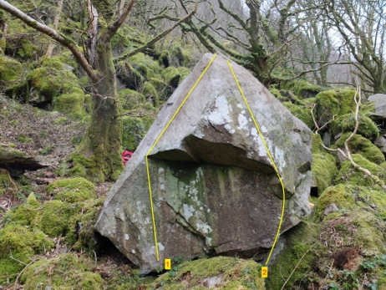
3 Mucilaginous Frenzy 6B
Sds and follow the good edge all the way to the left arete then rock over.
Mari Rees 7.3.2021
4 She Nose it all 5C
Sds and pull over to the jugs and the TO.
Mari Rees 4.3.2021
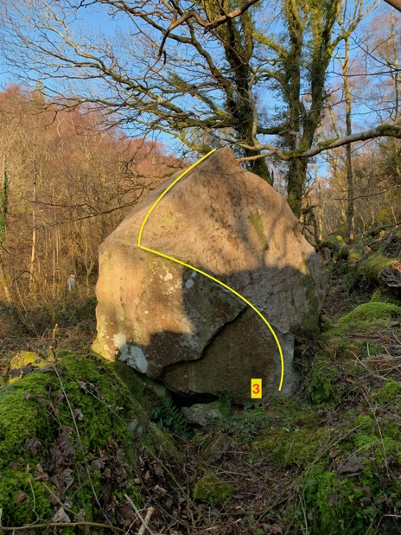

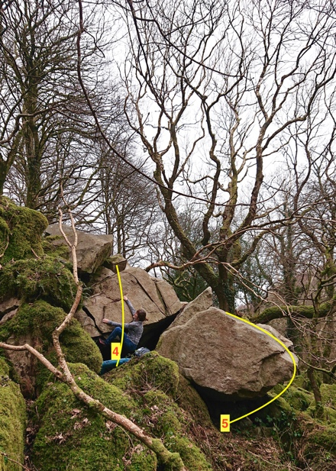

5 Folie a deux 7A
Sds and hang the sloping prow before a hard slap to the top and a wild TO above the drop.
Mari Rees and Terry Taylor 7.3.2021

project traverse from Folie rightwards

6 Sloper faction 6A+
Sds under the roof with LH high jug, RH sloper and rockover.
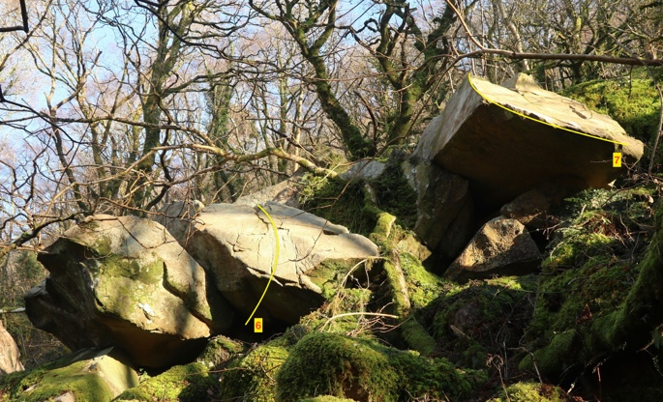
Terry Taylor 4.3.2021

7 Edge Hound 6B
Sds under the right side and follow the excellent edge all the way to the TO.
Terry Taylor 4.3.2021

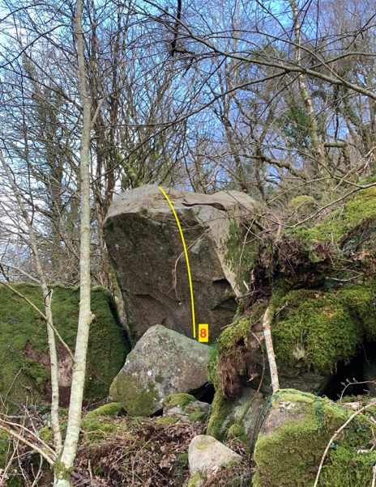

8 Top of the world 6B
Stand start with hands on the lip and mantel. Sounds easy.
Mari Rees 7.3.2021

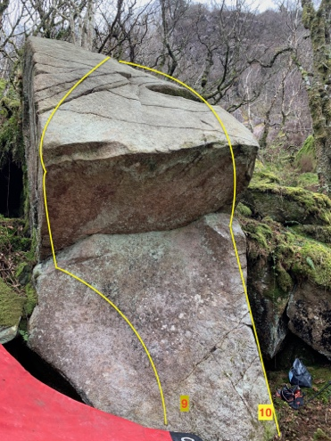

9 Diced man 5C
Sds under the centre of the slab using the good jug up and left. Gain and follow the crack out to the ledge and TO.

10 Roll it again 4B
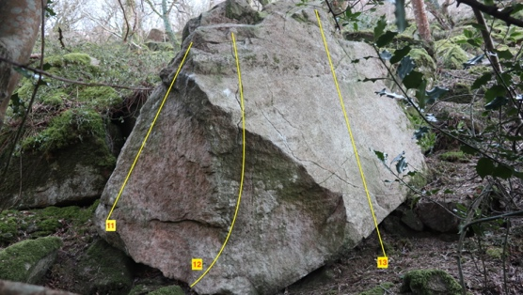
Sds under the right edge and waltz up.
11 Two on a Tower 4C
Stand start under the left edge.
12 Blue Tower 6A+
Sds under the centre and using a good crimp in the seam up and right follow the line up.
Terry Taylor 12.2.2021
13 Pair of Blue Eyes 3C
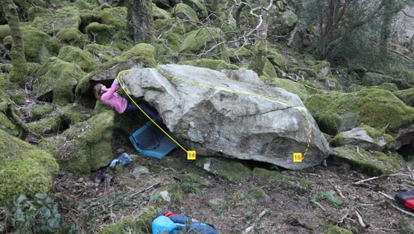
Stand start and pop up the slab.
14 Blue fingers and toes 6A+
Sds low under the roof and grab the left lip to traverse right to TO.
Mari Rees 12.2.2021
15 Blue Moon 6A
Sds and traverse left to TO. TT 12.2.2021
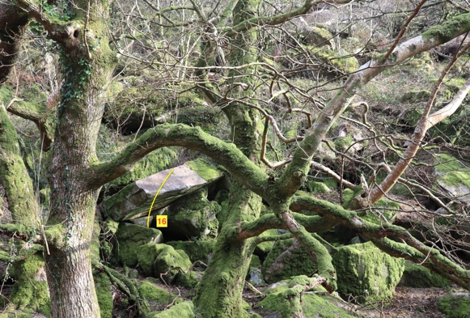

16 Friction Addiction 6B+
Sds under the roof and using the edge with pinches rub your way over.
Mari Rees 7.3.2021

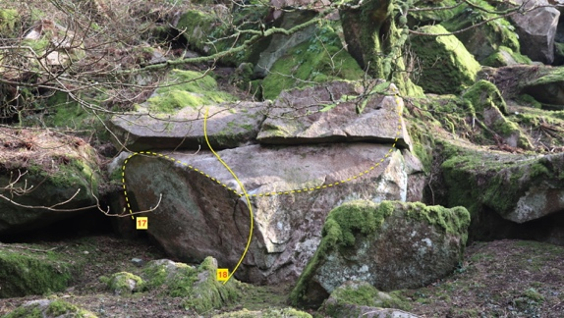
17 He who must not be named 5C
Sds up and left then drop to the edge before reaching the jugs up and right.

18 The Imposter 5C
Sds under the edge and vanish up leftwards.
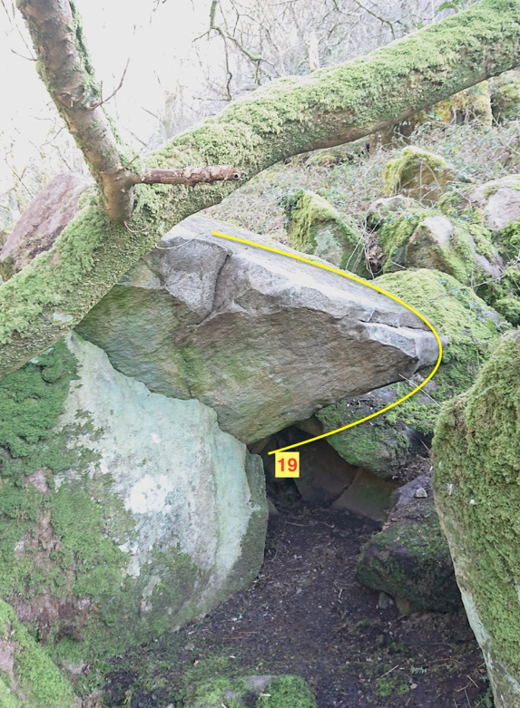

19 Dismantle 6B+
Sds under the right edge of this fascinating saucer, hit the centre and mantel …. Possibly
Mari Rees 7.3.2021

20 Moaning Myrtle 6A
Sds RH on the good edge, LH on poor slap and grab the left hand high juggy edge.
Mari Rees 3.3.2021

21 Cloak of Invisibility 6B+
Sds under the roof. Hit some good finger edges and pull up to the TO.
Mari Rees 7.3.2021
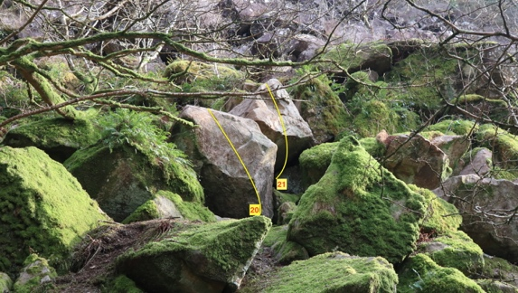

22 Teddy Bear picnic 5B
Sds under the right edge and dance left to the TO.

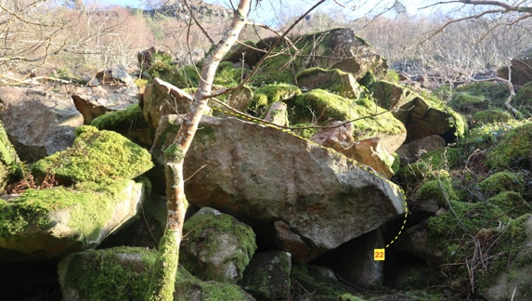

23 Mud Palace 5C
Crouch start with good left foot hold and good RH edge and TO.
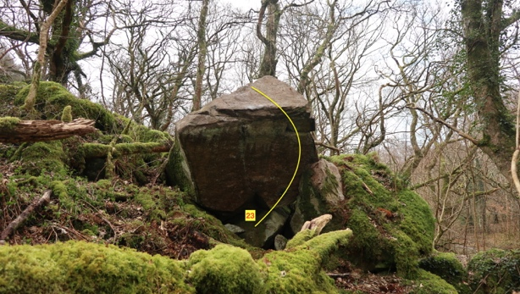

24 Mud, Mantel and Madness 6B+
Sds with both hands on poor boss on the lip and pull like a lunatic to TO.
Mari Rees 7.3.2021

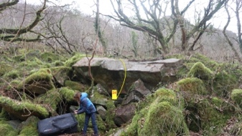

AREA 2 OS SH 66480 16167
The stones carry on across the hillside. There is a right hand track by the water tank in the stream. From here head straight up the steep hillside in the forest for a few minutes to reach the next set of stones. There is an old fence contouring across the hillside and most of the stones are by this.
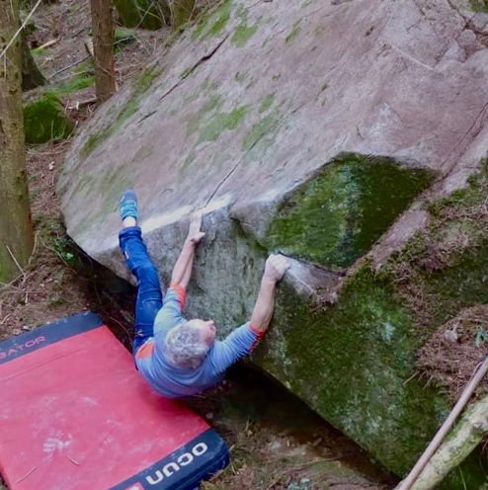

25 Scraping by 6C
Ridiculously low traverse and very awkward mantle. Be great if someone dug a trench.
Terry Taylor 28.3.2022

26 Rootone 6A+
Sds with good jug and step up.
Mari Rees 20.3.2021
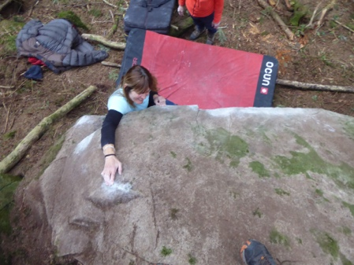Mari Rees on Rootone.
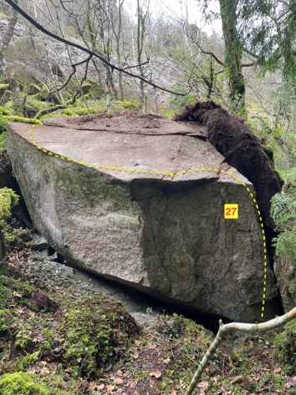
27 In a Whirl 6B
Sds with good RH edge, gain the good jug to turn the corner then slap leftwards until a big reach up to the finger ledge.
Mari Rees 15.3.2022

Contour rightwards for 50m meters
28 Don’t Push me, I’m close to the edge 6B+
Sds with the good ledge out right and using only the boulder elevate up then left to jugs.
Terry Taylor 15.3.2022
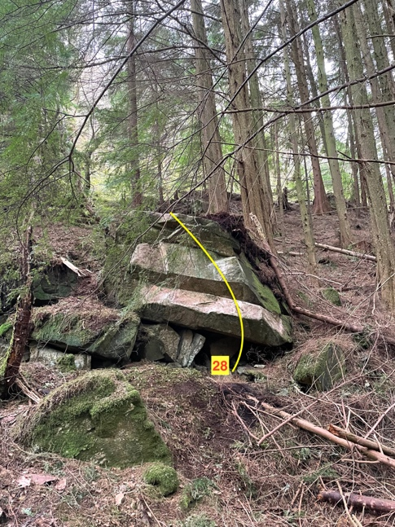

29 Platform nine and three quarters. 6B+
Sds hanging the edge and throw a high heel hook to rock up using only the boulder.
Mari Rees 15.3.2022

Follow the fence rightwards for 100 metres to the best climbing here in the forest.
30 La Mariquita 6B+
Sds way out left, cross the small middle stone and traverse the tall wall via the little triangular pocket to get to the right end and the TO.
Terry Taylor 15.3.2022

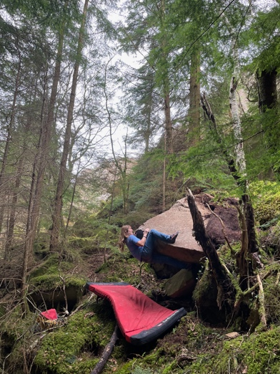

31 Madman Stand 6A
Stand with LH on arete and RH middle sidepull then squeeze up to finish via the top flat jug up and right.
Matthew Thompson 20.3.2022

32 Special Mossatary Operation 6B
Fine climbing straight up the middle from sds to gain the top flat jug for the TO.
Matthew Thompson 20.3.2022

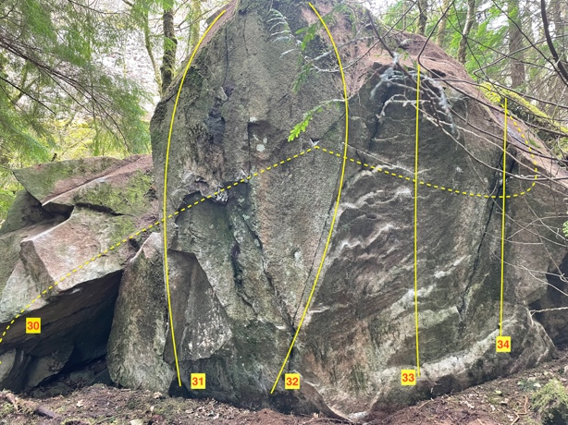

33 Las Mariquitas 6B
Sds under the right wall with good foothold and crimp to the TO.
Mari Rees 15.3.2022
34 Ladytirds 6A
Sds over on the right, up to good slot then step up and left to TO.
TT and MT 25.4.2022

35 Ladyboys 6A+
Sds under the back edge and layback up gracefully.
Mari Rees 20.3.2021

The very small boulder behind this monolith has one problem through the low roof.
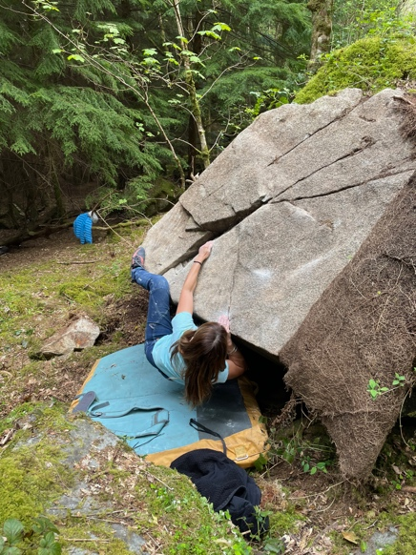

36 How did it come to this? 6C
Sds under the groove and find your way up on small dishes, layaways, hooks.
Mari Rees, Terry Tayler 25.4.2022

Up and right is a good lip.

37 Please may I have some more? Chalk 6A
Sds in the hole and traverse right to the TO around the corner.
Mari Rees 25.4.2022
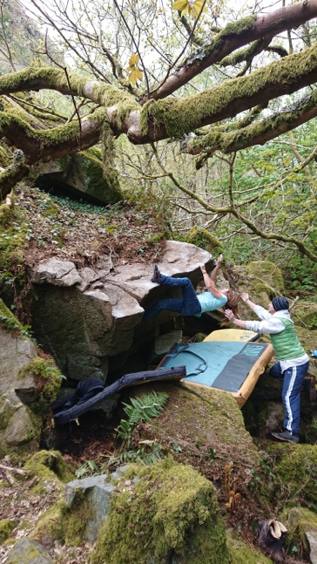

Area 3
Continue up the right hand track to where it ends in a field. The Wall is directly above and is approached by crossing the field to the far right corner then zig-zagging up the steep hill heading leftwards. This north-facing wall is embedded in the hillside above bracken and heather and takes a good 30 minutes to each. Vegetated on its top and prone to marked seepage it is a good piece of rock and still has major potential.

Halfway House 6A+
Based on the crackline near the middle of the wall. Good triangular slot for the right foot.
Jasper Ray 9.3.2022

Fun Fear 6B
Use the triangular slot for the left foot and head up to the challenging topout.
Jasper Ray 9.3.2022

Smitten 6A
Start at a distinct heart-shaped pocket (good undercut) and follow positive handholds in the crack.
Jasper Ray 9.3.2022

Show of Force 7A
Start at a large undercut hold in the shallow niche in the base of this compact section of wall. A big reach from edges on the left leads to a good jug high and right.
Jasper Ray 9.3.2022

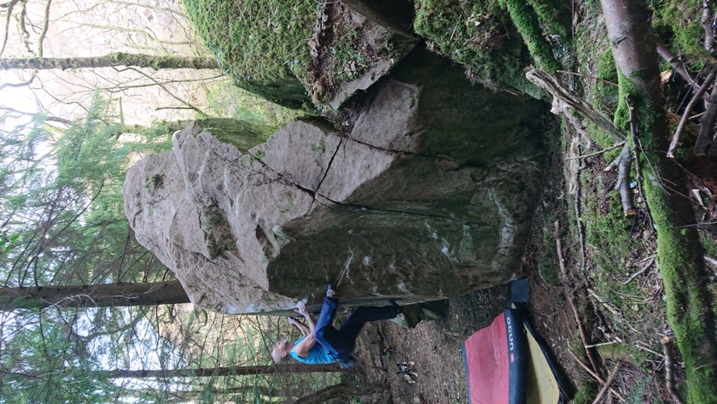
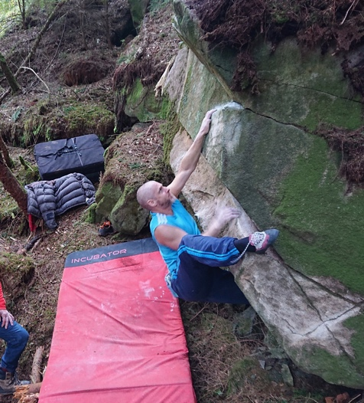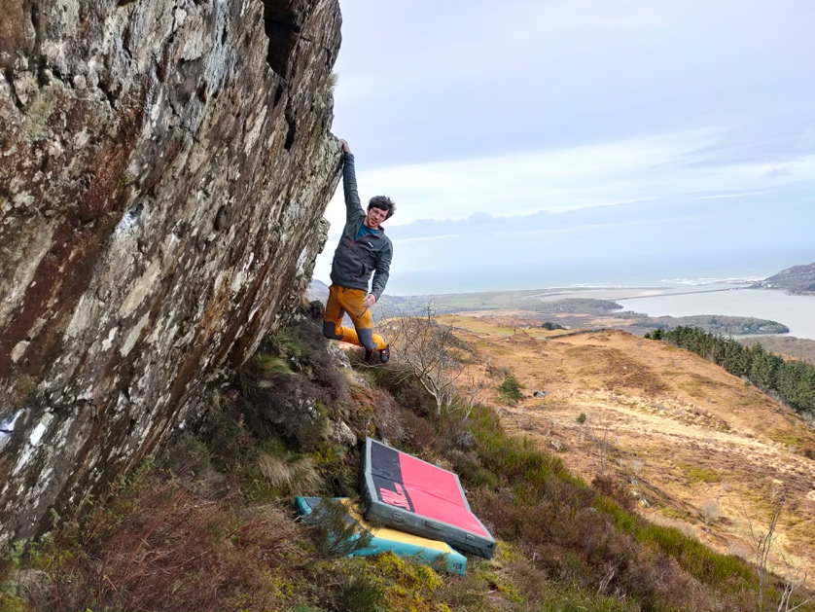

Clockwise
Mat Thompson on Special Mossatary Operation 6B, Jaspar Ray on FA Show of Force 7A(pic from S.Hobbs) and Mat on Don’t push me I’m close to the edge 6B+.

