Coed y Brenin 2026
OS SH 71179 25632. Elevation 300m. Produced by https://midwalesbouldering.com/
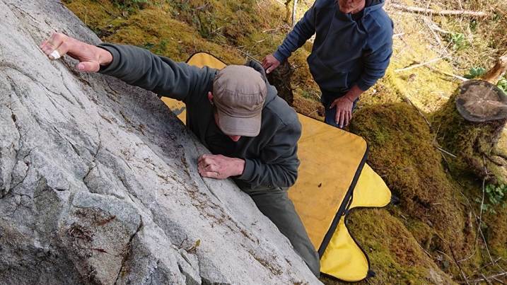
Elliot Twiddy on the perfect crimps in the forest.

Scattered boulders by the mountain bike trail of Tarw in Coed y Brenin. Developed by Mari Rees and Terry Taylor except where indicated.

Approach: take the steep road behind Tyn y Croes inn south of Ganllwyd village: Dolmelynllyn forest.
Drive over a small bridge and pass through a gate. The road now forks.
Left fork leads to the GwnDwn walls and The Rock Garden boulders.
Right fork leads to the MB trial above Coed y Brenin: follow the right fork past two houses through another gate and on until a bridge over the river. Drive across this bridge and park on the left. From here walk past the metal barrier on the forestry road to join the Tarw MB trail. Follow the trial as it swings left. 10 minutes from parking the white rocks are easily seen to the right of the trail.

Projects.

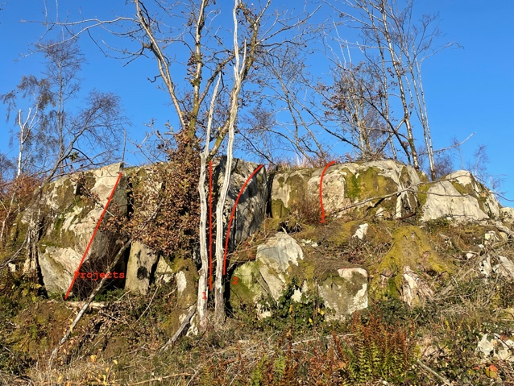1 Le talon d’Achille 6A
Sds and using the narrow block below the short arete compress the arete to the juggy top.
Needs a sans block
2 Warming wall 5B
Sds by the vertical crack and traverse the lip to the topout far right.
3 Easy Bloc 5A
The sweet square block from sds.
On the main trail there is a good block down and left.
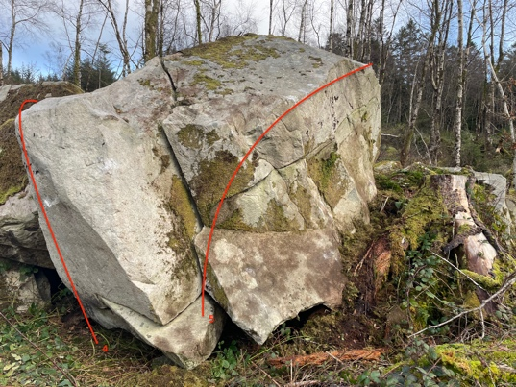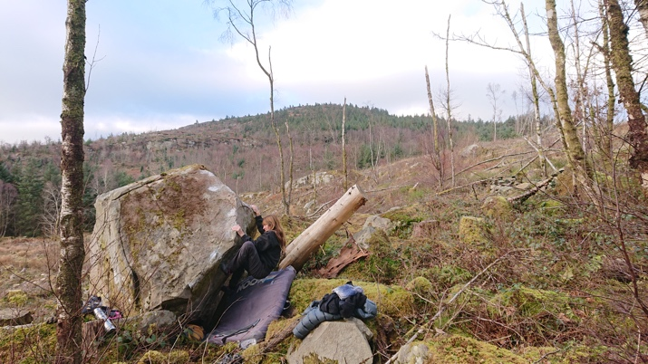

4 Prow 6A
Sds and up the gorgeous white stone.
5 Trav 6A
Traverse the sunny side of the boulder
6 Pit 6A
Sds under the undercut wall facing the track.
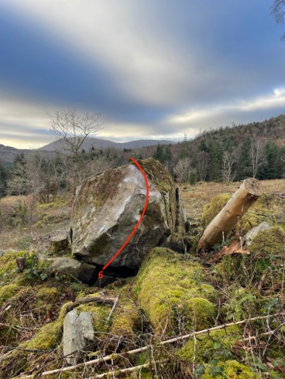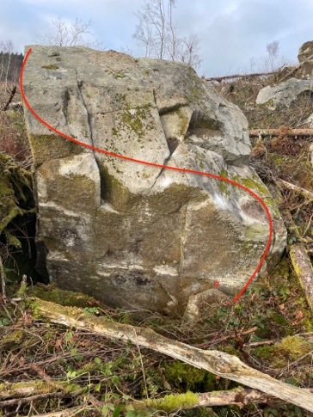
7 Wanderings 5B Neat right to left from a sit.

Follow the MB trail uphill to Al’s loop. There are developed boulders on the left just before the loop.
100 meters short of the loop a large flat white stone lies on the left side of the road. Head direct into the forest via an old machine clearing and a good boulder stands out on the tiers directly ahead.
8 L’heure a sonné. 6A+
Sds on the right and traverse left to the crack to topout.

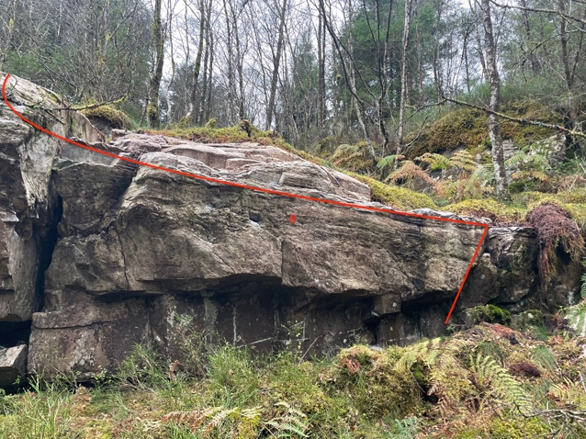

50 metres short of Al’s loop a clean white wall can be seen on the left just off the road.

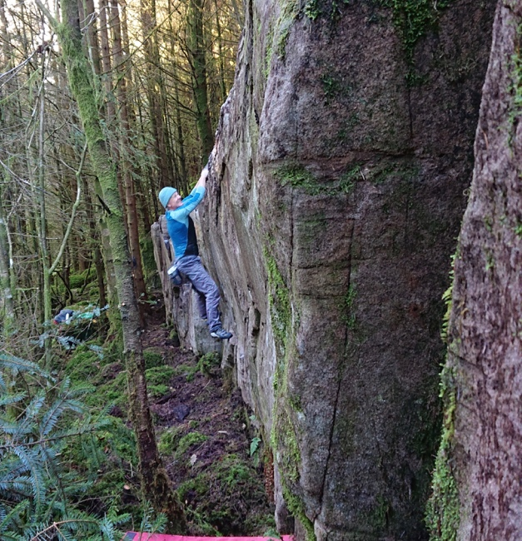
9 Sold my Skin to the Magician 6A
Traverse the long wall left to right.
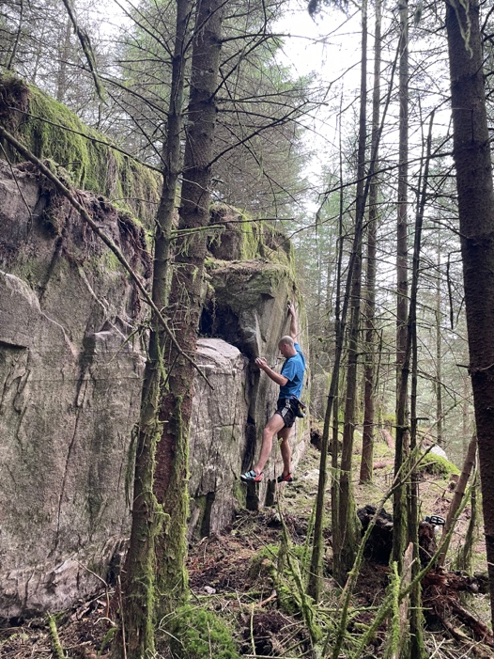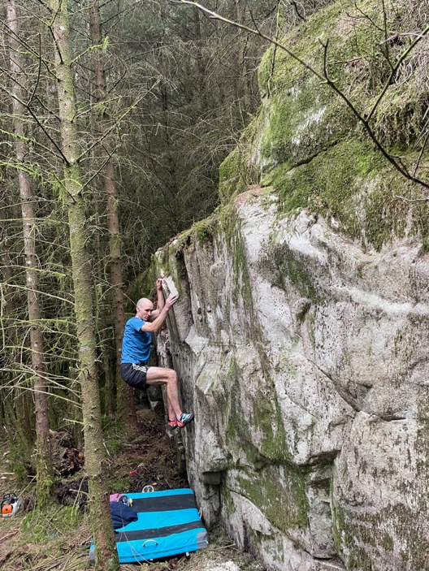

10 Fine Feller 6A
The wall just above traverse left to right.
Si Newman March 2025

11 Direct 6A
Sds under the good right end of the traverse and go direct.
Si Newman March 2025
West side continued
Park at SH 71639 27539
There is a good layby on the right. From here walk across the road and the first two boulders are 6 meters inside the forest.
1 5B The lower boulder has a sds under its right edge then a traverse left, around the prow and TO leftwards.
2 The Lonely slapper 6B+ Sds under the centre of the impressive leaning wall and use a small slot to gain access to finishing jugs. Martin Crook 2019 Video link
OS SH 71511 27186 The next collection is approached by following the tarmac road uphill from the layby. Turn left on the forestry trail and follow that past the spot where the MB trail crosses. A little further on a stone wall runs down the slope. Turn up into the forest before the wall and after 70 meters the first stone appears. Approx 10 minutes from the layby. From left to right they are
3 Goldcrest 4C
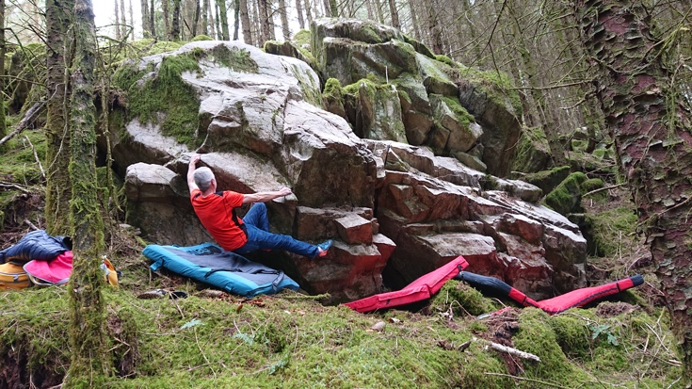Firecrest
4 Firecrest 6A+ Sds on the right but stay low with feet on small holds just above ground level. Turn the corner and still staying as low as possible slap way out left to a sloper from which the juggy finishing holds up and left are reached.
5 Baltasar Head 5C The impressive prow from a stand start, with nice compression moves on good holds to the juggy TO.
6 Wine Tears 5B LH on undercut, RH on sloping edge and shoot to the juggy TO.
7 Slow starter 4C Sds hanging the low prow then race on up

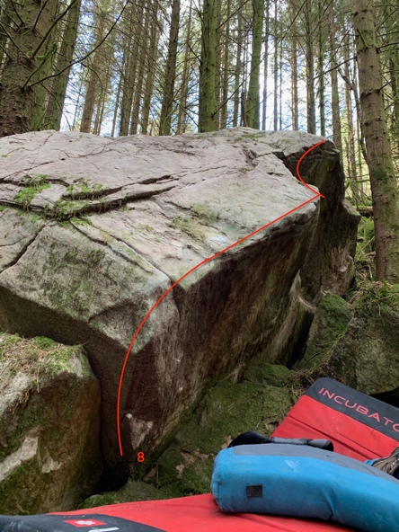
8 Tailspin 6B Sds over on the left and traverse the perfect hanging edge to gain the good foothold by the tree. Rock up and finish out right.

OS SH 71472 27255
9 Nonsensical behaviour 5B Sds under the right edge of the rib which is just to the left of the main block and rock over leftwards.
10 Human Touch 5C Sds on the supporting left-hand boulder with good footholds on the main block and rock up.
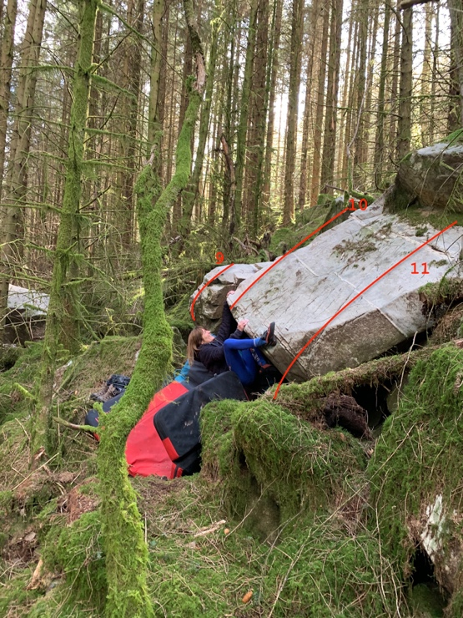Human Touch

11 Rock Solace 6B+ Sds down and left of the main face of the block and use the very small block on the left as the first low foothold to push off along the perfect, smooth edge which eases in the middle. Finish out right on a good, if distant, jug and rock up.
12 Long Time Comin’ 5B Sds under the great white edge and mantel over.
Cluster 2 and cluster 3 approach
Take the first left turn on the west side of the road and follow that to where it turns sharp right. The MB trail heads down and left at this point and directly opposite up in the forest is Cluster 3. From here walk up the road for 200 metres to cluster 2.
Time from layby 20 minutes Cluster 2 OS SH 72264 25566
This is the cluster above the wide turning area on the road where the R74 section of the Tarw mountain bike trail heads downhill.
1 Small Fry 5B Sds and up the crack and over.
2 Lesser Fry 5B Sds and layback the right edge to the top.
3 Elbow Dab 6A Sds with high LH jug and poor RH seam. Good right foot for simple move up and over. Trying to avoid the elbow dab with the left arm is challenging.
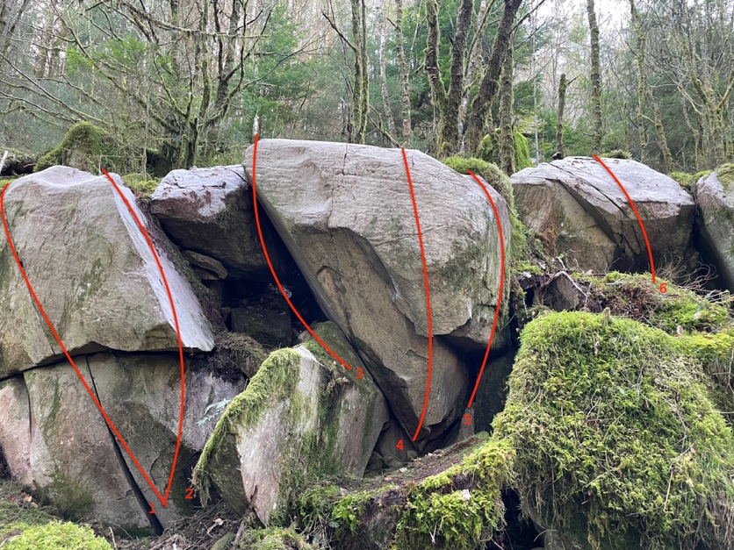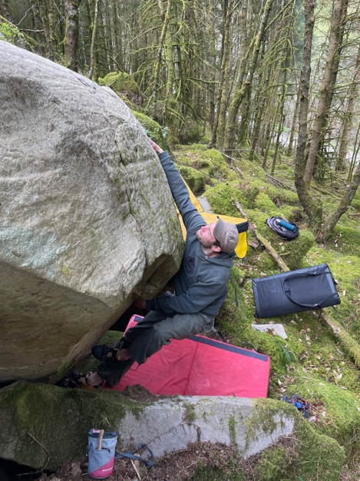
4 Stone Dreams 6B+ A sit under the jug and a long slap to topout. Elliot Twiddy March 2022
5 Nana Biscuits 6C Small people can squeeze into the gap just right and crank straight up.
6 Zuri 6B Fun sds under the steep stone with good starting jug. The neighbouring stone is not needed.
Directly above is a big wall with a perfect pinnacle to its left.
7 The Dawn Pinnacle 6A+ Stand start under the right edge and rock over onto the slab.
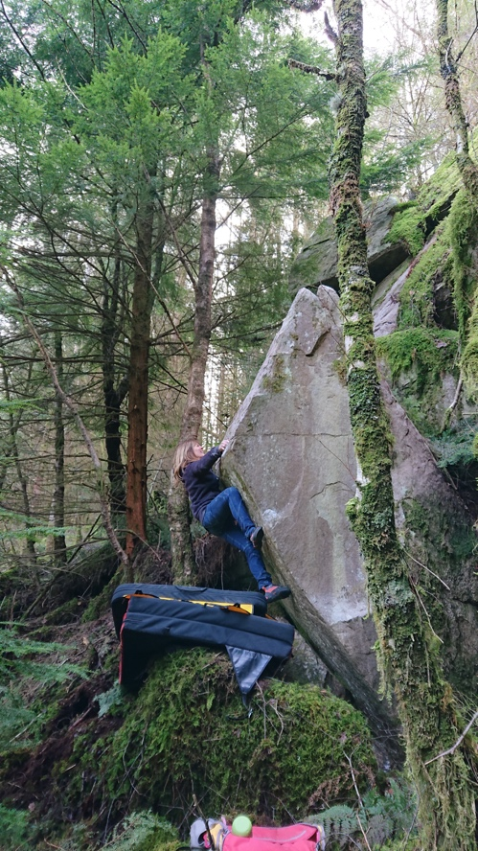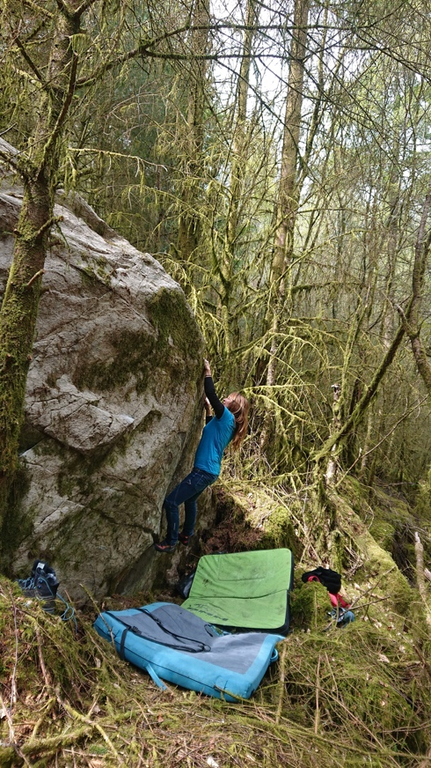
Dawn Pinnacle Hussle

The upper boulder
8 Tussle with Tussocks 6B An awkward sds just right of the tree with low LH layaway and good RH sloper and pull up directly.
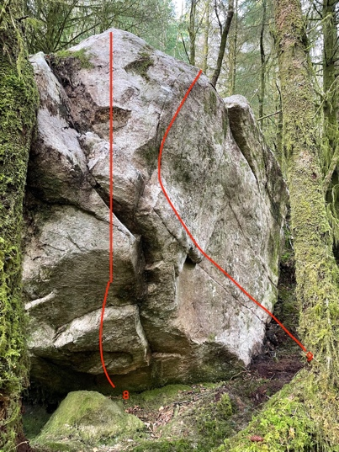
9 Hussle 6B Sds under the right edge and follow the seam leftwards to the good ledge for the rock up.
The lower boulder
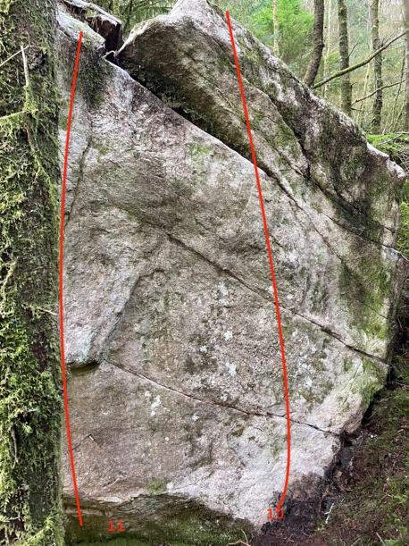10 The Jesus Crouch 5A Sds with low jugs and go direct.
11 Jes u It 5A Sds and follow the good edge

Cluster 3 OS SH 72012 25849
The roadside stones are tiny but perfectly formed.
Follow the forestry track uphill for 200metres. The collection runs from left to right just above the roadside.
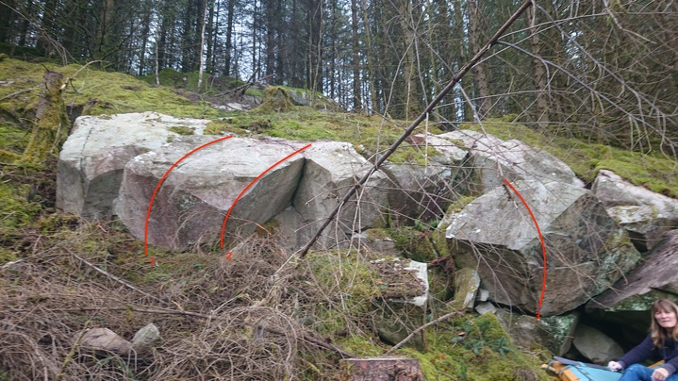
1 Doris Johnson Jollies 6A
Sds with LH seam and RH crimp and pop over.
2 The End of Doris Days 5C Sds with crimp LH and sloper RH and hit the apex of the groove to TO.
3 Party Time 5C Sds with good finger ledge on the face on the right of the two big boulders and pull off the mat with high right heel and TO over the boulder.
In the recess behind these two boulders are two problems.
4 Calapasca 6A Stand start with crimps and rock up onto the big footledge to pull onto the slab.
5 Cheerful Sunday Crucifix 6A+ Sds with good LH edge and pull up and over.

Big Slab
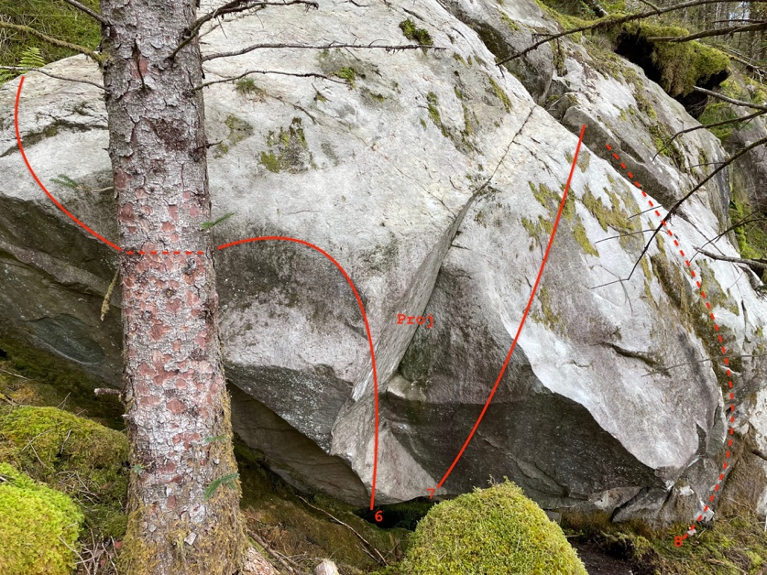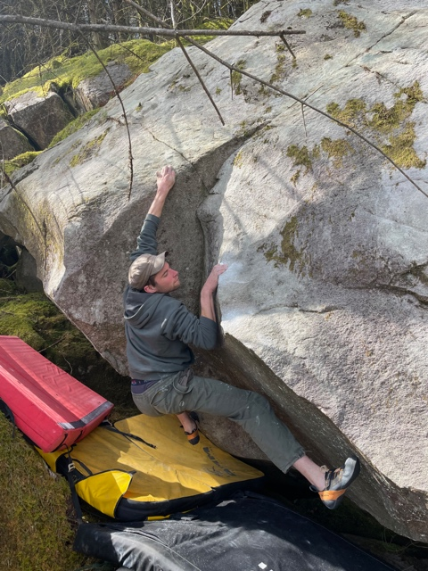
Elliot Twiddy on project groove direct.
6 Fling it and Wing It 6C Sit down on the left of the groove with good low LH and high RH crimp, pull on and stretch left to the slopers which lead leftwards to the slab edge and the easy rockover.
7 Fockit and Lockit 6C Sit down under the groove right side and rock over right onto the slab to pad directly up.
8 Easter Punday 5B The sds into the groove on the right side of the slab
9 Doris Day and the Parliamentary Cowboys 5C Sds with good LH layaway and launch for the good RH finger edge then high feet to hit the TO jugs.
10 Fly me to the Lung 6A Sds with good LH edge and something for the RH to go up and over.
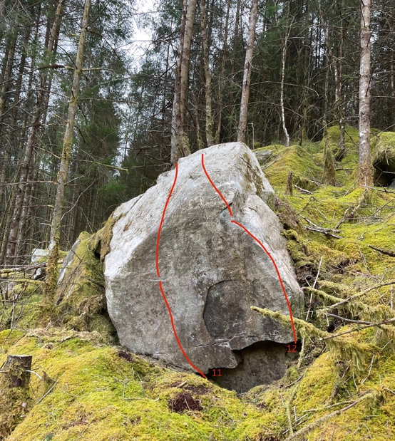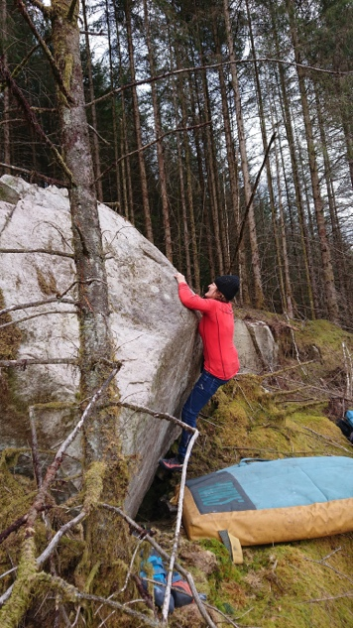
11 Screaming Blue Murder 6A+ Sds under the centre of this excellent boulder with good starting crimp and head direct.
12 Murder on the Coed y Brenin Express 6A+ Sds with great jug then head up and left to the top.
Up above this in the forest are more boulders
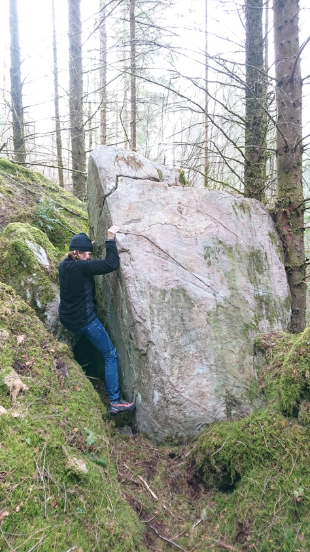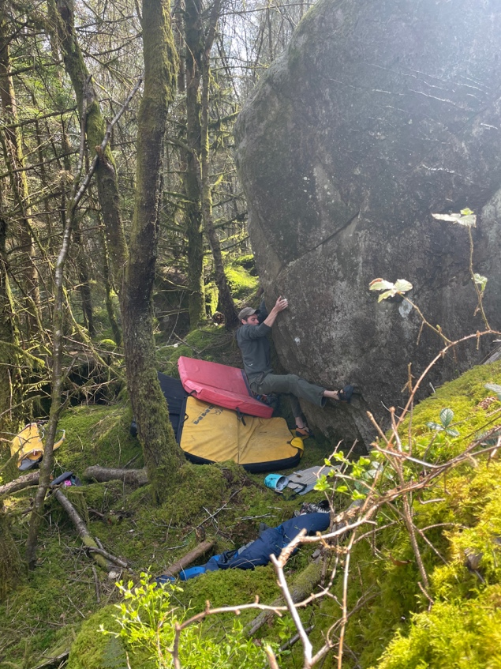
Some Route! Sylvan Dreams of Elliot Twiddy

13 Some Route! 5B Sds in the claustrophobic recess at the back of the boulder and layback the edge
14 Passerby 5B Sds and up the groove on the downhill side of same boulder
15 Sylvan Dream 6B+ Sds under the groove, gain the jugs and high topout on the slab. An exercise in self -belief.
Further south along the road are two more walls.
OS SH 72204 24762 elevation 180m.
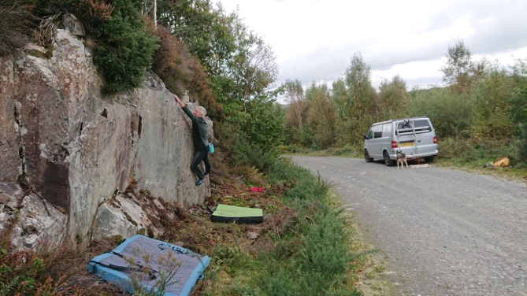
Roadside 6B A fun traverse from the stand over on the right to reach the last shelf on the left.
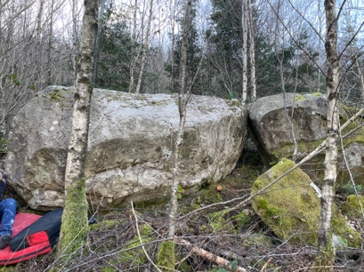 The Memory Stone 6B
A traverse on the low boulder 10 meters above the road in dense undergrowth. Forgettable.
The east side.
This is the car park and the MB centre. From the upper carpark walk north along the road, through a gate and into a large open area. There are two described boulders in the forest above the open area, the first should be visible as it is only 3 meters into the forest.
Boulder one Project
Boulder two is a little higher up.
1 Forest Life 5B This higher boulder is 10 meters above boulder one and forms a well-defined roof. Sds very low under the roof crack and rock up and over.
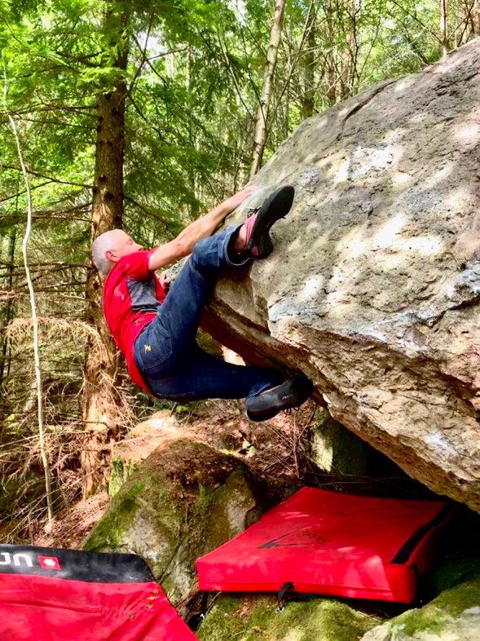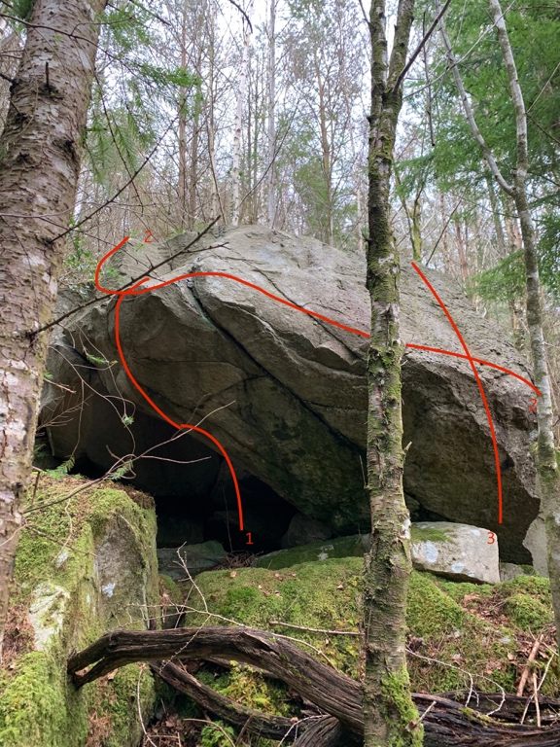
2 It Lives in the forest 6C Sds over on the right and slap and smooth your way all the way leftwards to the TO.
3 It groans in the forest 6B Sds under the right side of the face and pull directly up. Stand start is 5C.

The Burma Stones OS SH 72188 29048. Elevation 400 metres Topo at https://midwalesbouldering.com/
A minor collection of little, white, gritstone boulders on the old road to Moel Penmaen. Leave the main road just north of the MB centre and follow it to where the old road exits left. Pass through a wooden gate and follow the road for 400 meters (it is possible to park a vehicle here as there is plenty of space). The stones are visible on the hillside and are approached from the road on the right over brash and bramble in a few minutes.
Moel Penmaen TOPO at https://midwalesbouldering.com/

