Moelwyn Bach
OS SH 655 434. Elevation 600m
A good collection of blocks and walls on the hillside below the south facing walls of the summit cliffs. There are several outstanding problems here which make the walk-in worth a go.

Park OS SH 634 433
On the Rhyd to Croesor road pass the wide grassy bay and park 100 meters north of the electricity pole. Pass through the gate just north of the parking and take the public footpath. This passes through half-felled forest and then comes out onto steep open moorland. Drop down right past a prominent boulder (problem 1) and continue along under the summit cliffs. The big square Owl Boulder is a good landmark.
Time: 1 hour.
It is also possible to follow tracks directly up through the forest below the boulder field, an equally long walk.

1 Snow Luck 6b+
The left to right traverse of the big boulder.
Terry Taylor December 2019
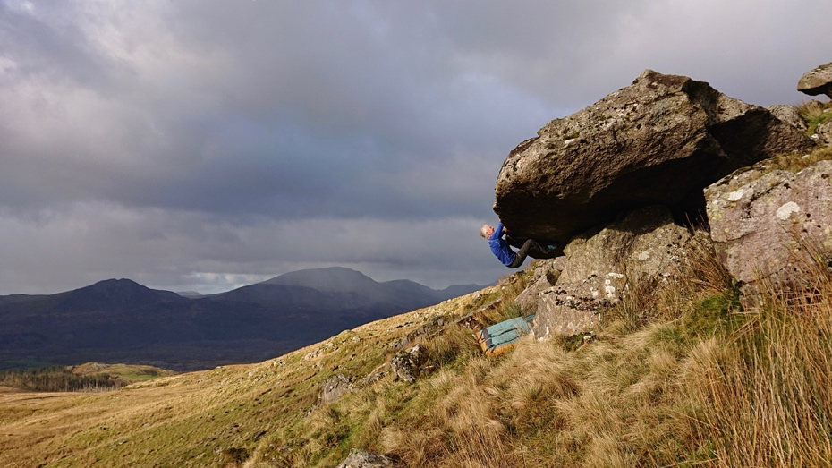
There are several good pillars behind this stone with easier problems.

The Owl Block is the large square block much further over on the hillside under the main section of the summit cliffs.

2 Fly Fall 6A+
Sds with undercut jug and make a hard pull up to good holds.
George Smith December 2020

3 Swan Flake 6A
Same sitter but then move up and right to the flakey edge.
George Smith December 2020

4 Owl Flake 6A
Stand under the diagonal flake line.
George Smith December 2020

5 Fly By 6B+
The blank wall is a wonderful from the stand with a busy topout.
George Smith December 2020

6 Owl Ridge 6A
Sds and up the edge
Crispin Waddy December 2020

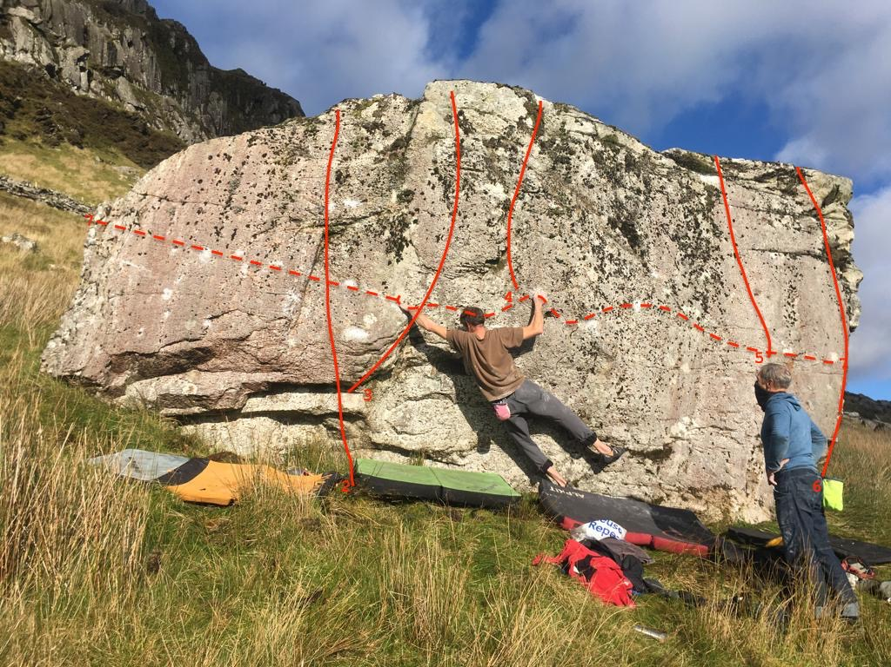

Noel Craine and Martin

7 No Fly Zone 7A
The excellent right to left traverse building to a fingery climax.
Martin Crook December 2020

8 Celebrity Owl 6A+
The brilliant arete next right from a sculptural sitter. From flat holds pop for the pinch and head for a series of flatties on perfect rock.
George Smith December 2020

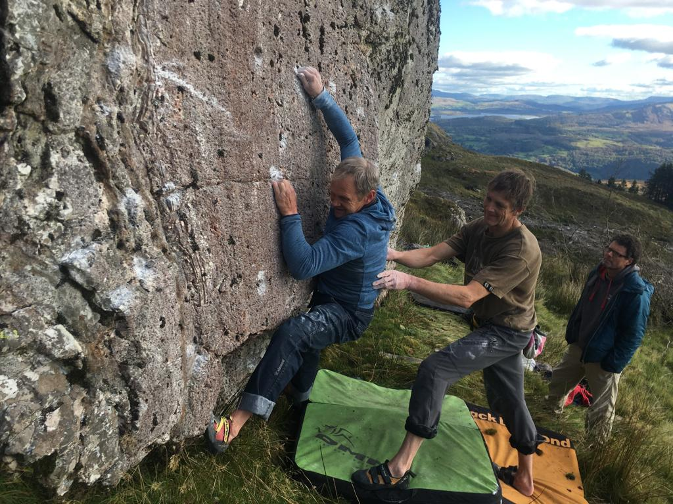

Martin entering the crux of No Fly Zone .

Follow the same contour line further east to
9 Pussy Cat Block 6B+
Sds then follow the ramp to a mantel.
George Smith December 2020

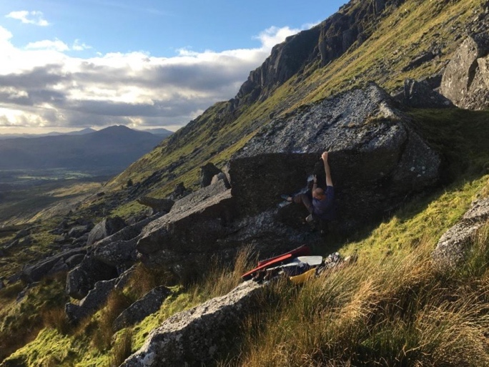Pussy cat

10 Wadd Wall 6B (no topo)
The centre of the obvious wall on the rocky knoll directly below the Owl.
Crispin Waddy December 2020

Further down the hill is another collection of walls and blocks. Over on the left is a good white wall.

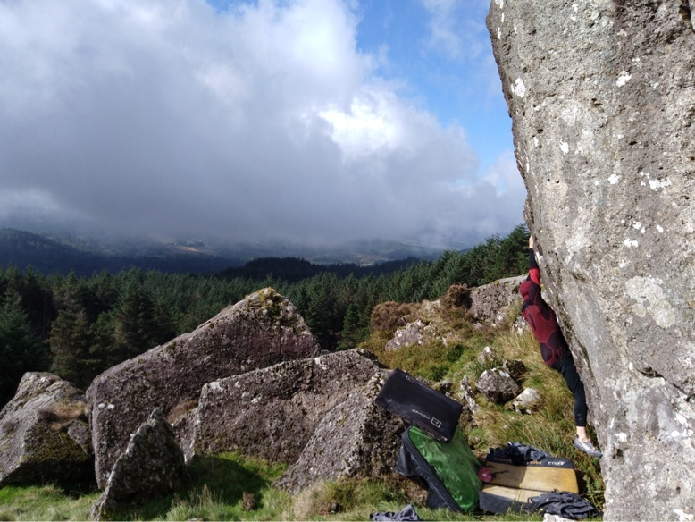
11 Ong Bach 7A
The excellent pocketed wall from a stand.
Martin Crook September 2018.

12 Prow 7B no topo
Up and over the prominent prow up and right of Ong Bach past the good deep pocket.
Pete Robbins 2021.

Below this is another area with a few walls and blocks.

13 Bone Tomahawk 6B+ no topo
The fine, finger-crack from right to upper left.
Martin Crook 27 September 2018
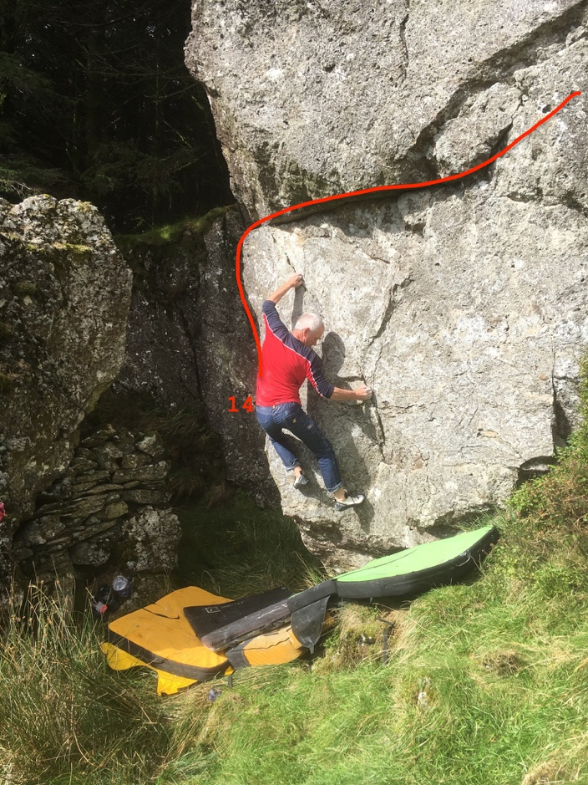

14 Haul LLwynog 6B
Up the fine edge then traverse right to the step off.
Terry Taylor 27 September 2018.

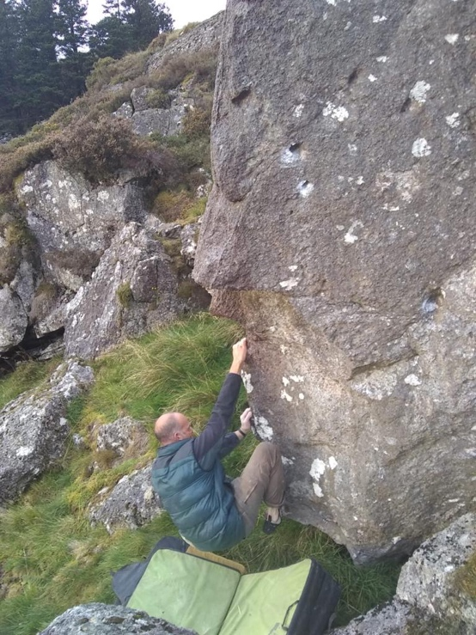George Smith repeating Ridge Wrestler
15 Ridge-Wrestler 6B
From the sit make overdramatic layaways up the rib.
Terry Taylor 27 September 2018

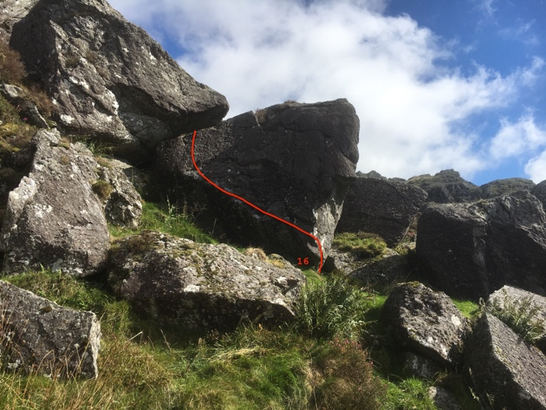

16 Lost in Translation 6B
Low traverse right to left from sit.
Terry Taylor 27 September 2018

There is one more wall in the trees below.

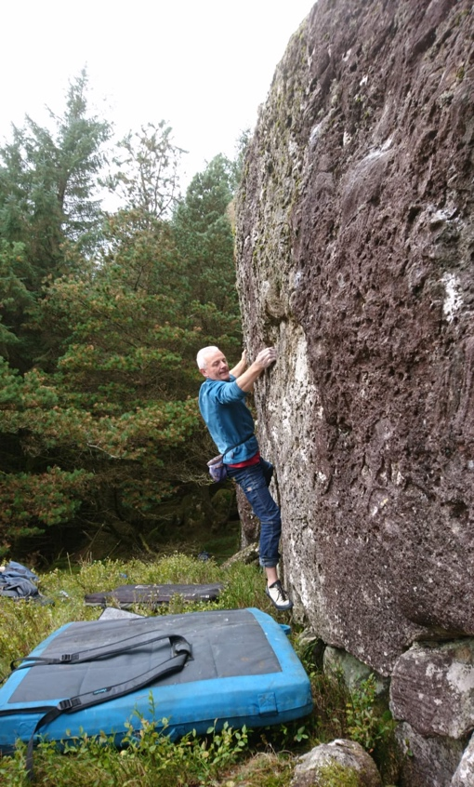

17 Lost in Time 6B
Traverse left to right above the good platform.
Terry Taylor 15 October 2018.

